Chapter 4

Teaching a
Discussion
Section


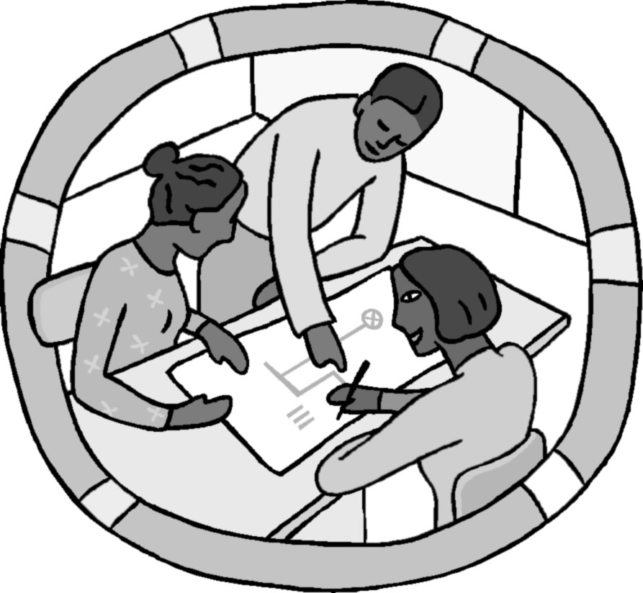

Page
I. Overview of Teaching a Discussion Session 97
II. Outline for Teaching a Discussion Session 99
III. Detailed Advise for Teaching a Discussion Session 101
IV. Preparation for Teaching a Discussion Session 105
V. Some Other Teaching Tools 107
VI. Characteristics of Good Group Problems 115
VII. Level of Difficulty of a Good Group Problem 119
VIII. How to Change an Unsuitable Textbook Exercise 123
into a Good Group Problem

I. Overview of Teaching a Discussion Session


The usual Cooperative Problem Solving (CPS) routine, like a game of chess, has three parts -- Opening Moves, a Middle Game, and an End Game. As in chess, both the opening moves and the end game are simple, and can be planned in detail. The middle game - collaborative problem solving -- has many possible variations.

Opening Moves (~5 minutes). Opening moves determine the mind-set that students should have during the Middle Game -- the collaborative solving of a problem. The purpose of the opening moves is to answer the following questions for students.
- Why has this particular problem been chosen?
- What should we be practicing and learning while solving this problem?
- How much time will we have?
- What is the product we should have at the end of this time?
Educational research indicates that providing students this simple information before they start leads to better learning and higher achievement. Here is an example of an opening move for the Skateboard problem, shown in Figure1 on the next page.

“We have been studying two conservation principles in class -- the conservation of energy and the conservation of momentum. The problem you will solve today was selected to help you learn how to decide when and how to apply these principles.

You will have 30 minutes to work on the problem. At the end of that time, you will be asked to draw on the board your diagrams and write a numbered list of the equations you used to solve the problem.”

Middle Game (~30 - 35 minutes). This is the learning activity -- students work collaboratively to solve the problem. During this time, your role is one of listener and coach. You circulate around the room, listening to what students in each group are saying and observing what the Recorder/Checker is writing. You intervene when a group needs to be coached on an aspect of physics (see Chapter 2, page 13).

At the end of the allotted time, you have your groups draw and write on the board the parts of the solution that you specified in your opening moves.

In most CPS sessions (except for a group test problem), students may not have time to complete the problem solution before you stop them to conduct the whole-class discussion. This makes some students anxious or uncomfortable, and it is very difficult to get groups to stop solving the problem. Because the class discussion cannot go over the entire problem solution, many students need reassurance that their solution is correct (or at least on the right track). Anxiety is relieved when they know they will get a complete solution when they leave class, and it is then easier to stop the groups and have them participate in the whole-class discussion.

Figure 1. The Skateboard Problem

You are helping your friend prepare a skateboard exhibition. The idea is for your friend to take a running start and then jump onto a heavy duty 15-lb stationary skateboard. Your friend, on the skateboard, will glide in a straight line along a short, level section of track, then up a sloped concrete wall. The goal is to reach a height of at least 6 feet above the starting point before rolling back down the slope. The fastest your friend can run and safely jump on the skateboard is 20 feet/second. Can this program work as planned? Your friend weighs in at 125 lbs.

End Game (~10 - 15 minutes). The end game determines the mind-set students have when they leave the class -- do they think they learned something or do they think it was it a waste of their time. The purpose of the end game is to help students answer the following questions.
- What have I learned that I didn't know before?
- What did other students learn?
- What should I concentrate on learning next?

That is, a good end game helps students consolidate their ideas and produces discrepancies that stimulate further thinking and learning. Typically, the instructor gives students a few minutes to examine what each group produced, then leads a whole-class discussion of the results. Your role as the instructor is to facilitate the discussion, making sure students are actively engaged in consolidating their ideas. Here is a short example of a few end-game questions for the Skateboard problem.

“Look at the momentum vector diagrams on the board. How are they the same and how are they different?

Is there different physics represented in the momentum diagrams, or the same physics?

Look at the momentum diagrams for group #1 and #5. What is missing in these diagrams?

Does the order – x direction first or y direction first – make any difference to the final solution?”

At the end of this discussion, you may need to model some parts of a solution – like how to draw a good physics diagram (motion, force, energy, or momentum), how to apply Newton’s Laws to the problem, how construct a solution that helps you keep track of the unknowns, and so on. [See page 105 for some tools that will help you model and coach these aspects of a logical, organized problem solving procedure.

II. Outline for Teaching a CPS Discussion Session

This outline, which is described in more detail in the following pages, could serve as your "lesson plan" for each discussion session you teach.

Preparation Checklist
❑ New Group/Role assignments (if necessary, written on board)   Photocopies of Problem & Useful Information (one per person)  OR Problem and list of useful information to put on board | ❑ Photocopies of Answer Sheet (or later, blank sheets of paper) (one per group)   Photocopies of problem solution (one per person)   Group Evaluation forms (optional one per group) and extra photocopies of Problem Solving Roles sheets

 | Instructor Actions | What the Students Do
Opening Moves  ~3-5 min. | ⓪ Be at the classroom early  ① Introduce the problem by telling students:  a) what they should learn from solving problem;  b) the part of the solution you want groups to put on board  ② Prepare students for group work by:  a) showing group/role assignments (and classroom seating map if necessary);  b) passing out Problem, (& Useful Information) and Answer Sheet. | • Students sitting and listening  • Students move into their groups, and begin to read problem.  • Checker/Recorder puts names on answer sheet.
Middle Game  ~35 min. | ③ Coach groups in problem solving by:  a) monitoring (diagnosing) progress of all groups  b) helping groups with the most need.  ④ Prepare students for class discussion by:  a) giving students a “five-minute warning”  b) selecting one person from each group to put specified part of solution on the board.  c) passing out Group Evaluation Sheet (as necessary) | • Solve the problem:  - participate in group discussion,  - work cooperatively,  - check each other’s ideas.  • Finish work on problem (many will not finish the solution).  • Write part of solution on board  • Discuss their group effectiveness
End  Game  ~10 min. | ⑤ Lead a class discussion focusing on what you wanted students to learn from solving the problem  ⑥ Discuss group functioning (as necessary)  ⑦ Pass out the problem solution as students walk out the door. | • Participate in class discussion

III. Detailed Advice About Teaching a

Discussion Section

You should notice a lot of repetition of the same advise given for teaching a lab session (page 83) because the goals of the discussion sessions and labs are the same – practice and coaching in a logical, organized problem solving process.

Opening Moves

Step ⓪. Be at the Classroom Early
The classroom will probably need some preparation, so it is best to go in and lock the door, leaving your early students outside. [The best time for informal talks with students is after the class or during your office hours.]
Early in the course, arrange the chairs for group work (see page 38). Then write on the board:
(a) group assignments (if new) and roles;
(b) the part of the solution you want groups to write on the board (see example below);
(c) early in course, a seating map for the groups.

Step ①. State the Purpose of This CPS Session (~ 2 minutes)
Introduce the problem by telling students:

a) What They Should Learn. Tell your students why the group problem was selected and what they should learn from solving the problem. For example: “For the past few weeks we have been studying the conservation of energy and the conservation of momentum. The problem you will solve in your groups today was designed to help you think about the difference between the two conservation laws and when to apply a conservation law.”

b) The Part of the Solution You Want Groups to Put on the Board. For example, For example, for the Skateboard problem: “After about 30 minutes, I will randomly select one person from each group to write two things on the board, first your conservation diagram(s) with defined symbols; and second a list of the specific equations that you need to solve the problem. [It is helpful to write this on a board, as shown below] Then we will discuss the features of a good diagrams that are useful for solving problems.”

1. Conservation Diagram(s) & Defined Symbols.
2. List of specific equations needed to solve the problem

DO NOT have students write their mathematics solutions on the board. You can tell by a list of equations whether the students have the right equations to solve the problem. Students will see the detailed mathematics solution when you hand out the solution at the end of class.

Step ②. Prepare Students for Group Work (~ 1 minute)
a) Group Role Assignments. If students are working in the same groups, remind them to rotate roles. If you have assigned new groups, show students their group assignments and roles. Then tell your students to move the chairs for their group.

b) Pass Out Materials. While the students are getting into their groups, pass out the Problem/information Sheet and Answer Sheet (or blank pages) to each group. As you do this, make sure all groups are seated according to your map -- facing each other, close together but with enough space between groups for you to easily observe and circulate between groups.

If you do not have equations on the problem sheet, write the equations on the board. NEVER LET STUDENTS USE THEIR TEXTBOOKS.

Middle Game (~ 30-35 minutes)
There are two instructor actions during the middle game: coaching students in problem solving, and preparing students for the whole class discussion. You will spend most of this time coaching groups.

Step ③. Coach Groups in Problem Solving (~ 25-35 minutes)
Below is a brief outline of coaching groups. For detailed suggestions for coaching and intervening techniques, see pages 13 - 27.

a) Diagnose initial difficulties with the problem or group functioning. Once the groups have settled into their task, spend about five minutes circulating and observing all groups. Try not to explain anything (except trivial clarification) until you have observed all groups at least once. This will allow you to determine if a whole-class intervention is necessary to clarify the task (e.g., “I noticed that very few groups are drawing conservation diagrams. Be sure to draw and label a diagram. . . .”).

b) Monitor groups and intervene to coach when necessary. Establish a circulation pattern around the room. Stop and observe each group to see how easily they are solving the problem and how well they are working together. Don't spend a long time with any one group. Keep well back from students' line of sight so they don't focus on you. Make a mental note about which group needs the most help. Intervene and coach the group that needs the most help. If you spend a long time with this group, then circulate around the room again, noting which group needs the most help. Keep repeating the cycle of (a) circulate and diagnose, (b) intervene and coach the group that needs the most help.

Step ④. Prepare Students for Class Discussion (~ 5 minutes)
a) Five-minute Warning. About five minutes before you want students to stop, warn the class that they have only five minutes to wind up their solution. Then circulate around the class once more to determine the progress of the groups. Make a mental note of what you need to discuss with the class.

b) Posting Partial Group Solution. Tell one person in each group, who is not the Recorder/Checker, to write the (previously specified) part of their solution on the board (or butcher paper if there is not enough board space). In the beginning of the course, select students who are obviously interested and articulate. Later in the course, it is sometimes effective to occasionally select a student who has not participated in their group as much as you would like. This reinforces the fact that all group members need to know and be able to explain what their group did.

c) Pass out Group Functioning Evaluation form (as necessary). If you decided to have your groups evaluate their effectiveness, pass out the forms (one per group) and have groups complete the form.

End Game (~ 10 - 15 minutes)

There are many similarities to leading a class discussion at the end of a lab problem and at the end of a discussion section. We will discuss leading a class discussion in TA Orientation and in the seminars throughout the year.

The end-game discussion focuses on what you told students they would learn from solving this problem. After group pictures, diagram, and/or equation lists are posted (on board, whiteboards, butcher paper) for all to see, give students a few minutes to compare the results from each group. Then lead the class discussion

Step ⑤. Lead a Class Discussion (~ 10 minutes)
The whole-class discussion is always based on the groups, with individuals only acting as representatives of a group. This avoids putting one student "on the spot." The trick is to conduct a discussion about the problem solution without (a) telling the students the "right" answers or becoming the final "authority" for the right answers, and (b) without focusing on the "wrong" results of one group and making them feel stupid or resentful. To avoid these pitfalls, you could try starting with general, open-ended questions. Examples of some questions for the Skateboard problem are:
- How are the representations of the conservation of energy and conservation of momentum similar? [Need to consider initial and final states of the system, and whether there is a transfer into or out of the system]
- How are the representations different? [momentum is a vector; energy is not.]

In the beginning of a course, students naturally do not want to answer questions. They unconsciously play the waiting game -- “If we wait long enough, the instructors will answer his/her own question and we won’t have to think.” Try counting silently up to at least 30 after you have asked a question. Usually students get so uncomfortable with the silence that somebody speaks out. If not, call on a group by number and role: “Group 3 Manager, what do you think?”

After the general questions, you can become more specific. Of course, the specific question you ask will depend on what you observed while groups were solving the problem and what your groups write on the board. For the skateboard problem, some example questions might include:
- How are the representations of the conservation of energy and conservation of momentum similar? [Need to consider initial and final states of the system, and whether there is a transfer into or out of the system]
- How are the representations different? [momentum is a vector; energy is not.]

Remember to count silently up to 30, then call on a group if necessary. Always encourage an individual to get help from other group members if he or she is "stuck."

Encourage groups to talk to each other by redirecting the discussion back to the groups. For example, when a group reports their answer to a question, ask the rest of the class to comment: "What do the rest of you think about that?" This helps avoid the problem of you becoming the final "authority" for the right answer.

Step ⑥. Discuss group functioning (as necessary, ~ 5 minutes)
An occasional whole-class discussion of group functioning is essential. Students need to hear the difficulties other groups are having, discuss different ways to solve these difficulties, and receive feedback from you. Randomly call on one member of from each group to report their group answer to the following question on the Evaluation form:
- one difficulty they encountered working together, or
- one way they could interact better next time.
After each answer, ask the class for additional suggestions about ways to handle the difficulties. Then add your own feedback from observing your groups (e.g., "I noticed that many groups are coming to an agreement too quickly, without considering all the possibilities. What might you do in your groups to avoid this?")

Step ⑦. Pass out the solution.
Passing out the solution is important to the students. They need to see good examples of solutions to improve their own problem solving skills. Again, it is important to pass them out as the last thing you do -- as students leave the room. If you pass them out earlier, your students will ignore anything that you say after you have passed them out.

IV. Preparation for Teaching a Discussion Session

The overall goal of the CPS discussion section is to help students slowly abandon their novice problem-solving strategies (e.g., plug-and-chug or pattern matching) and adopt a more logical, organized problem-solving procedure that includes the qualitative analysis of the problem. The learning focus of a particular lab session will always be on some aspect of the analysis of the problem and/or the application of the fundamental principles.

The learning focus of a discussion session is established and carried out in your opening moves and end game (see Section I, page 97). So before you teach a discussion session, there are two decisions you need to make.
Opening Moves
1. What will I tell my students the learning focus is? Which part(s) of the problem solution will I tell groups to draw/write on the board during the end game?
End Game
2. How much time should I set aside for the end game?

The following is a guideline for making these decisions.

Step 1. Browse through the Competent Problem Solver for examples of (a) how to draw the physics diagram for the group problem (e.g., motion, free-body, energy, and/or momentum diagram), (b) how to apply fundamental concepts and principles to solve problems, and (c) how to keeping track of the unknowns while constructing a solution.

Step 2. Solve the group problem in the way you would like students to solve the problem, so you know what to look for while coaching your students. Use the notation that is in the students’ textbook. [If kinematics is involved, try to use only three kinematics equations in your problem solution. See the next section, Useful Information.]

Step 3. Decide the learning focus for the discussion session. What part(s) of the problem solution do you want groups to draw/write on the board?

One factor that influences your choice of learning focus is the timing.
• Has a new fundamental principle been introduced (e.g., Newton’s Laws, Conservation of Energy)?
• Have new concepts been introduced? NO (e.g., students in last week of projectile motion) or YES (e.g., students just starting circular motion).
You should know this information from your team meeting and from teaching the lab session earlier in the week.

Decision Table

Timing | Rule of Thumb for Learning Focus  What to Tell Groups to Draw/Write on The Board
New fundamental principle just introduced (e.g., forces, conservation of energy) | Learning focus is on how to draw new physics diagram(s) (where most alternative conceptions show up)
New concept has been introduced (e.g., independence of motion in the horizontal and vertical directions. | Learning focus is on how to incorporate the new concept in physics diagram(s), but you can often have students list equations as well.
No new concept has been introduced (or new concept is easy) | Learning focus is usually on the list of equations students need to solve the problem (indicates difficulties students continue to have in applying a principle and concepts)

Another factor that influences your choice of learning focus is the difficulties students had with solving the last lab problem. What aspect of solving problems with this principle and
associated concepts are still difficult for your students? The Decision Table above gives only a general rule of thumb for deciding what part of the solution to have groups draw/write on the board.

Step 4. The two factors above (timing and your knowledge of the difficulties students are having solving problems) also influence your decision of how much time to spend on the end game, as well as your coaching of your groups while they solve the problem.

The one thing you can count on is that when a new fundamental principle or difficult concept has just been introduced, the discussion of your group’s partial solution will take longer. At the end of the discussion, you may need to show students how to do something (model). For example, you may need to model how to draw vector components on their motion diagrams, or how to determine what forces are acting on an object, how to label the forces, how to draw a free-body diagram, the meaning of Newton’s 2nd Law, how to draw an energy diagram, and so on.

V. Some Other Teaching Tools

You have several teaching tools available for CPS discussion sessions, including the Problem Solving Framework and Answer sheets, the Group Roles (page 16), and the Problem Framework Roles (page 46).

Three additional tools, which will make your teaching role easier and more rewarding, are discussed in this section: list of useful information, the Competent Problem Solver, and a Table of Interactions and Forces.

List of Useful Information

Many students believe that solving a physics problem requires them to know the right equation for that particular problem. So part of their plug-and-chug and pattern-matching strategies is the memorization of all the equations in each chapter of their textbook. These equations are of equal importance to students. They do not distinguish the mathematical formulations of fundamental principles (e.g., Newton’s Laws, conservation of energy and momentum) from equations that are applicable only in specific circumstances or for specific types of interactions (e.g., equations for the gravitational interaction, spring interaction, friction). Worse yet, the equations memorized for one chapter are promptly forgotten while memorizing the formulas for the next chapter.

The use of a list of useful equations (written with the problem statement or on the board) is an example of applying the 3rd Law of Instruction -- Make it easier for students to do what you want them to do than to do what you don't want. In this case, you don't want students to spend time searching a textbook (or their memory) for appropriate equations or a matching example
problem, so you supply them with the information they need to solve the problem. Then groups must spend their time discussing what the equations mean and how the concepts and principles should be applied to solve the problem.

There are three features of a list of useful equations that can help promote student development of a coherent knowledge base and reinforce logical analysis of a problem using fundamental concepts and principles.

1. Separate the Fundamental Concepts and Principles from the concepts that apply Under Certain Conditions, as shown in the list on the next page.

2. Have the list of useful equations grow with time. For example, the list on the next page is near the end of the first semester.

3. Supply only the equations that state the fundamental principles that are stressed in the course. Students are not allowed to use any other equations to solve a problem.

List of Useful Equations

Fundamental Concepts and Principles:
F12 = F21

Under Certain Conditions:

Feature 1 is easy for you to carry out. Feature 2 is more difficult if you write the list of useful equations on the board. It is easier to write the list once below the group problem before you photocopy the problem for your class.

You cannot implement Feature 3 unless your team (professor and other TAs) agrees. Feature 3 is another example of applying the 3rd Law of Education: Make it what you want students to do easier than what you don’t want students to do. For example, if students are allowed to use all of the derived equations in kinematics, then they can solve most of the kinematics problems using their plug-and-chug and pattern-matching strategies. By limiting the kinematics equations they can use, students must think about what each equation means and how they can use these equations to solve the problem.

Most kinematics problems can be solved with only three equations: the definition of average velocity, the definition of average acceleration, and one derived formula that applies only when the acceleration is constant. Using only three equations increases the number of steps in the solution. But an advantage is that the equations are independent. Students know that when they have the sane number of equations as unknowns, they can solve the problem – the rest is just mathematics.

In a calculus-based course that limits the number of equations, the derived formula is usually
$$x_{f}=\frac{1}{2}a_{x}{Dt}^{2}+v_{\text{ox}}Dt+x_{o}$$
because it is directly connected to the solution of the differential equation defining acceleration. In the algebra-based course, the derived equation is often replaced by

$${\bar{v}}_{x}=\frac{v_{i}+v_{f}}{2}$$
because this equation is easier for students to understand.

The Competent Problem Solver

The Competent Problem Solver – Calculus Version contains explanations and examples of:
• pictures and motion diagrams [pages 1-4 to 1-5; pages 1-8 to1-9, pages 2-4 and 2-12; pages 2-6 and 2-14; and pages 3-6 to 3-13, 3-18 to 3-19]
• free-body and force diagrams [pages 4-1 through 4-21]
• conservation of energy and conservation of momentum diagrams [pages 5-1 through 5-31]

You have seen how Competent Problem Solver can help you in your preparation for a lab session. You may also want to photocopy some of the pages to hand out to your students. For example, you may want to copy and hand out one or two examples that include the use of motion diagrams (e.g., pages 1-8 to1-9). You could white out the labels of the steps and write in the new labels). If your students are having difficulty with free-body diagrams, you may want to photocopy pages 4-1 though 4-7. And so on.

Table of Interactions and Forces

You learned from your reading that students have many alternative conceptions about the nature of forces, particularly the passive normal and tension forces. If you notice that many of your students have misconceptions about the nature of forces, you may want to hand out the Table of Interactions and forces. Allow the students to use this table while they are solving problems in groups.

The information in the table is spread out in their textbook. The table organizes the information in a way that is easy to use.

Contact  Interaction | Description of Contact Interactions | Empirical  Approx. | When Is the Contact  Interaction Present?
Normal | This interaction occurs when two objects are "pressed" together. The surfaces of the objects exert forces on each other where they are in contact. These forces are called "normal" forces. A normal force on an object is always a push directed at a right angle from the pushing surface. (In mathematics, the word normal means perpendicular.) The normal force has no force law or empirical approximation; you must calculate the magnitude of the normal force from the acceleration of the system and the other forces acting on it. | None  (must use  ΣF = ma  to calculate  normal force) | Whenever two objects are in contact, each will exert a normal force on the other. A normal force on an object will assume whatever value is required to keep the object from going "through" the surface of the other object. For example, a book does not fall through a table because of the normal force the table exerts on the book.
Tension | Another type of contact interaction occurs when a cord (rope, wire, or string) pulls on another object or system of objects. The force exerted by the cord is often called the "tension" force. A cord cannot push, so a tension force always a pull in the direction the cord is pulling. Like the normal force, the tension force has no force law or empirical approximation; you must calculate the magnitude of the tension force from the acceleration of the system and other forces acting on it. | None  (must use  ΣF = ma  to calculate  tension force) | Whenever a cord is attached to an object, the cord will exert a tension force (unless the cord is slack). For most problems, the cord is much lighter than the object(s) it is pulling, so the mass of the cord can be ignored. For most problems, you can also assume that the cord does not stretch, deform or break.
Spring | A spring interaction occurs whenever a spring attached to an object is stretched or compressed. The force of the spring on the object is called the spring force. Empirically, the spring force is proportional to the displacement (∆x) of the object from the spring's relaxed or unstretched position. The constant of proportionality, k, is the same for compression and extension and depends on the "stiffness" of the spring being used. The minus sign in the empirical approximation (called Hooke's Law) indicates that the direction of the spring force is always towards the relaxed position of the spring. That is, a stretched spring pulls on an object attached to its end, and a compressed spring pushes. | FS = - k∆x  or  FS = k∆x | A spring force will be present any time an object is attached to a spring that is stretched or compressed. Hooke's law is only accurate when the spring is neither stretched nor compressed too far from its relaxed length.
Air  Resistance | Another type of contact interaction occurs when an object is moving relative to the air. The resulting force on the object is called air resistance. At speeds we normally encounter, the magnitude of the air resistance force is approximately proportional to the square of the object's velocity relative to the surrounding air. Thus, if wind is present, an object may experience air resistance without moving! The constant of proportionality, A, is called the shape parameter. It depends on the size and shape of the object and on the density of the air. The direction of the air resistance force is the same as the direction of the air relative to the object. Air resistance is not a type of friction. The empirical relationship is more approximate than those for friction, springs and gravity close to the Earth's surface | FAIR = Av2 | An object experiences air resistance whenever it moves through air (or through any other gas), or if there is a wind blowing on the object. In many problems, the object is either small enough (so that A is very small) or moving slowly enough relative to the air that air resistance is much smaller than the other forces in the problem and you can ignore it. In other problems, air resistance is ignored to make the problem simple to solve while still maintaining the main features of the motion.

Contact  Interaction | Description of Contact Interaction | Empirical  Approx. | When Is the Contact  Interaction Present?
Friction | Kinetic: When the surfaces of two objects slide over each other, each surface exerts a force (push) on the other called the kinetic friction force. The direction of a kinetic friction force on an object is parallel to its sliding surface and opposite from the direction the object is sliding. Empirically, the magnitude of the kinetic friction force that a surface exerts on a sliding object is approximately proportional to the normal force the surface exerts. The value of the proportionality constant µk, called the coefficient of kinetic friction, depends on the types of materials of the two surfaces and the roughness of the surfaces. It does not depend on the surface area in contact or the velocities of the objects in contact.  Static: Even when two objects are not sliding over each other, they may exert a "static friction" force on each other to keep from sliding. They act as though they are "stuck" together. For example, a car parked on a hill remains stationary because the road exerts a static friction force on the tires; if the hill were icy, the static friction force might not be large enough to keep the car from slipping.  Empirically, the magnitude of the static friction force that a surface exerts on an object has a maximum value that is proportional to the normal force the surface exerts. As with kinetic friction, the proportionality constant µs, called the coefficient of static friction, depends on the types of materials of the two surfaces and the roughness of the surfaces. The exact value of the static friction force will be whatever is necessary to keep the object from sliding; it is always less than or equal to the maximum value (µsFN). The direction of the force is parallel to the surface and opposite from the direction the object would slide if there were no static friction.  General Comments: For any particular pair of surfaces in contact, the value of µs is always larger than µk. Static and kinetic friction forces always push; they can never pull. | Kinetic:  Fk = µkFN  Static:  Fs ≤ µsFN | Kinetic frictional forces will be present whenever two surfaces slide against each other (including an object on a large surface like a ramp or table, or two objects in contact, like a book sliding over another book).  Static frictional forces will be present whenever two objects move as though they are "stuck" together. They become "unstuck" when the net force due to all the other interactions exceeds µsFN and the friction becomes kinetic.  General Comments: Only one kind of friction acts between any two surfaces at one time: it must be either kinetic or static friction. A friction force is sometimes so small that it makes no difference and you can ignore it (for example, objects sliding on an icy surface). For some problems, the surfaces are treated as ideal (µk = 0, µs = 0), and they exert no frictional forces. We refer to surfaces as frictionless when the friction is small enough to be ignored.

Long-Range  Interaction | Description of Long-range Interaction | Force Law | When Is the Long-range  Interaction Present?
Gravitation | A long-range gravitational interaction occurs between any two objects having mass. The gravitational force on each interacting object is proportional to the product of the two masses (m1 and m2), and inversely proportional to the square of the distance r between the centers of mass of the objects. The proportionality constant, G, is a called a universal constant because it does not depend on any other properties of the objects such as chemical composition, shape, texture, etc. The gravitational force is always attractive: the force on one mass is always directed toward the other mass. The magnitude of gravitational forces is extremely small (compared to common, everyday forces) unless both interacting objects are very massive (such as the sun and the Earth) or one is very massive and they are very close to each other (such as an object near the surface of the Earth).  Weight: For objects that are relatively close to the surface of a planet, the gravitational force of the planet on an object is called its "weight."  If the distance the object moves from the center of the planet does not change appreciably, then r is approximately equal to the radius of the planet (RP), and we can define a new variable,  which is very nearly a constant.  Then the gravitational force of the planet on an object is approximately equal to the object's mass times the gravitation "constant" g:  Fg = mg.  The average value of g close to the surface of the Earth is 9.81 N/kg. |  | Objects with mass always exert a gravitational force on each other. However, in everyday situations, the gravitational forces between ordinary-sized objects are so extremely small that they can be ignored. For example, the gravitational force exerted by a 100 lb woman on a 200 lb man standing 3 feet away is only 0.000000074 lbs.  If both interacting objects are very massive (e.g., sun, planets), then the gravitational forces are large and the force law should be used to calculate the forces.  If one of the interacting objects is very massive (e.g., a planet like the Earth), then the gravitational force on an ordinary-sized object is large and must be calculated. If the object remains close to the surface of the planet, then the gravitational force exerted by the planet on the object (the object's weight) can be found using the approximation:  Fg = W = mg  However, if the object's change of position from the center of the planet is an appreciable fraction of the radius of the planet (e.g., rockets, satellites, objects deep inside the Earth), then the gravitational force law should be used.

Long-Range  Interaction | Description of Long-range Interaction | Force Law | When Is the Long-range  Interaction Present?
Electric | A long-range electric interaction occurs between any two objects that are electrically charged. For point charges, the force law (called Coulomb's Law) states that the electric force on each charge is proportional to the product of the two charges (q1 and q2), and inversely proportional to the square of the distance r between the centers of the charges. The value of the proportionality constant, ke, depends on the conducting properties of the medium between the charges.  When the two charges are different (one positive and one negative), then the electric force is attractive: the force on one charge is directed toward the other opposite charge. When the two charges are the same (i.e., both positive or both negative), then the electric force is repulsive: the force on one charge is directed away from the other charge. |  | Charges always exert an electric force on each other. However, Coulomb's Law only holds for point charges like electrons and protons. For these subatomic particles, the electric force is very large compared to the gravitational force.  For ordinary objects that are charged, the electric forces between the objects depend on how the charge is distributed on the objects. If the objects have a spherically symmetric charge distribution, then they behave as if all the charge were at the center of the spheres. In such cases, the electric force has the same form as the Coulomb force for point charges:  However, ordinary spherical objects cannot hold a large charge (the range is about 10-9 to 10-7 Coulombs). If the charged spherical objects are heavy, then the electric forces will be very small compared to the other forces acting on the objects, and can be ignored.  If the objects with spherically symmetric charge distributions are light (e.g., ping pong balls, pith balls, balloons, small pieces of foil or paper) and close together (e.g., a few inches apart), then the electric forces will be comparable in size to the other forces acting on the charged objects. In such cases, the mathematical form of Coulomb's law can be used to calculate the forces.

NOTES:

VI. What are the Characteristics

of a Good Group Problem?

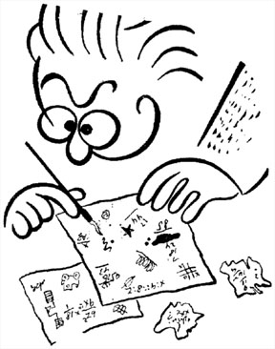
Good group problems encourage students to use an organized, logical problem-solving framework instead of their novice, formula-driven, plug-and-chug or pattern-matching strategy. Specifically, they should encourage students to (a) consider physics concepts in the context of real objects in the real world; (b) view problem-solving as a series of decisions; and (c) use their conceptual understanding of the fundamental concepts of physics to qualitatively analyze a problem before the mathematical manipulation of formulas.

In other words, good group problems place barriers (fences) on all solution paths that do not involve using a logical and organized problem-solving framework.
- It is difficult to use a formula to plug numbers to get an answer.
- It is difficult to find a solution pattern to match to get an answer. [A solution pattern is a memorized procedure for solving “inclined plane problems”, “free fall problems,” and son on.]
- It is difficult to solve the problem without first analyzing the problem situation.
- Physics words such as “inclined plane,” “starting from rest,” or “inelastic collision” are avoided as much as possible.
- Logical analysis using fundamental physics concepts is reinforced.

Consider the following problem.

Traffic Accident Problem. You have a summer job with an insurance company and are helping to investigate a tragic "accident." At the scene, you see a road running straight down a hill that is at 10° to the horizontal. At the bottom of the hill, the road widens into a small, level parking lot overlooking a cliff. The cliff has a vertical drop of 400 feet to the horizontal ground below where a car is wrecked 30 feet from the base of the cliff. A witness claims that the car was parked on the hill and began coasting down the road taking about 3 seconds to get down the hill. Your boss drops a stone from the edge of the cliff and, from the sound of it hitting the ground below, determines that it takes 5.0 seconds to fall to the bottom. You are told to calculate the car's average acceleration coming down the hill based on the statement of the witness and the other facts in the case. Obviously, your boss suspects foul play.

The application of some of these criteria to the Traffic Accident Problem is shown on the next page.


Feature 1. It is difficult to use a formula to plug in numbers to get an answer.
The student “knows” that acceleration is velocity divided by time, but no velocity is given and there are two different times in the Traffic Accident problem. OK, the student also “knows” that velocity is distance divided by time, so one time is to get the velocity and the other is to get the acceleration. Unfortunately for the student, there are two distances in the problem. Which one should be used? There is also an angle given. Does the student need to multiply something by a sine or cosine?

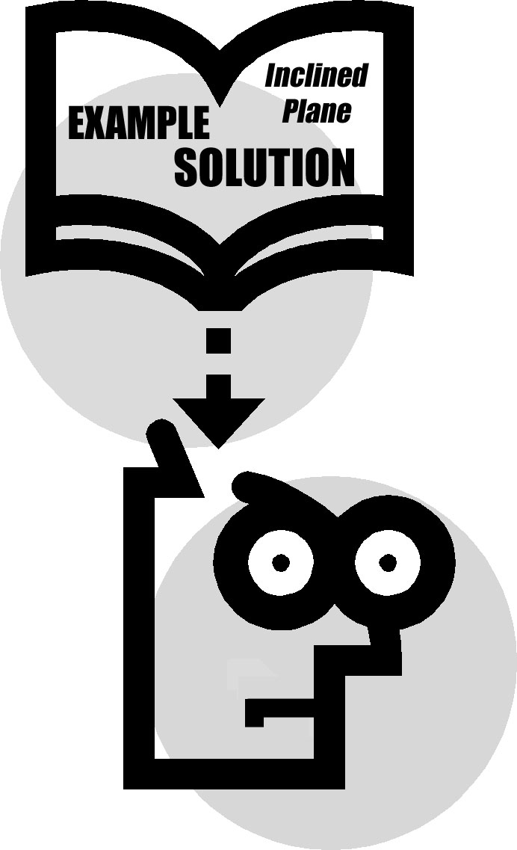
Feature 2. It is difficult to find a matching solution pattern to get an answer.
In the Traffic Accident problem, going down the hill this looks like an “inclined plane problem.” Is the acceleration just g sinθ? But what about the other numbers in the problem? When the car goes off the cliff, this is a “projectile problem.” You can calculate an acceleration from the distance (which one?) and the time the car falls. Why would that be the acceleration down the hill?

Feature 3. It is difficult to solve the problem without first analyzing the problem situation.


It is difficult to understand what is going on in the Traffic Accident problem without drawing a picture and designating the important quantities on that picture.
- Making the situation as real as possible, including a plausible motivation, helps students in the visualization process.
- Making the student the primary actor in the problem also helps the visualization process. This also avoids gender and ethnic biases that can inhibit learning. The other actors in the problem are as generic as possible, so the student’s visualization is not hampered by unfamiliar names or relationships.
- Students are forced to practice visualization because no picture is given to them. What path does the car travel when it goes off the cliff? What are the velocity and acceleration of the car at interesting positions in its motion? What are those positions?
- The visualization of a realistic situation gives the student practice connecting “physics knowledge” to other parts of the student’s knowledge structure. This makes the physics more accessible, and so more easily applied to other situations. What does a car going off a cliff have to do with dropping a stone? Does physics really apply to reconstructing accidents?
- In real situations, assumptions must always be made. What are reasonable assumptions? What is the physics that justifies making those assumptions? Can friction be ignored? Where? Is the acceleration down the hill constant? Do you care? This gives students practice in idealization to get at the essential physics behind complex situations.

Feature 4. Physics cues, such as “inclined plane”, “starting from rest”, or “projectile motion”, are avoided as much as possible.
Avoiding physics cues not only makes it difficult for students to find a matching pattern, it encourages students to find connections and apply their physics knowledge.
- Using common words helps students practice connecting “physics knowledge” to other things they know. This makes the physics more capable of being applied to other situations. In the Traffic Accident problem, the car goes down a hill (instead of an inclined plane) and begins by being parked (instead of starting from rest).
- Physics cues automatically set students thinking along a single path. They do not require students to re-examine many of their physics concepts to determine which are applicable. In the Traffic Accident problem, the student must apply physics knowledge to decide on where the acceleration of the car is constant and where the velocity, or a component of the velocity of the car is constant.

Feature 5. Logical analysis using fundamental concepts is reinforced.
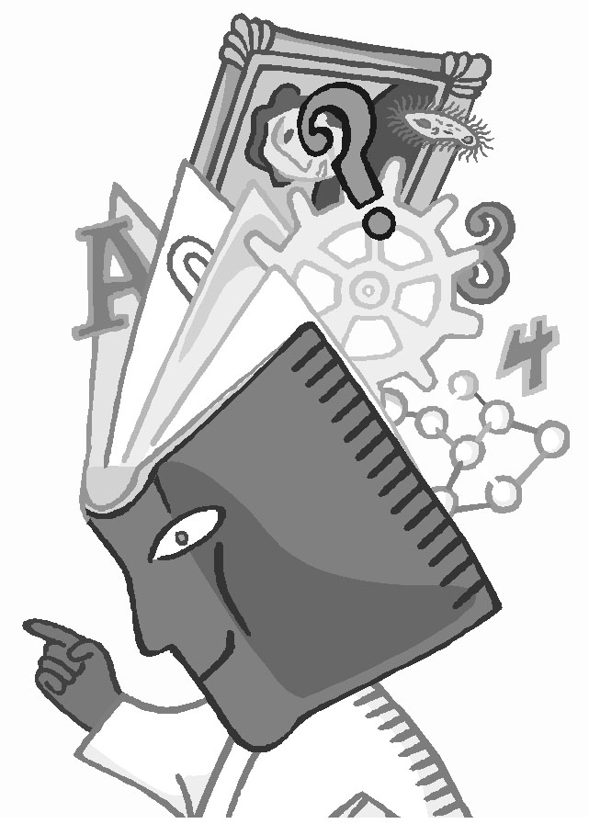
Logical analysis is reinforced because there is no obvious path from the information given to the desired answer. Each student must examine his or her own knowledge to determine that path.
- Using a logical analysis helps to determine which information is relevant and which is not. The extra information is not simply chaff to confuse the student. It is information that they would likely have in that situation, and it might be used if the student has incorrect or fragile physics knowledge.
- After a logical analysis using the most fundamental physics concepts, the answer can be arrived at in a straightforward manner. In this case, the fundamental concepts are (a) the definition of average acceleration (b) the definition of average velocity, (c) the connection between average and instantaneous velocity for constant acceleration; and (d) the independence of horizontal and vertical motion).
- A logical analysis is necessary because this question cannot be answered in one step.

Problems like the Traffic Accident Problem are called context-rich problems Context-rich problems have the following characteristics:
• The problem is a short story in which the major character is the student. That is, each problem statement uses the personal pronoun "you."
• The problem statement includes a plausible motivation or reason for "you" to calculate something.
• The objects in the problems are real (or can be imagined) -- the idealization process occurs explicitly.
• No pictures or diagrams are given with the problems. Students must visualize the situation by using their own experiences.
• The problem requires more than one step of logical and mathematical reasoning. No single equation that solves the problem.

In addition, most context-rich problems have a few characteristics that make them more difficult to solve
- The unknown quantity is not explicitly specified in the problem statement (e.g., Will this design work?).
- More information is given in the problem statement than is required to solve the problems.
- Unusual ignore-or-neglect assumptions are necessary to solve the problem.
- The problem requires more than one fundamental principle for a solution (e.g., kinematics and the conservation of energy).
- The context is very unfamiliar (i.e., nuclear interactions, quarks, galaxies, etc.)

VII. Level of Difficulty of a Good Group Problem

Group problems should have an appropriate level of difficulty for its intended use as either a group practice problem or graded/test problem. All group problems should be more difficult to solve than easy problems typically given on an individual test. But the increased difficulty should be primarily conceptual, not mathematical. Individuals, not groups, best accomplish difficult mathematics. So problems that involve long, tedious mathematics but little physics, or problems that require the use of a shortcut or "trick," which only experts would be likely to know, do not make good group problems. In fact, the best group problems involve the straight-forward application of the fundamental principles (e.g., the definition of velocity and acceleration, the independence of motion in the vertical and horizontal directions) rather than the repeated use of derived formulas (e.g., vf2 - vo2 = 2ad).

There are many characteristics of a problem that can make it more difficult to solve than a standard textbook exercise. Thirteen of these difficulty characteristics are described below.

Analysis of Problem

Problem analysis is the translation of the written problem statement into a complete physics description of the problem. It includes a determination of which physics concepts apply to which objects or time intervals, specification of coordinate axes, physics diagrams (e.g., a vector momentum diagram), specification of variables (including subscripts), and the determination of special conditions, constraints, and boundary conditions (e.g., a₁ = a₂ = constant). The next 8 traits are all examples of how problems that require a careful and complete qualitative analysis are more difficult for students to solve.

1. Choice of useful principles. The problem has more than one possible set of useful concepts that could be applied for a correct solution. For example, consider a problem with a box sliding down a ramp. Typically either Newton's Laws of Motion or the conservation of energy will lead to a solution, but deciding which principles to use can be difficult for students.

2. Two general principles. The correct solution requires students to use two or more major principles. Examples include pairings such as Newton's Laws and kinematics, conservation of energy and momentum, conservation of energy and kinematics, or linear kinematics and torque.

3. Excess numerical data. The problem statement includes more data than is needed to solve the problem. For example, the inclusion of both the static and kinetic coefficients of friction in a problem requires students to decide which frictional force is applicable to the situation

4. Numbers must be supplied. The problem requires students to either remember a common number, such as the boiling temperature of water, or to estimate a number, such as the height of a woman.

5. Uncommon assumptions. The problem requires students to generate an uncommon simplifying assumption to eliminate an unknown variable. All problems require students to use their common sense knowledge of how the world works (e.g., boats move through water and not through the air!). Typically, assumptions, such as frictionless surfaces or massless strings, are explicitly made for the students in class or in textbooks. Therefore, asking students to make their own simplifying assumptions is a new and difficult task. Problems that require students to make their own simplifying assumptions are more difficult to solve. To be included as a difficulty trait, the simplifying assumption must be uncommon, such as ignoring a small frictional effect when it is not obvious to do so. The two categories of uncommon simplifying are neglect and ignore. The first category includes situations where the students must neglect a quantity, such as neglecting the mass of a flea when compared to the mass of a dog. The next category of assumptions involves ignoring effects that cannot be easily expressed mathematically, such as how a yo-yo’s string changes its moment of inertia.

6. Special conditions or constraints. The problem requires students to generate information from their analysis of the conditions or constraints. An example is the generation of the relationship a₁ = a₂ for the two masses in an ideal Atwood machine.

7. Diagrams. The problem requires students to extract information from a spatial diagram. A simple example is when students must express the cosine of an angle between forces in terms of known and unknown distances, as in the Safe Ride problem you solved (Homework #3)

8. Two directions (vector components). The problem requires students to treat principles (e.g., forces, momentum) as vectors. This requires both the decomposition of the physics principle and the careful subscripting of variables. Some students are still tripped up taking vector components even after weeks of using vectors.

Mathematical Solution

Mathematical difficulty is last category of traits. A teacher can put into a problem some simple mathematical hurdles that prevent some students from reaching a final answer. Some of these are included in the last five traits.

9. No numbers. The problem statement does not use any numbers. Many students use numbers as placeholders to help them remember which variables are known and which are unknown. Therefore, if a problem is written without numbers, it is more difficult for the students.

10. Unknown(s) cancel. Problems are more difficult to solve when an unknown variable, such as a mass, ultimately factors out of the final solution. The students must not only decide how to solve the problem without all the cues they expect, but keep symbolic track of all the variables.

Decision Table

Type of Problem | Timing | Diff. Ch.
Group Practice Problems should be shorter and mathematically easier than graded/test group problems. | • just introduced to concept(s)  • just finished study of concept(s) | 2 - 3  3 - 4
Graded/Test Group Problems can be more complex mathematically. | • just introduced to concept(s)  • just finished study of concept(s) | 3 - 4  4 - 5

11. Simultaneous equations. The solution requires solving simultaneous equations. Simultaneous equations are difficult for the students not only because of the algebra involved, but because there are at least two unknowns in each equation and they need to keep track of these variables. A typical circuit-analysis problem best illustrates this trait.

12 Calculus or vector algebra. The solution requires the students to use sophisticated vector algebra, such as cross products, or calculus. Most students are still learning these skills in their math courses and have not learned how to transfer these skills from their math class to their physics class.

13. Lengthy or Detailed Algebra. A successful solution to the problem is not possible without working through lengthy or detailed algebra. While these calculations are typically not difficult, they require careful execution. A typical example is a problem that requires students to solve a quadratic equation.

Of course, other factors contribute to whether a problem is a good group problem. One factor is whether the problem is intended for a group practice problem or a graded/test problem. Students have only about 25 - 30 minutes to solve a group practice problem, but they have 45 - 50 minutes to solve a graded/test problem. So practice problems should be shorter and the mathematics should be easier. Graded/test problems can be more difficult (have more difficulty characteristics), and involve more detailed or complex mathematics. Another factor is the timing of the problem – whether the problem is given just after students learn the physics concepts, or just as they are finishing a topic. A problem given at the end of a topic should be more difficult than a problem given just after students have been introduced to the concepts.

The table above shows how these factors influence a judgment about whether a problem is a good choice for a group problem.

NOTES:

VIII. How to Change an Unsuitable Textbook

Exercise into a Good Group Problem

Occasionally, you may be given a problem for your discussion session that is not a suitable group problem. For example, consider the three problems below.

1. A ball starts from rest and accelerates at 0.500 m/s2 while moving down an inclined plane 9.00 m long. When it reaches the bottom, the ball rolls up another plane, where, after moving 15.0 m, it comes to rest.
(a) What is the speed of the ball at the bottom of the first plane?
(b) How long does it take to roll down the first plane?
(c) What is the acceleration along the second plane?
(d) What is the ball's speed 8.00 m along the second plane?

2. A merry-go-round has a circular platform which turns at a rate of one full rotation every 10 seconds. A passenger holds himself to the surface with a pair of very sticky shoes with a coefficient of static friction of 0.4. Determine how far away from the center he can go before falling down to the platform?

3. As shown in the diagram, mass M1 rests on an inclined plane with a rope tied to it. The rope goes through a frictionless, massless pulley, and is connected to another mass, M2, which hangs off the edge of the table. There is a coefficient of friction, µk, between mass M1 and the inclined plane. The angle of the inclined plane is θ. | 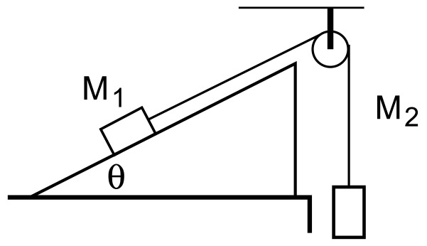
(a) Draw a free body diagram showing all forces (solid lines) and the acceleration (dotted line).
(b) Write a general solution for the acceleration of the masses in terms of the variables given plus any other you need to define.
(c) What is the expression for the acceleration if µk goes to zero?
(d) What is the expression for the acceleration if θ = 0?
(e) What is the acceleration if M1 = 10 kg, M2 = 4 kg, µk = 0.2, and θ = 30 degrees?

None of these problems have the features of a good group problem (see page 115). They can all be solved with one equation (or one equation at a time) using novice plug-and-chug or pattern-matching strategies. There are no decisions to make, so there is no physics to discuss. There is no advantage to working in a group to solve these problems. The best student in the group would solve any of these problem in a few minutes.

How could you change an unsuitable problem to make it an appropriate group problem? It is difficult and time-consuming to change a textbook problem into a context-rich problem. But you can make several other changes that would make the problem suitable for a practice or graded/test group problem. The guidelines for doing this are given below.

Step 1. Take out any diagram in the original problem. If necessary, reword the problem so students can draw a picture of the situation from the description.

Step 2. As far as possible, make idealized objects real objects. Take out as many physics cues as possible. For example, “an inclined plane” can be a ramp, and a “block” could be a package or a car with its brakes on. “At rest” can be stopped, parked, not moving, and so on. “Free fall” can be simply falling.

Step 3. Change the problem so it requires at least two equations to solve. Some ways to accomplish this are:
A. For problems with a series of questions, select one target variable. This is often, but not always, the target variable in the last question in the series.
B. Change the given quantities in the problem.
C. Change the target variable for the problem (e.g., change the target variable from velocity to a time, or from an acceleration to a force).

Step 4. Make sure the problem can be solved with the information given in the problem. At the same time, determine if the changes from Step 3 added any difficulty characteristics to the problem.  Step 5. Change some other features of the problem to make it more difficult to solve. The easiest difficulty traits to add are:  A. Uncommon assumption. Take out or change a statement of an assumption or idealization. For example, replace “frictionless” with “low friction surface” or “massless” with “very light.”  B. Excess data. Add information to the problem statement that is not needed to solve the problem. But be careful. This information must be the type of information that would be natural to have in the given situation. | Analysis  ___ 1. Choice of principle  ___ 2. Two principles  ___ 3. Excess data  ___ 4. Numbers required  ___ 5. Assumptions  ___ 6. Special constraints  ___ 7. Diagrams  ___ 8. Vectors  Mathematical Solution  ___ 9. No numbers  ___ 10. Unknown(s) cancel  ___ 11. Simultaneous eqns.  ___ 12. Calc/vector algebra  ___ 13. Lengthy algebra
C. Numbers must be supplied. Take out some relevant information. But be careful. Groups must be able to estimate this information from their collective general knowledge (e.g., the height of a baseball bat above the ground when a batter swings and hits the ball; the boiling temperature of water).
Decision Table

Type of Problem | Timing | Diff. Ch.
Group Practice Problems should be shorter and mathematically easier than graded/test group problems. | • just introduced to concept(s)  • just finished study of concept(s) | 2 - 3  3 - 4
Graded/Test Group Problems can be more complex mathematically. | • just introduced to concept(s)  • just finished study of concept(s) | 3 - 4  4 - 5

D. Diagrams. Change the information given in the problem so students must extract information from a spatial diagram. A simple example is when students must express the cosine of an angle between forces in terms of known and unknown distances.

Step 6. Use the Decision Table (above) to decide if the problem now makes a good group practice problem. If so, solve the problem again (to check that you haven’t added or taken out too many things, so the problem can’t be solved). Make a final edit of the problem. You may need to write a new example solution.

Note: You should not change a graded/test problem unless you receive it early enough to discuss with your professor or in a team meeting.

You may be asked (once a semester) to write a group practice problem. Don’t start from scratch! Several faculty members at different colleges and universities have written context-rich problems for individual and cooperative groups. These problems are available at our web site:
http://groups.physics.umn.edu/physed/Research/CRP/on-lineArchive/ola.html

But be sure to check the difficulty of the problem. The collection includes easy, medium, and difficult problems for use both on individual tests and for group practice and graded/test problems.

NOTES:

