Introduction

There is usually more than one effective method to teach a class; in other words, there is no known “best” way to teach. The methods to use will depend on the goals of the course, the strengths of the instructor(s), the needs of the students, and the constraints imposed by the situation (for example, the number of students in the introductory courses, the size of the laboratory rooms.) Among the various teaching methods which have been established, it is often nearly impossible to decide which ones are most suited for your situation. Cooperative Problem Solving (CPS) is one technique we have found that fits our goal (for students to learn physics through problem solving) and constraints for the introductory physics courses at the University of Minnesota (UMn). For this teaching method to be effective, however, it needs to be executed well. As a TA, you have important roles to play in our teaching of undergraduate students. If you do your job well, everyone around you – your students, your professor as well as the Chair of the department – will appreciate your contribution to our educational mission.

With this handbook, we hope to help you become a good teacher by providing you with (1) a background about why we organize our Freshman Physics teaching in the way we do, (2) an overview of how the lab and discussion sessions are taught, (3) a description of your main task: coaching of students on how to solve problems, (4) tips about teaching, (5) logistics such as how lab computers and their programs work and how you need to enter grades, etc.

Brief Background

As we said moments ago, the major goal of our Freshman classes is to help students learn physics through problem solving. But what does it mean to “learn physics” and what do we mean by “problem solving”? You should take some time to think about what these two concepts mean to you, because you will encounter this question again throughout the TA orientation and weekly TA seminar sessions. Given your understanding of these terms, does this goal make sense to you?

We (those who are involved in TA orientation) wish to make a few remarks at this point, which may help you focus your thinking:
- Most physics classes assess students’ “understanding of physics” at least partially by measuring how well they can solve problems.
- We believe that most students we teach in our classes don’t know how to solve problems and need to be taught this skill explicitly.
- We distinguish problems and exercises. If you know the outline of your solution soon after you read the “problem”, then it is an exercise. If applying the single right formula is sufficient to solve the “problem” it is an exercise. Problems force you to try to reach the goal step by step, not in one step, and to make subjective decisions about the appropriateness of your approach along the way. Long division is an exercise once one is taught how to do it. When we ask students to derive F, m or a given that the other two variables are known after they are taught F = ma, we are giving them an exercise.
- When students tell you they don’t know how to get started, it is a problem for them.
- Many of perfectly good problems for our undergraduate students are actually exercises for you. Similarly, many of the problems you face in written and oral examinations or graduate classes are exercises for (some) professors. Unfortunately, some professors who teach Introductory Physics classes are oblivious to, indifferent to, or disagreeable to some of the above statements. In such a case, you may have to discuss possible compromise between his or her teaching ideas and what we ask you to do, mixing in what you personally like to do to teach well.

Even if we all accept that teaching problem solving should be a major part of our classes, we have more questions to answer. For example, how can we teach these classes as effectively as possible? Most of you are pretty good at solving problems, but that does not necessarily mean that you can teach it well. Not all good piano players can teach piano well, and not all good baseball players can teach lower-level baseball. How can we teach those who are not naturally good at solving physics-type problems so that they will be good solvers?

Should we show them examples, and explain logically how our solutions work? When you learn how to play the piano or soccer, it is certainly helpful to see (and hear) how experts play them. Then, perhaps you can emulate what you have seen. It would also be helpful to many of us if some of the experts or coaches could articulate some of the tricky points that casual observation would miss. After that, we could execute our play even better. But usually, these activities are not all learners need to do to become good players. What else should coaches and teachers do to train new players, either in piano or soccer?

Then you may ask how far this analogy between learning physics and learning music and sports can hold. It may be beneficial to have a discussion about this with your peers and the TA orientation leaders if a significant number of you are skeptical about the analogy.

We believe that CPS is a powerful tool for us to help students learn how to solve problems effectively in the lab and discussion sessions because:

- Students can learn to play various roles within a group, which are needed to be good problem solvers; they can focus on practicing one (or a few) things at a time instead of trying to do it all. This is, again, analogous to learning different aspects of piano playing, or soccer playing during a practice session, even though at a game or concert, you would need to execute it all. You may practice your left hand and right hand separately for piano. You may learn notes first and musical expression next. You may practice individual skills and team play strategies separately in soccer. What different skills, then, do students need to learn to become effective problem solvers?

- Students can get individualized feedback from the group partners about what they do to solve problems. Given that there is only one teacher to so many students, the teacher will not have many opportunities to give feedback to each student. If feedback is an important component of learning problem solving, this needs to be addressed.

At times it may seem that students are actually more effective than an instructor at explaining concepts to one another (refer to Eric Mazur’s book on Peer Instruction.) A plausible reason is that the students who have only recently begun to understand a concept know the difficulties involved (they can relate to their peers’ confusion), and can precisely explain it in a way that other students will grasp.

- Although the feedback from other students may not be always correct or appropriate, this is not a serious hindrance since the process raises issues that the students encounter when they solve problems alone. For example, an essential component of being a good problem solver is to critically receive ideas and question the reasoning behind the ideas when working through each step of a problem. In groups students practice this Skeptic role explicitly, so they are better prepared to assess their own ideas when solving problems individually.

What would be potential negative effects of working in groups? How can we minimize these negative effects while enhancing possible positive outcomes?

With these ideas in mind, our Freshman Physics classes are organized in the following way and your major roles as a TA are also given below:

- In lectures, the professor shows examples of good problem solving techniques. He or she will explain physics concepts and apply them to simple situations to help students develop physics intuition, etc. The latter is not directly related to problem solving, but probably helpful indirectly.
- In discussion sessions, students work in groups of 3-4 students to solve a problem (or at most two) while the TA coaches them. By coaching, we mean giving feedback to students, giving a little push or some hints, if needed, to get students moving again when they are stuck. You also need to manage less-than-optimally operating groups: a group member not participating much, or a member too dominating and not utilizing the intellectual resources within the group.
- The lab sessions in our classes are very similar to the discussion sessions. They are NOT meant to have students confirm fundamental physics laws. Neither are they meant to teach students experimental techniques or details of errors analysis (though some sense of how errors propagate needs to be understood by the students). The labs provide another occasion for students to solve problems. Some problem solving happens before the lab as part of their preparation, and some is done during the class with their groups. Instead of the TA summarizing which groups’ solutions are right and which are wrong, they do experiments to see themselves if their predicted solutions make sense against the results of the experiments. Your role in the lab is therefore very similar to that in the discussion session. Additionally, you need to be cognizant to where the experiments tend to go wrong, how computers tend to misbehave, when and how you need to get help on malfunctioning equipment, etc. so that students won’t justify wrong problem solutions with wrong experimental results and avoid delay in their experiments due to equipment problems.

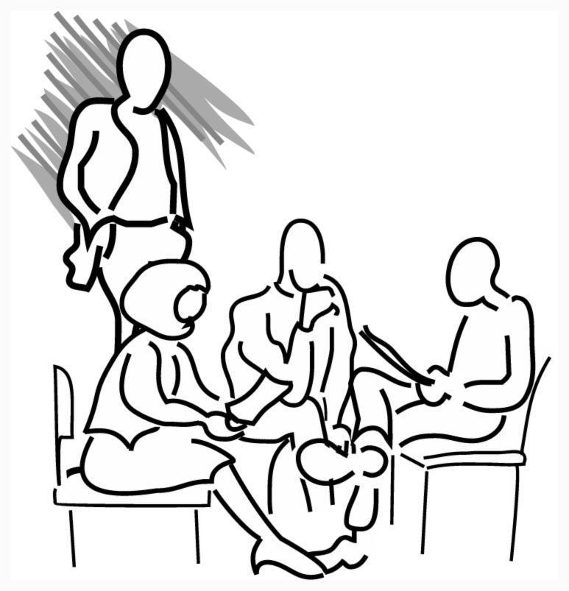
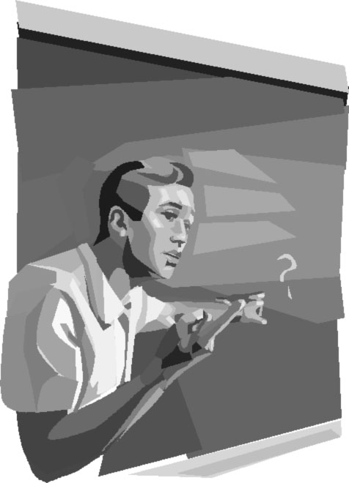
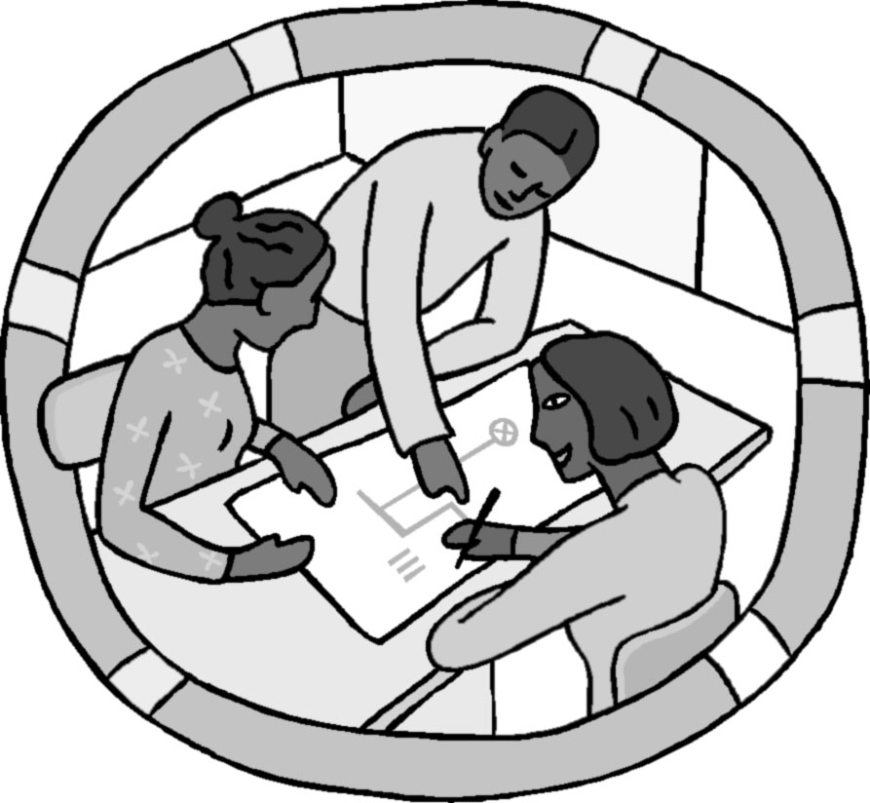

Chapter 1

Your Teaching
Responsibilities

Page
I. A Description of Specific Duties 5
II. Using Your Mentor TAs 11

I. Description of Specific Duties

Most teaching assistants (TAs) will be assigned to a teaching team responsible for one of the introductory physics courses. Your most likely assignment is the first term of the calculus-based course for scientists and engineers (Physics 1301) since this course serves the most undergraduates. A teaching team typically consists of one faculty member and 8 - 9 TAs. This team is responsible for all aspects of the course for about 200 undergraduates.

If you are not assigned to 1301 or 1302 (E&M part of the same sequence), you may be teaching a similar class for biology and premedicine students (1201/02), or an algebra-based course (1101/02). Many of the contents in this handbook apply to any of these classes. For the few of you who will teach upper-level courses, fewer parts of this handbook are relevant. Since you are likely to teach one of the Introductory classes at some point in your career, it is important that you learn most of the things in this handbook.

If you have a 25% appointment, you will be teaching one discussion session and one lab, with the same set of students (less than 20). If you have a 50% appointment, you will be teaching two discussion sessions and two labs, with two sets of students. Discussion sessions meet for 50 minutes once a week, and labs meet throughout the week for 2 hours at a time.

Failure to fulfill your TA duties in a serious way could result in a loss of teaching assistantship. Many things the mentor TA’s do is to prevent this from happening by providing useful feedback to you as you accumulate teaching experiences.

Preparation for Laboratory
You will have new lab problems to teach every week. You should become very familiar with the equipment, and consult the Instructor's Guide for the Lab Manual and experienced TAs to find what might go wrong with it or what kinds of mistakes students might make. If you can, it is a good idea to observe someone else's lab session before you teach yours. With your team, select which Lab problems have priority.
• Your team should decide during each weekly team meeting (see below) which lab problems your students will solve the following weeks. If this topic is not discussed in a timely manner (~2 weeks in advance) within the team, please don’t hesitate to bring it up during the meeting. Otherwise, it will interfere with your ability to adequately prepare for the lab.
• You need to solve the assigned lab problems by answering the Prediction and Warm-up Questions. In the team meetings (and some seminars), you will discuss difficulties that students have had with the physics principles they need to solve the lab problem.
• Most students will be required to solve computer laboratory preparation quizzes before each lab session (the professor will determine the specifics of this requirement.) You will be shown how to use a program to check whether your students have successfully passed the quiz before they get to lab. This will help you formulate how you will start your next lab session. You should go through these questions before your students do, because some of your students might ask questions about them.
- Have a goal (learning focus) for each Lab session, something you want your students to learn. This should be decided in your team meetings after discussion with the professor and other TA’s. See page 89 for more about how to prepare for a lab session.

Teaching Laboratory Sections
Make sure you get to your laboratory room at least 5 – 10 minutes before class starts, and do not let the students enter until you are ready. Use this time alone to check the lab equipment to make sure it is all there, neatly arranged, and in working order. If you are teaching a computer lab, you should check to make sure the computers are working properly. Any other quiet time can be used to make final preparations. Make sure the door is locked and the lab is in order before you leave.

If you are late for your lab, be sure to call Mette Marie Stewart, 624-7375.

Preparation for Discussion Sections
• Solve the group problem students will solve in discussion section. Discuss with your team the parts of the qualitative analysis of the problem that you expect will be difficult for the students. Some professors are not attentive to the need of their TA’s to have the discussion problem well in advance of the class. If this happens to you, politely remind your professor of your need to have the problem early.
• Look at the syllabus and homework problems assigned for the week. Be prepared to tell your students which homework problems are similar to the group problem.
• In some sections, you may be asked to work with other TAs to design or write a group problem. As a first-year TA, if you don’t feel comfortable about writing a problem, you may negotiate to swap this duty with another. If you accept this role, you will present the first draft of your problem to your team for critique, and may be asked to write a second draft. This will occur once or twice a semester.
• In some sections, you may be asked to choose the material for the discussion sections for some of the weeks. You may want to pool your skills and ideas with other members of your team, either during your team meeting or outside of it.
• Occasionally, a problem that is inappropriate for a group problem is selected (e.g., one- step problems). Consult with a lead TA (usually there is one TA who is more experienced than you in your team) and discuss how to deal with it. You may need to modify the problem slightly so it will work productively in a discussion session. If this happens repeatedly (because your professor’s teaching philosophy is different from what we are assuming in the TA orientation) you may work with other TA’s to come up with strategies to deal with it so that your discussion sessions will be productive learning experiences.

Refer to additional information about planning a discussion session on page 105.

Teaching Discussion Sections
Try to get to your assigned classroom several minutes early (before your students. You may need to tidy the classroom, clean the blackboard, rearrange the chairs (see Fig.1 and 2 on Page 38), and/or write on the blackboard (see page 101).
Well before the first class, check out the room to see if it is appropriate for a discussion section. If it is not appropriate, tell the undergrad office and they will try to get it changed.

If you are late for your discussion section, be sure to call Mette Marie Stewart, 624-7375.

Office Hours/Tutoring
Office hours are held in the tutor room, Physics 230. This is your chance to interact one-on-one with students, and it is your students' chance to get some personal tutoring. You will have one office hour a week for each of your sections (i.e., one office hour/week for 25% appointment and two office hours/week for a 50% appointment). During office hours, you must wear a name tag. Refer to page 135 for more information about office hours.

Meeting with Your Mentor TA
You will each have a half hour appointment with one of your mentor TAs twice in the semester. These meetings generally occur after a mentor TA has observed your class, and the purpose is to provide you with coaching to become better teachers. You might ask about problems with your students, difficulties in grading, classroom management, course organization, or other questions or problems you may have. You will also discuss other things that your mentor may have noticed in your section. Feel free to bring up anything else that relates to being a TA.

Grading Labs
You will grade written lab reports at least four times during the semester. As with all grading, prompt feedback to the students is essential. Discuss the grading policy (e.g. how many points each lab report has, the criteria to decide points) in the first team meeting because every TA in your team must have the same policy. Be sure to return graded lab reports within a week, unless otherwise specified by the professor, so that students can use the feedback to get help.

You will also collect and grade your students’ answers to the Prediction and Warm-up Questions for the next lab session you will teach (see page 75). These are useful to gauge your students’ understanding of the material of the lab.

Grading Homework
Different teams will make different decisions about how homework will be collected and graded. Whatever scheme you decide to use cannot take much of your time. Be sure to grade and return homework as soon as possible, so that students can use the feedback to get help. Be sure to return graded homework within a week, unless otherwise specified by the professor, so that students can use the feedback to get help.

Grading Tests
• At this time, the estimate for how much time it takes to grade a difficult problem is as follows:
$$\left(0\text{.}5 \text{hr} \text{classifying}\right)+ \left(\frac{\text{200} \text{probs}}{\text{quiz}}×\frac{3 \text{min}}{\text{prob}}×\frac{1 \text{hr}}{\text{60} \text{min}}\right)+\left(0\text{.}5 \text{hr} \text{recording}\right)=\text{11} \text{hr}$$
On average, each TA will grade 3 such questions each semester, plus one group problem (about 70 problems). This should average to less than 3 hours/week. In your team meetings you will arrange which TAs will grade which problems.
• After you spend the time classifying a subset of tests, it is estimated that a quiz problem will take, on the average, 3 minutes to grade. Obviously some student solutions will be extremely convoluted and some will be blank (see the details of grading on page 138).
• After you have completed the grading, you will enter the grades into the computer (see Electronic Submission of Grades on page 141).
• Grading should be completed and scores should be entered into the computer as soon as possible. It is important the students receive prompt feedback on all graded assignments.

Proctoring
You will all be asked to proctor the tests for your course. While proctoring, you are responsible for answering student questions and deterring cheating. The schedule for proctoring will be discussed in one of the first team meetings. Make sure to get spare pencils and calculators from room 148 when you pick up a test. Refer to page 136 for more information.

Final Exams and Lab Grades
Each TA will probably grade one or two final exam problems that will take about 11 hours each. This grading will occur, in most cases, after your last final exam so make sure that you plan enough time at the end of the semester. Keep the record of your students’ lab grades throughout the semester and make a backup of the grade periodically.

Team Organization Meetings
Each week, the TAs and professor will meet as a team to discuss their course. The most important reason for the meetings is the communication between the different members of the teaching team. Important issues are:
• The professor describing what is going on in lecture and why.
• Discussion about what to emphasize in the next discussion and lab sessions.
• Trading information and analyzing what students understand and do not understand. Since there can be a large diversity between the different discussion and lab sections, each TA should discuss and compare their section(s) with other sections. This information is an invaluable input for the professor(s), who do not have the close contact with students that you do.

The meetings also provide opportunity to discuss the mechanics of the course (e.g., who will grade what, who will proctor, etc.). It is very important that the schedule of these duties be discussed and decided in the beginning of each semester. As a student, you need to gather information about which of your classes have tests and other major assignments due when, so that you won’t have to deal with preparing for a test as a student while doing a significant grading as a TA. If needed information is not provided by your professor(s), please remind them since it is crucial to your well being later in the semester.

Attendance at these meetings is mandatory. If you inadvertently miss a meeting, be sure to call or e-mail your professor right away and find out what happened in the meeting from the professor or one of the other TA’s.

TA Seminar
All new TAs are required to take the course "Teaching Introductory College Physics (Phys 5072)" in both Fall and Spring semesters. In the seminar, you will prepare for the next labs by becoming familiar with the equipment and procedures for them you will teach (part of your lab preparation time). Instructors will also help you deal with various issues which arise in your classes. The fall semester seminar has one credit; the spring semester seminar has two credits to include the work from TA orientation.

Average Time/Week During the Semester

Your average weekly work load during the entire semester (for a 50% appointment) should be approximately that listed below. It includes a week leading to the start of the actual teaching and completion of the final exam grading and entering of the results

Contact with Students:
2 Discussion Sections 2.0 hrs
2 Laboratory Sections 4.0 hrs
Office Hours 2.0 hrs
8.0 hrs

Preparation:
Laboratory 1.0 hrs
Discussion 1.0 hrs Teams will decide how to
Team Meeting 1.0 hrs structure this between team
TA Seminar 1.0 hrs meetings and individual prep.
4.0 hrs

Proctoring, Grading and Entering Grades:
Labs 2.5 hrs (average)
Tests and Homework 4.0 hrs (average)
6.5 hrs

Feedback and Support:
Meet with Mentor TA 0.5 hrs
0.5 hrs

Miscellaneous: 1.0 hrs
(dealing with the front office, helping
students outside of office hours, etc.)

TOTAL 20.0 hrs/week

If you are spending more time than the above estimate, you need to do something since it will affect your performance as a student. For example, if the grading is taking more time than the estimate, please consult with the mentor TA to see how you can do this more efficiently. Perhaps, the first time will take more time, but by the 2nd grading you should be able to grade within the allotted time.

On the other hand, if your professor is asking you to do more things beyond those included in the above table without compensating it by reducing the standard duties, you should gently remind him that you don’t have infinite amount of time, and need to be relieved of some of the duties. If this gentle reminder does not solve the problem, you should talk to the other TAs in the same team to increase the pressure on the professor or talk to mentor TA, DGS, Department Chair, or grievance committee members as you see appropriate. Do not do simply disregard the issue if you suffer from overworking as a TA.

The University does not recognize the time between terms as holidays. i.e. you are paid to work as a TA during the holidays. Although the Physics Department typically does not assign TA duties after final exam grades are recorded, you are obliged to carry out any duties associated with teaching assistantship even if they fall during the break time. Check with your professor before you make a holiday plan which involves leaving town that you are not expected to do something which requires you to be in town during that time. In particular, do not plan to be away right up until the day before the new semester starts as some of the planning meeting for the new class may take place up to a week before the actual start of the new semester. If you want to leave before the grading of the final examination is complete, you should plan to do a larger share of grading during the semester so that you are not obliged to grade the final exam.

II. Using Your Mentor TAs

Your mentor TAs are there to help you grow as a TA. They will help you cope with problems you may encounter in your teaching and in graduate school. They will also help you improve the skills you need to become a better TA. If you ever need help, talk to them.

Specifically, the duties of the mentor TAs include:
- Be active instructors in the TA orientation in August.
- Co-teach the TA Seminar in the Fall and Spring, to discuss topics such as:
  - lab preparation;
  - grading exams and homework;
  - alternative conceptions your students may have;
  - effective coaching of problem solving;
  - difficult students; and
  - issues you have encountered and your ideas about teaching.
- Visit several of your labs and discussion sessions to:
  - observe your teaching techniques;
  - give you feedback and answer questions about your teaching.
- Make recommendations for the TA award given at the end of the year.

If you ask them to, the mentor TAs will also:
- be resources for you in the physics department.
- serve as an anonymous conduit of your concerns to an individual professor or the department.
- help you find information in the education literature.
- help you write your lesson plans.
- help you find and practice with the laboratory equipment.
- advise you on grading, writing cooperative group problems, interacting with professors, and forming new groups.
- write letters of recommendation about your teaching.
- be willing to discuss the graduate school experience (both good and bad.)
- respond to any reasonable questions, requests, … The only limit is your imagination☺

