

Chapter 2

Cooperative
Problem Solving


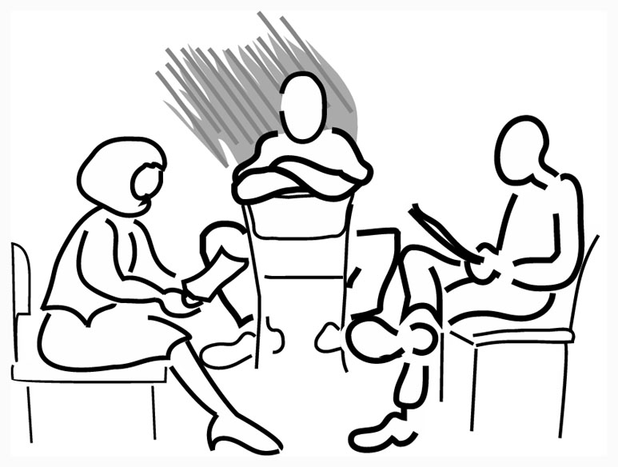


Page
I. How do I coach students in problem solving? 13
II. How do I form cooperative groups? 27
III. What criteria do I use to assign students to groups? 31
IV. How can I structure CPS to maintain well-functioning 37
groups?

I. How Do I Coach Students in Problem Solving?

Your role during discussion and lab sessions is to coach students in physics problem solving, particularly the qualitative analysis of the problem. That is, you want to coach students so they will slowly abandon their novice problem-solving strategies (e.g., plug-and-chug or pattern matching) and adopt a more expert-like problem solving procedure that includes the qualitative analysis of the problem. “In order for most students to learn how to learn and think about physics, they have to be provided with explicit instruction that allows them to explore and develop more sophisticated schemas for learning.” (Recall Redish’s second teaching Commandment)

Learning physics through problem solving is a difficult, time consuming, and frustrating process -- like climbing a steep mountain. Many students try to run around this mountain by using their novice problem-solving strategies. Some of them give up (drop the course). A course structure must include scaffolding (ladders) that help students learn how to solve problem solving and barriers (fences) to keep students from succeeding using their novice strategies

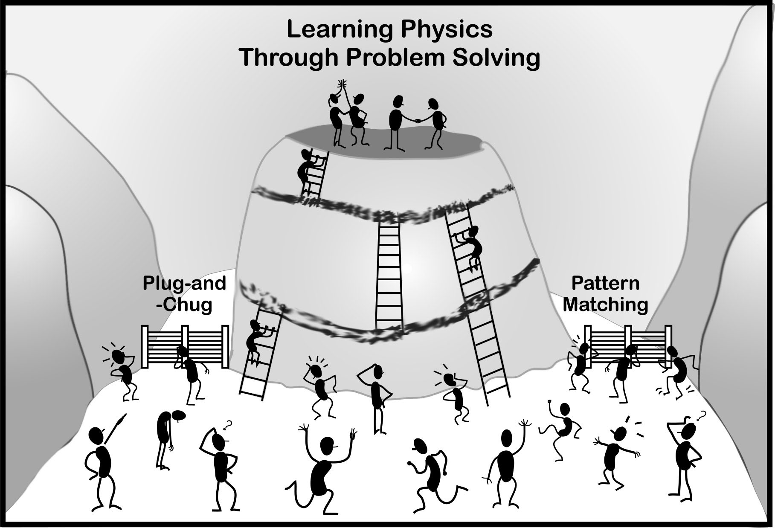

For efficient coaching in problem solving, you will use several instructional “tools.” One tool is a problem solving framework and answer sheet you design during TA Orientation. The second tool is the Warm-Up Questions in the labs (see Chapter 3). A third tool is the assignment and rotation of group roles.

Group Roles

Many different roles can be assigned for different types of tasks. For physics problem solving, you will assign planning and monitoring roles that each student will have to assume when they solve challenging physics problems individually -- Manager, Summarizer, Recorder, and Skeptic. When a student solves a homework or test problem, she has to be an executive manager, organizing a plan of action to solve the problem, and making sure that she doesn’t lose track of where she is relative to the final goal of solving the problem and decide what may be the best thing to do next. This requires that she continually summarizes what decisions she has made. At the same time, she is also a recorder of the solution. During this process, she must check her solution and make sure it explains what she did (to a knowledgeable reader) in a logical and organized fashion. Finally, she has to continually be skeptical, asking herself questions about each step -- "Am I sure that I am going in the right direction and getting closer to the final solution?" "This doesn't seem right. What have I forgotten to take into account?"

One reason for assigning roles (and rotating the roles among group members) is that it allows students to practice the different metacognitive actions individually. Students also have an opportunity to observe other people executing metacognitive actions as the group co-constructs a problem solution.

The second reason for assigning the roles is that they provide you with a useful tool for coaching students in the metacognitive skills that they need to learn in order to become better problem solvers.

If you read Redish, 2003, pages 62 – 65, you will recognize the roles of Manager, Summarizer, Recorder, and Skeptic as “metacognitive” roles. A copy of the group roles you will give your students is shown on the next page (copies of the group role sheets are available on the bookshelf in room 146, or you can make copies of the following handbook pages.) The metacognitive actions are in ALL CAPS. The remaining actions (Small Caps) are group functioning actions. These are discussed in the next section.

Group Roles for Discussion Sessions
In your discussion sessions for this course, you will be working in cooperative groups to solve written problems. To help you learn the material and work together effectively, each group member will be assigned a specific role. Your responsibilities for each role are defined on the chart below.

ACTIONS | WHAT IT SOUNDS LIKE
MANAGER  Direct the sequence of problem-solving steps.  Keep your group "on-track."  Watch the time spent on each step.  Make sure everyone in your group participates. | "First, we need to draw a picture of the situation."  “Now we need to draw a motion diagram and define our symbols.  "Let's come back to this later if we have time."  "We only have 5 minutes left. Let's finish the algebra solution.”  "Chris, what do you think about this idea?"
RECORDER/CHECKER  Record your group’s problem solution.  Check for understanding of all members.  Make sure all members of your group agree with each thing you write.  Make sure names are on the group solution. | "Is this where you wanted the acceleration on the motion diagram?"  “Does everyone agree this algebra is correct?”  "Explain why you think that …?"  "Do we in agree that this term is zero?"
SKEPTIC/SUMMARIZER  Help your group avoid coming to agreement too quickly by  • making sure all possibilities are explored.  • suggesting alternative ideas.  Keep track of different positions of group members and summarize before deciding.  Summarize (restate) your group's discussion and conclusions. | "Why do you think this moves with a constant acceleration?"  "I'm not sure we're on the right track here. Let's try to look at this another way. . ."  "Why?"  "What about using conservation of energy ... instead of forces?  "Chris thinks we should …, while Pat thinks we should …." Are these really different?  "So here's what we've decided so far..."

Group Roles for Laboratory Sessions
In your laboratory for this course, you will be working in cooperative groups to solve laboratory problems. To help you learn the material and work together effectively, each group member will be assigned a specific role. Your responsibilities for each role are defined on the chart below.

ACTIONS | WHAT IT SOUNDS LIKE
MANAGER  Make sure the group follows the instructions for each lab Problem.  Make Sure Group members rotate entering predictions and analyzing data on the computer.  Keep your group "on-track."  Make sure everyone participates in decisions and measurements.  Watch the time! | I think we forgot to try enough different masses for the object (Exploration).  Last time Pat was at the keyboard, so this time Chris should do it.  I think we forgot to measure the length of the string.  "Pat, what do you think about doing it this way?"  "We only have 10 minutes left. Let's finish the analysis.”
RECORDER/CHECKER  Make sure all members of your group are writing in their lab journals.  Make sure all members of your group agree with each prediction typed in the computer.  Check for understanding of all group members.  Make sure all of the computer data is saved or printed correctly. | "Hey Pat! You forgot to write our measurement plan in your journal.”  "Do we all agree on this prediction before we accept it on the computer?"  Can everyone explain the shape of this graph?”  Before we go on to the next problem, can everyone explain the solution of this problem?
SKEPTIC/SUMMARIZER  Help your group avoid coming to agreement too quickly by:  • making sure all possibilities are explored;  • suggesting alternative ideas.  Summarize (restate) your group's discussion and decisions.  Keep track of different positions of group members and summarize before deciding. | "How do you know this is the right function for the prediction?"  "I'm not sure we're on the right track here. Another way to do this is …"  "Why?"  "Isn’t it more accurate to measure from the top instead of from the bottom?  "So here's what we've decided is our measurement plan. ..."  "Pat thinks we should …, while Chris thinks we should …." Which should we do, or can we do both?

Coaching Groups

You can use the following two actions to coach your students efficiently and in a timely manner while they are working to solve a problem:
- monitoring all groups and diagnosing their difficulties; and
- intervening and coaching the groups that need the most help.

Monitor and Diagnose

Coaching groups that are solving problems is similar to triage in a medical emergency room. When there are more patients than available doctors, doctors first diagnose what is wrong with each patient to decide which patients need immediate care and which can wait a short time. The doctors then treat the patient with the most need first, then the second patient, and so on. Similarly, with CPS the instructor needs to first diagnose the “state of health” of each group by observing and listening to each group (without interacting with the groups). As with medical triage, your next step is to intervene with the group that is in the worst state of health -- the group that is having the most difficulty solving the problem or with group functioning.

With CPS, you diagnose:
- what physics concepts and problem-solving procedures each group does and does not understand; and
- what difficulties group members are having working together cooperatively (see Section IV).

The following steps are helpful to monitor and diagnose the progress of all groups:
Step 1. Establish a circulation pattern around the room. Stop and observe each group to see how they are solving the problem and how well they are working together. Don't spend a long time observing any one group. Keep well back from students' line of sight so they don't focus on you.

Step 2. Make mental notes about each group’s difficulty, if any, with group functioning or with recognizing and applying appropriate physics principles to the solution, so you know which group to return to first.
If you begin intervening immediately (without first diagnosing all groups), it is not fair to the last groups. By the time you recognize that all groups have the same difficulty, the last groups will have wasted considerable time while you went from one group to the next. The monitor and diagnose actions will help you maintain efficient and timely coaching of all groups.

Step 3. If several groups are having the same difficulty, you probably want to stop the whole class and clarify the task or make additional comments that will help the students get back on track. For example, there is a tendency for students to immediately try to plug numbers into equations each time new physics concepts and principles are introduced. If about half of your groups are doing this, stop the whole class. Remind your students that the first steps in problem solving are to understand and analyze the problem qualitatively before the generation of mathematical equations.

Intervene and Coach

From your observations (circulation pattern), decide which group is obviously struggling and needs attention most urgently. Return to that group and watch for a few minutes to diagnose the exact nature of the problem, and then join the group at eye level. You could kneel down or sit on a chair. Do not loom over the students.



If you spend a long time with this group, then circulate around the room again, noting which group needs the most help. Keep repeating the cycle of (a) circulate and diagnose, (b) intervene with the group that needs the most help.

The general approach to coaching is to ask questions to give a group just enough help to get them back on track, then leave. That is, spend as little time as possible with a group, then go to the next group that needs help, and so on. Below are some general guidelines for coaching groups that are having difficulty applying physics concepts and principles to solve a problem.

Step 1. Before you intervene, listen to the discussion in a group for a few minutes while you examine the picture, physics diagram, and/or the first one or two equations the Recorder/Checker has written. Diagnose the group’s problem solving difficulty.
• Have they drawn a picture of the problem, and/or a physics diagram?
- Does the picture include all of the important information needed to solve the problem?
• Is the physics diagram(s) (motion, free-body force, energy, or momentum diagram) complete and correct? If not, what is missing or incorrect?
• Are the first equations complete and correctly applied to the problem with specific variables appropriate to the problem rather than generic ones which are used to express the formula in a general way? If not, what is missing or incorrect?
A more detailed checklist of common student difficulties is shown in Table 1 on the next page.

Step 2. Based on the nature of the group’s difficulty, decide how to begin your coaching of the group. There are two general coaching approaches, depending on whether you can point to the difficulty on the group’s answer sheet.

Table 1. Common Difficulties in Solving a Problem

Understand and Analyze the Problem
1. Picture of situation is missing, misleading, or inaccurate
a. picture is missing
b. picture is missing important objects or time sequence of events
c. picture includes spurious (irrelevant) objects or events.
d. given quantities are not labeled on or near the picture.
2. Physics Concepts and principles, assumptions, and special conditions
a. application of principles is inappropriate (e.g., trying to solve a problem with a principle that will not lead to a solution)
b. misunderstanding of a specific concept (e.g., frictional force, tension force)
c. simplifying approximations not stated or inappropriate
3. Physics Diagram(s) missing, misleading, or inaccurate
a. physics diagram (motion, force, energy, momentum) is missing
b. diagram is missing important objects, events, or interactions
c. diagram includes spurious (irrelevant) objects or interactions
d. other incorrect diagrammatic translations of problem information
4. Relevant variables not assigned and clearly labeled
a. many important unknown variables are not defined on the physics diagram(s)
b. defined variables are not clearly distinguished from each other (e.g., same symbol for two variables)
c. does not explicitly state target variable
d. target variable does not match problem statement (will not solve problem)
5. Incorrect assertion of relationships between variables
a. application of principles to inappropriate parts of the problem
b. incorrectly assumed relationship between unknown variables, such as T1=T2.
c. overlooked important relationship between unknown variables (e.g., a1=a2.or spatial relationship between variables)
d. misunderstanding of a physics concept
6. Major misconception (alternative conception) about a fundamental principle (e.g., confusion between v and a, incorrect concept of the nature of forces or Newton’s Laws of Motion).
Construct a Solution
7. Poor use of the physics description to generate a set of equations
a. physics description was not used to generate a set of equations
b. inappropriate equation(s) introduced
c. undefined variables used in equations
8. Improper construction of specific equations
a. inappropriate substitution of variables into equations
b. numerical values were substituted too soon
9. Solution order is missing or unclear
a. there is no clear logical progression through the problem
b. solution order can't be understood from what is written
10. Equations can’t lead to a solution
a. there are not enough equations (usually an equation needed from analysis of problem)
b. a relationship was used more than once

- Use Group Roles. Point to something on the answer sheet and state the general nature of the difficulty or error. Then ask, "Who is the Manager (or Skeptic/Summarizer, or Recorder/Checker)? What could you be doing to help resolve this difficulty?" Using roles can also make calling on a person less personal and reduce its potentially negative effect on the student. If the student/group does not have any suggestions, then model several possibilities.
- General Metacognitive Questions. If you can not point to something specific written on the group’s answer sheet, begin by asking Alan Schoenfeld’s questions for helping students learn to focus on metacognitive issues:
- What (exactly) are you doing? (Can you describe precisely what you are doing? What would be the final outcome of this step?)
- Why are you doing it? (How does what you are trying to do fit into the final solution?)
- How does it help you? (What will you do with the outcome when you get it?)
- If the students do not seem to figure out what the next step might be,
- What information do you wish you knew?

Step 3. Based on the answers you get to your initial question(s), ask additional questions until you get the group thinking about how to correct their difficulty. That is, try to give a group just enough help to get them back on track, then leave. Check back with the group later to see if your coaching was sufficient for the group to discuss the difficulty and get back on track.

A general rule-of-thumb for coaching is that you do NOT draw or write anything on your groups’ answer sheets. If you need to show a group how to do something, first select an example that is similar to the problem they are working on (but not the same). For example, you might want to show a group how to find the components of a vector. On a blank sheet of paper, draw a vector and show the coordinate axes. Then draw and explain how to find the components of this vector. Tell the group to use this same procedure on their problem, then leave the group. Check back later to see if the group was able to draw the correct components.

Examples of Coaching a Discussion Session Using Roles

Suppose your students are solving the following modified Atwood machine problem

You have taken a summer job at a warehouse and have designed a method to help get heavy packages up a 15° ramp. A package is attached to a thin cable that runs parallel to the ramp and over a pulley at the top of the ramp. After passing over the pulley, the other end of the cable is attached to a counterweight that hangs straight down. In your design, the mass of the counterweight is always adjusted to be twice the mass of the package (so all packages will accelerate up the ramp). Your boss is worried about this pulley system. In particular, she is concerned that the package will be too difficult to handle at the top of the ramp and tells you to calculate its acceleration. You run some tests and determine that the coefficient of kinetic friction for a package on the ramp is 0.51, and the coefficient of static friction is 0.85.

Some examples of coaching with group roles are on the following pages.

Example 1. Misunderstanding of a Physics Concept (difficulty 2b)  You observe that a group has drawn the frictional force in the wrong direction on their free-body diagram of the package. Point to the diagram: “There is something wrong with one of the forces in this diagram. Skeptic, what questions could you ask about each of these forces that would help correct the mistake?” | 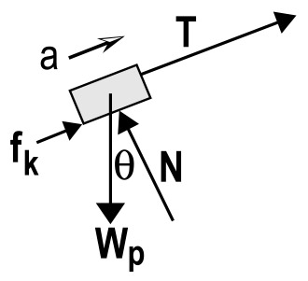
If the Skeptic knows what questions to ask (Is each type of force a push or a pull on the package? In what direction?), then leave the group.

If the Skeptic (and the rest of the group) can not think of appropriate questions to ask, then:
• Early in semester. Point to the section of the Skeptic/Summarizer’s Problem Framework Roles sheet and have her/him read the questions our loud.
• Later in semester. Tell group: “Two questions a Skeptic can always ask about each force in a diagram: Is the force a push or a pull? In what direction?
Example 2. Improper Construction of Specific Equation (difficulty 8a)  You observe that a group has drawn a correct force diagram for the package, but there is a wrong sign for the weight component in Newton’s 2nd Law component equation, as shown at right. | 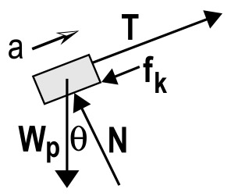  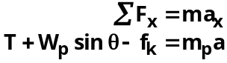

Point to the force diagram and the equation: “You have made a mistake in translating from your free-body diagram to this equation. Who is the skeptic? Skeptic, what questions could you ask about each translation?” When the group has responded (i.e., Is the sign right?), then leave the group.

Example 3: Incorrect Physics Diagram (difficulty 3d)  In your second circulation around the room, you observe a group who drew an incorrect free-body diagram of the counterweight. They also wrote the equations shown at right.  Point to the diagram of the counterweight: “There is something wrong with one of the forces in this diagram. There is also some information about the motion of the counterweight that would help. Who is the Manager? Manager, describe how the counterweight is moving.” | 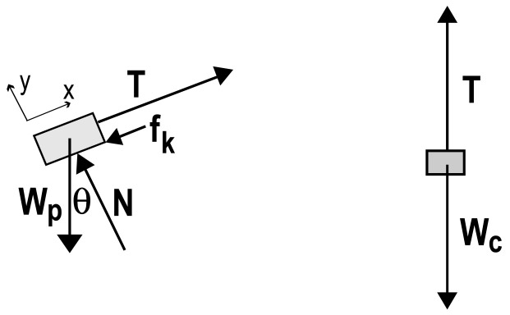  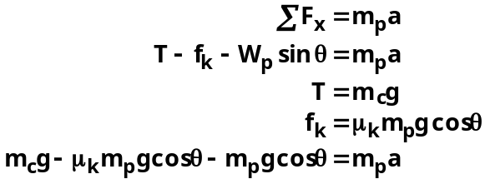

After the Manager has concluded that the counterweight is accelerating downwards:
“Recorder/Checker, draw an acceleration vector to the right of your force diagram.”
After the Recorder/Checker has drawn the acceleration vector, point to the counterweight diagram.
“Skeptic, what question could you ask about the size (magnitude) of the tension force (T) compared to the size (magnitude) of the gravitational force (Wc)?” (e.g., According to Newton’s 2nd Law, should these forces be the same magnitude or different magnitudes? Why?) If the Skeptic has no ideas, then model (in this case tell) the group the questions they should ask.

After the group has concluded that Wc must be larger than T for the counterweight to be accelerating downwards, the group members may conclude right away that their equation,
T = mcg, is incorrect, and you can leave the group.

If this does not happen
“Recorder/Checker, correct the free-body force diagram.”

After the Recorder/Checker has corrected the force diagram, point to the equation T = mcg
“Skeptic, one question you can always ask is whether a specific equation like this is the correct application of Newton’s 2nd Law of motion. What do you (group) think here? Does this specific equation match the force diagram for the counterweight? Why or why not?”

Example 4: Major Misconception – Nature of Forces and Newton’s 2nd Law (difficulty 6)  You observe a group that has not drawn separate free-body force diagrams for the package and the counterweight. Instead, they sketched some forces on their picture. In addition, they did not start their equations with Newton’s 2nd Law in its general form, ΣFx=max. Instead, they wrote the equations shown at right. | 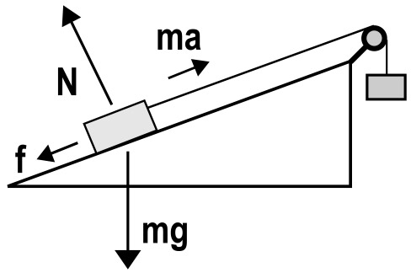  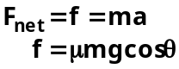

There are several possible conceptual difficulties the students may have:

• They may not understand the nature of forces. [for example: passive forces described in McDermott (1984) or pseudo-forces like inertia described in McDermott (1984), Hughes (2002), and Arons (1997)]

• They may not understand or know how to apply Newton’s 2nd Law. Research at the University of Minnesota indicates that about 20% of students in the calculus-based course for scientists and engineers solve Newton’s 2nd Law problems by setting an unknown force (e.g., friction, tension) equal to “ma” or by setting the sum of the forces equal to zero, even when there is acceleration. In addition, about 20% of students solve Newton’s 2nd Law problems by setting an unknown force (e.g., tension) equal to the sum of all the known forces, as shown at right. | Example of Setting Unknown Force  Equal to the Sum of the Known Forces  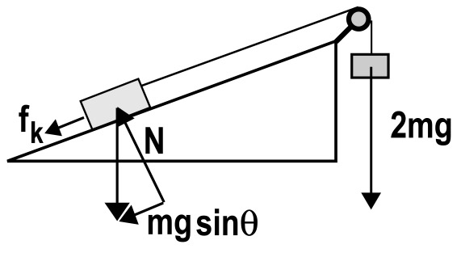  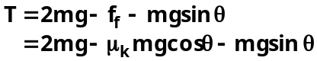
This group could take a very long time to coach. You decide to circulate around the class one more time to make sure that your other groups are on track. You quickly coach another group with a minor difficulty (Example 2), then return to this group. You need to ask questions to diagnose the group’s misconceptions.

You could start by asking the Recorder/Checker or the Skeptic/Summarizer to explain each force on their diagram. If students have a misconception about the nature of forces, you could:  1. Model drawing a free-body diagram of a book at rest; or  2. Hand out the part of the Competent Problem Solver that explains how to draw free body diagrams (pp 4-1 to 4-6); or  3. Hand out the Table of Interactions and Forces (see Chapter 4, pp 110); or  4. Do some combination of 1 – 3. | What are the Misconceptions?

 | You would not have time to coach these students completely through all of their difficulties. Even with coaching about the nature of forces, the students probably have additional misconceptions about Newton’s 2nd Law.

Guidelines for Coaching Groups During a Lab Session

At the beginning of the lab session, while students are coming to consensus about the answers to warm-up questions you asked them to put on the board, your coaching is similar to what you do in a discussion session.

Below are some guidelines and a few examples for coaching students in solving problems (making decisions) while they are checking their solutions.

Exploration. Give students a lot of encouragement to explore with the equipment. We know that exploration is the essence of physics, but many students view it as a “waste of time.”

Example. Your students have just started to check their solution to the Lab problem: Mass and the Acceleration of a Falling Ball. You circulate around the class and help a few groups. When you get back to the first group, you notice that they appear to be taking data from a video. You do not think that this group had enough time to complete the exploration and come up with a measurement plan. They were not very efficient in the last lab session.

Join the group and ask: Who is the Skeptic/Summarizer? Skeptic/Summarizer, summarize your groups’ decisions about how far the camera should be positioned from the falling ball to get enough data points, what reference object to use, and where the reference object should be placed to determine the distance scale.” Some follow up questions could include: “ How do you know the camera is positioned in the right place? How do you know where the reference object should be placed?”

If the group gives satisfactory answers to these questions, then congratulate the group on their efficiency and move on. If the group does not give satisfactory answers, then ask: “Who is the Manager? Manager, remember that part of your job is to make sure the group follows the instructions for each part of the lab. Help your group follow the directions in the Exploration section, so each group member could write a good lab report (if this problem were assigned).”

Measurement. Students need encouragement to pay attention to their measurements as they take them. While they are taking data, they should be able to tell if their measurements “make sense” and why. If the measurements don’t make sense to them, this is an ideal coaching moment. Either they have a misconception of physics or a misconception about the measurement process. In either case, you should work with them to set them straight.

Example. You are watching a student take data using videoTOOL. She is not being very careful about selecting the same spot on the on the ball. She has not adjusted the position versus time graph scale to show the data points as they are taken. You also notice that the other students are not paying much attention to what is going on.

Join the group and ask the keyboarder what her group role is. If she is not the Manger, then ask: “Who is the Manager? Manager, one of you jobs is to make sure that the group follows the lab instructions. What instruction is not being followed right now?” [Make sure you set the scale of the axes on your graph so you can see the data points as you take them.]

Wait until the keyboarder has adjusted the scale of the graph so the data points are showing. Ask the group: “Do these data points make sense?” You may need to follow up with: “Skeptic, What are some possibilities for why the data looks like this? Keep asking questions until the group agrees that the keyboarder needs to be more careful about measuring the position on the same part of the object each time.

Analysis. When students analyze their data by finding a function to represent the data, it is important that they understand the meaning of the constants in that function. By using some calculus and/or analyzing the data with computer programs such as VideoTOOL, students should be able to predict those constants reasonably precisely. Do not let your students get into the random guessing mode. This wastes a lot of time and eliminates some of the learning built into the lab. It is especially important that they should be able to tell you the units of those constants for the particular situation.

Example. You are watching a student at the keyboard making repeated guesses for the values of the constants in the function for the position-versus-time graph of a freely falling ball. The other group members are watching passively.

Join the group and ask: “Who is the Manager? Manager, you are letting the group waste a lot of time trying to guess the constants of this function. Have the manager write the function with the dummy variables and the function with the kinematics quantities:

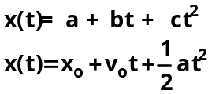

The sequence of questions you ask next depends on the knowledge of the group. Here is a brief outline of a series of possible questions:

“What kinematics quantity does the constant “a” represent? [a is xo] What is the meaning of xo? [the position of the ball at time t = 0] Look at your graph. How can you estimate the constant xo from the graph? Have the group show you and write down their estimate in their journal. What are the units of xo? [m or cm]

“What kinematics quantity does the constant “b” represent? [b is vo] What is the meaning of vo? [the instantaneous velocity of the ball at time t=0] Look at your graph. How can you estimate the constant vo from the graph? Have the group show you and write down their estimate in their journal. What are the units of vo? [ m/s or cm/s]

“What kinematics quantity does the constant “c” represent? [c is 1/2 a] What is the approximate value of the acceleration for freely falling bodies? [9.8 m/s2 or 980 cm/s2] What value of “c” would be a good place to start? [4.9 m/s2 or 490 cm/s2]. Have the students write down the estimate in their journal

Have the keyboarder put in the estimates of the constants in the function. Tell the group to read the lab instructions for how to estimate the constants in the velocity versus time graph. Before you leave the group, tell the Recorder/Checker that one of his/her jobs is to make sure everyone writes the groups’ estimates of the constants of a function (with units) in their journal. Everyone should also write the fitted constants (results of analysis) in their journals.

In computer labs, there is a tendency for students to rely too much on the printout of their analysis. The printout, however, does not give the solution to the problem – it is only a step toward the solution. The remainder of the information they need to solve the problem should be in their journals. Use the roles of Manager and Recorder/Checker to remind groups to record all the information they need to solve the problem in their journals.

Conclusion. This section gives many students a great deal of difficulty, especially at the beginning of the course.
• Make sure they write an outline of their conclusions for the problem before going on to the next problem.
• The conclusion should include a corrected, logical, and organized solution to the problem.
• Finally, the conclusion should address the validity of the prediction and the measurement. Students love to give “human error” as a reason for a discrepancy. This is not an acceptable reason. Human error should always be corrected before a report is written.

Expectations

Learning how to be a good coach of problem solving is very, very difficult. During the first few weeks of the semester, you may not be able to think of appropriate metacognitive questions to ask. If you intervene to coach a group and end up telling the group what to do instead of asking metacognitive questions, don’t be too hard on yourself. The important thing is that the next time you intervene with a group, you try asking using the roles to ask some questions. Like learning to drive a car or learning a new sport, with practice, coaching gets easier and easier.

You also have available other tools to make your coaching easier. One tool is the problem-solving framework and answer sheets you designed during the TA Orientation. It is much easier for you to diagnose students’ difficulties when they draw pictures and physics diagrams, define variables, and try to construct a logical solution. Without these written cues, you could not coach 5 - 6 groups during discussion and labs. Instead, you would probably either give up or spend all you time coaching only one or two groups, while the majority of your students fail to learn.

II. How Do I Form Cooperative Groups?

The learning advantage of CPS lies in the students’ co-construction of a problem solution. There are several aspects of group structuring that affect learning, such as group size, group composition, how long groups stay together, and the roles of individual students in the groups. The structures you will use and their rationale are described in this section. The sidebars in the next few pages contain a brief description of the research that supports each structure (taken from published papers, of research conducted at the University of Minnesota).

Group Size and Assignment

The optimal group size for solving physics problems is three. Of course, if your class is not divisible by three, then you will have a few pairs or a four-member group. We found that four-member groups generally work better than pairs in discussion sections. For the laboratory, break the group of four into two pairs.

You will assign students to groups, rather than letting students form their own groups. Below are the advantages of group assignment.

Optimal Learning. The most important reason to assign students to groups is because over 25 years of past research in cooperative group learning indicates that students learn more (become better problem solvers) when they work in mixed-achievement groups (i.e., based on past test performance) than when they work in homogeneous-performance groups. You do not, however, want students to wonder whom the high, medium and lower-performance students are in their groups, so do not tell them directly that this is how we assign group membership.

Psychological Advantage. There is a psychological reason for assigning groups. This reason is so important it is called the 2nd Law of Instruction:

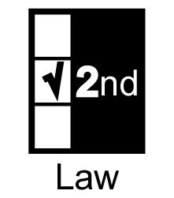 | Don't change course in midstream. Instead, structure early then fade.

It is much easier to set and enforce rules in the beginning of a class and loosen the enforcement later than it is to not have any rules at the beginning, and discover later that you have to establish a new rule. By assigning groups at the beginning, you will have fewer disgruntled students.

Why are three-member groups better than pairs or four-member groups?

For the co-construction of a physics problem solution by students in introductory courses, we found the "optimal" group size to be three members. A three-member group is large enough for the generation of diverse ideas and approaches, but small enough to be manageable so that all students can contribute to the problem solution.

An examination of written group problem solutions indicated that three- and four-member groups generate a more logical and organized solution with fewer conceptual mistakes than pairs. About 60 - 80% of pairs make conceptual errors in their solution (e.g., an incorrect force or energy), whereas only about 10 - 30% of three-or four member groups make these same errors. Observations of group interactions suggested several possible causes for the lower performance of pairs. Groups of two did not seem to have the "critical mass" of conceptual and procedural knowledge for successful completion of context-rich problems. They tended to go off track or get stuck with a single approach to a problem, which was often incorrect.

With larger groups, the contributions of the additional student(s) allowed the group to jump to another track when it seemed to be following an unfruitful path. In some groups of two, one student dominated the problem solving process, so the pair did not function as a cooperative group. A pair usually had no mechanism for deciding between two strongly held viewpoints except the constant domination of one member, who was not always the most knowledgeable student. This behavior was especially prevalent in male-female pairs. In larger groups, one student often functioned as a mediator between students with opposing viewpoints. The issue was resolved based on physics rather than the personality trait of a particular student.

In groups of four students, however, one person was invariably left out of the problem solving process. Sometimes this was the more timid student who was reticent to ask for clarification. At other times, the person left out was the most knowledgeable student who appeared to tire of continually trying to convince the three other group members to try an approach, and resorted to solving the problem alone. To verify these observations, we counted the number of contributions each group member made to a constant-acceleration kinematics problem from the videotapes of a three-member and four-member group. Each member of the group of three made 38%, 36%, and 26% of the contributions to the solution. For the group of four, each member made 37%, 32%, 23%, and 8% of the contributions to the solution. The only contribution of the least involved student (8%) was to check the numerical calculations. Our results are consistent with the research on pre-college students.

Practical Advantage. There are practical reasons for assigning students to groups. For example, most of our students do not know each other at the beginning of class. They would feel very uncomfortable being told simply to "form your own groups." Even if students know each other well, they typically have established behavior patterns that are not based on learning physics and are not conducive to it. Assigning groups allows the natural breakup of existing social interaction patterns.

Changing Groups

There are both optimal-learning and practical reasons for changing groups.

Avoid Homogeneous Groups. One reason to change groups is that you are likely to have many homogeneous-achievement groups, which is not optimal for student learning. Normally you do not know the problem-solving performance of your students at the beginning of class. With a small number of students, there can be large random fluctuations in the achievement-mix of your groups.

Avoid Role Patterns. In groups, the necessity to verbalize the procedures, doubts, justifications and explanations helps clarify the thinking of all group members. In addition, students can rehearse and observe others perform these roles, so they become better individual problem solvers. If students stay in the same group too long, they tend to fall into role patterns. The result is that they do not rehearse the different roles they need to perform on individual problems, and consequently do not achieve optimal gains in improving their problem solving performance.

Difficult Students. A third, practical reason for changing groups is that your first groups may have some very dysfunctional groups (because of personality conflicts). Students find it miserable to contemplate working a whole semester with someone who isn’t compatible, and may disengage. However, most will accept the challenge of working together if they know that it is for a limited time. After you get to know the students better, you can place the "difficult" students in better groups. Strategies for dealing with difficult group members are discussed in Section IV.

Individual Responsibility. Finally, one of the most important reasons to change groups is to reinforce the importance of the individual in cooperative problem solving. The most difficult point in the course for group management is the first time you change groups. By that time, most groups have been reasonably successful, and students are convinced they are in a “magic” group. Changing groups elicits many complaints, but is necessary for students to learn that success depends on individual effort and not on a particular group.

How often should groups be changed? Students need to work in the same group long enough to experience some success. The frequency of changing groups can fade over the course as students become more confident and comfortable with CPS. For example, change groups about 3 - 4 times in the first semester, but fewer times in the second semester. Since students are very sensitive to grades, change groups only after a class test.

Why is it better to assign students to groups?

In our research, we examined the written problem solutions of both homogeneous and mixed-achievement groups (based on past problem-solving test performances). The mixed-performance groups (i.e., a high, medium and lower performing student) consistently performed as well as high performance groups, and better than medium and low performance groups. For example, our algebra-based class was given a group problem that asked for the light energy emitted when an electron moves from a larger to a smaller Bohr orbit. 75 percent of the mixed-performance groups solved the problem correctly, while only 45% of the homogeneous groups solved this problem.

Observations of group interactions indicated several possible explanations for the better performance of heterogeneous groups. For example, on the Bohr-orbit problem the homogeneous groups of low-and medium-performance students had difficulty identifying energy terms consistent with the defined system. They did not appear to have a sufficient reservoir of correct procedural knowledge to get very far on context-rich problems. Most of the homogeneous high performance groups included the gravitational potential energy as well as the electric potential energy in the conservation of energy equation, even though an order-of-magnitude calculation of the ratio of the electric to gravitational potential energy had been done in the lectures. These groups tended to make the problem more complicated than necessary or overlooked the obvious. They were usually able to correct their mistake, but only after carrying the inefficient or incorrect solution further than necessary. For example, in the heterogeneous (mixed-performance) groups, it was usually the medium or lower performance student who pointed out that the gravitational potential energy term was not needed. ["But remember from lecture, the electric potential energy was lots and lots bigger than the gravitational potential energy. Can't we leave it out?"] Although the higher performance student typically supplied the leadership in generating new ideas or approaches to the problem, the low or medium performance student often kept the group on track by pointing out obvious and simple ideas.

In heterogeneous groups, the low- or medium-performance student also frequently asked for clarification of the physics concept or procedure under discussion. While explaining or elaborating, the higher-performance student often recognized a mistake, such as overlooking a contributing variable or making the problem more complicated than necessary. For example, a group was observed while solving a problem in which a car traveling up a hill slides to a stop after the brakes are applied. The problem statement included the coefficient of both static and kinetic friction. The higher performance student first thought that both static and kinetic frictional forces were needed to solve the problem. When the lower-performance student in the group asked for an explanation, the higher-performance student started to push her pencil up an inclined notebook to explain what she meant. In the process of justifying her position, she realized that only the kinetic frictional force was needed. Our results are consistent with the research on pre-college students.³

III. What Criteria Do I Use
to Assign Students to Groups?

There are three criteria for assigning students to groups.

1. Problem-solving Performance. The most important criterion for assigning students to groups is their problem solving performance based on past problem-solving tests. That is, a three-member group would ideally consist of a higher-performance, a medium-performance, and a lower-performance student. Four-member groups would ideally consist of a high performance, medium-high performance, medium-low performance, and a low-performance student. There are two other "rules of thumb" for assigning students to groups.

We observed a group, consisting of a lower-performance man, a medium performance man and a high performance woman, having a vigorous discussion about the path of a projectile. The men insisted on a path following the hypotenuse of a triangle; while the woman argued for the correct parabolic trajectory.
At one point, she threw a pen horizontally, commenting as it fell to the floor, "There see how it goes. It does not go in a straight line!" Even so, she could not convince the two men, who politely ignored her.
2. Gender. Our observations indicated that frequently groups with only one woman do not function well, especially at the beginning of class. To be on the safe side, avoid groups with only one woman. We found the difficulty is with the men, not the women (see example at right). Regardless of the strengths of the lone woman, the men in the group tend to ignore her. On the other hand, we found it is dangerous to assign all the students in a class to same-gender groups. The women notice and tend to suspect gender discrimination. Curiously, no one seems to notice when all mixed-gender groups have two women.

3. English as a Second Language (ESL). Students from other cultures often have a difficult time adjusting to group work, especially in mixed-gender groups. Their difficulties are exacerbated if English is their second language (ESL). So to be on the safe side, whenever possible we assign each ESL student to a different, same-gender group.

An Example of How to Assign Students to Groups

The following example, for a class of 17 students, describes the steps you can follow to assign students to groups with roles.

Step ① Calculate the total test score (sum of test scores) for each student. Identify each student’s gender (M for male and F for female) and whether English is a second language (ESL). A spreadsheet is the most convenient way to do this.
Name | Gen. | ESL | Test 1 | Test 2 | Total
Anderson, Max | M |  | 62 | 71 | 133
Black, Jennifer | F |  | 93 | 85 | 178
Brown, John | M |  | 78 | 79 | 157
Edwards, Mark | M |  | 54 | 58 | 112
Fairweather, Joan | F |  | 73 | 65 | 138
Freedman, Joshua | M |  | 86 | 92 | 178
Good, Mary | F |  | 100 | 95 | 195
Green, Bill | M |  | 79 | 83 | 162
Johnson, Fred | M |  | 69 | 70 | 139
Jones, Rachel | F |  | 59 | 63 | 122
Nygen, Tan | M | Yes | 84 | 85 | 169
Peterson, Scott | M |  | 69 | 61 | 130
Smith, Patricia | F |  | 70 | 77 | 147
South, David | M |  | 48 | 50 | 98
West, Tom | M |  | 52 | 55 | 107
White, Sandra | F |  | 55 | 49 | 104
Yurrli, Tamara | F | Yes | 57 | 60 | 117

Step ② Sort the class by total test score (highest to lowest). Divide the class into approximate thirds (high performance, medium performance and low performance students). Identify the performance level (Perf.) of each student, as shown below.

Name | Sex | ESL | Test 1 | Test 2 | Total | Perf.
Good, Mary | F |  | 100 | 95 | 195 | Hi
Black, Jennifer | F |  | 93 | 85 | 178 | Hi
Freedman, Joshua | M |  | 86 | 92 | 178 | Hi
Nygen, Tan | M | Yes | 84 | 85 | 169 | Hi
Green, Bill | M |  | 79 | 83 | 162 | Hi
Brown, John | M |  | 78 | 79 | 157 | Hi/M
Smith, Patricia | F |  | 70 | 77 | 147 | Med
Johnson, Fred | M |  | 69 | 70 | 139 | Med
Fairweather, Joan | F |  | 73 | 65 | 138 | Med
Anderson, Max | M |  | 62 | 71 | 133 | Med
Peterson, Scott | M |  | 69 | 61 | 130 | Med
Jones, Rachel | F |  | 59 | 63 | 122 | M/Lo
Yurrli, Tamara | F | Yes | 57 | 60 | 117 | Lo
Edwards, Mark | M |  | 54 | 58 | 112 | Lo
West, Tom | M |  | 52 | 55 | 107 | Lo
White, Sandra | F |  | 55 | 49 | 104 | Lo
South, David | M |  | 48 | 50 | 98 | Lo

Step ③ Within each performance group, sort by gender and ESL. Assign each student to a numbered group (Gr.). First, assign the ESL students to same-gender, mixed performance groups of three (high, medium, and low performance), as illustrated on the next page (bolded group numbers). Assign the remaining students to three- or four-member groups using the mixed-performance and gender criteria.

Name | Gen. | ESL | Test 1 | Test 2 | Total | Perf. | Gr.
Nygen, Tan | M | Yes | 84 | 85 | 169 | Hi | 1
Freedman, Joshua | M |  | 86 | 92 | 178 | Hi | 3
Green, Bill | M |  | 79 | 83 | 162 | Hi | 4
Brown, John | M |  | 78 | 79 | 157 | Hi/M | 5
Good, Mary | F |  | 100 | 95 | 195 | Hi | 2
Black, Jennifer | F |  | 93 | 85 | 178 | Hi | 4
Johnson, Fred | M |  | 69 | 70 | 139 | Med | 5
Anderson, Max | M |  | 62 | 71 | 133 | Med | 5
Peterson, Scott | M |  | 69 | 61 | 130 | Med | 1
Smith, Patricia | F |  | 70 | 77 | 147 | Med | 3
Fairweather, Joan | F |  | 73 | 65 | 138 | Med | 2
Jones, Rachel | F |  | 59 | 63 | 122 | M/Lo | 4
Edwards, Mark | M |  | 54 | 58 | 112 | Lo | 1
West, Tom | M |  | 52 | 55 | 107 | Lo | 4
South, David | M |  | 48 | 50 | 98 | Lo | 5
Yurrli, Tamara | F | Yes | 57 | 60 | 117 | Lo | 2
White, Sandra | F |  | 55 | 49 | 104 | Lo | 3

Then sort the groups by group number.

Name | Sex | ESL | Perf. | Gr.
Nygen, Tan | M | Yes | Hi | 1
Peterson, Scott | M |  | Med | 1
Edwards, Mark | M |  | Lo | 1
Good, Mary | F |  | Hi | 2
Fairweather, Joan | F |  | Med | 2
Yurrli, Tamara | F | Yes | Lo | 2
Freedman, Joshua | M |  | Hi | 3
Smith, Patricia | F |  | Med | 3
White, Sandra | F |  | Lo | 3
Black, Jennifer | F |  | Hi | 4
Green, Bill | M |  | Hi | 4
Jones, Rachel | F |  | M/Lo | 4
West, Tom | M |  | Lo | 4
Brown, John | M |  | Hi/M | 5
Johnson, Fred | M |  | Med | 5
Anderson, Max | M |  | Med | 5
South, David | M |  | Lo | 5

Step ④ Check the groups. If necessary, modify the groups using your knowledge of your students’ strengths and weaknesses working cooperatively. For example, suppose Joshua Freedman (Group 3) tries to dominate groups by “railroading” his ideas through a group without listening to other ideas. Patricia Smith and Sandra White are shy and quiet, but work well in congenial groups. You could replace Joshua with another higher-performance male who is listens well and is good at clarifying and explaining ideas, for example Bill Green (Group 4). However, you also have to make sure Joshua is placed in a group that will not let him dominate. Max Anderson has excellent group management skills, so you could put Joshua in Group 5, and move John Brown to Group 4.

If you teach a calculus-based course, you may not have many women in your discussion class, and you cannot put them in the same group all the time. Use your knowledge of their strengths and weaknesses in working cooperatively to assign them to groups.

Step ⑤ Sort the students by group number, as shown below. Then assign roles to each group member: Manager (M), Skeptic/Summarizer (Sk/Su), and Recorder/Checker (R/C) for three-member groups and Manager (M), Skeptic (Sk), Recorder/Checker (R/C) and Summarizer (Su) for four-member groups. [See Section I for the reasons for assigning roles.]

Use two rules of thumb for the assignment of roles to new groups:
a. Assign the role of Recorder/Checker to the ESL students (see bolded R/C roles in groups 1 and 2 below); and
b. Do not assign the role of Recorder/Checker to the man in a mixed-gender group of three (see italicized R/C role in group 3 below).

Name | Sex | ESL | Perf. | Gr. | Role
Nygen, Tan | M | Yes | Hi | 1 | R/C
Peterson, Scott | M |  | Med | 1 | M
Edwards, Mark | M |  | Lo | 1 | Sk/Su
Good, Mary | F |  | Hi | 2 | M
Fairweather, Joan | F |  | Med | 2 | Sk/Su
Yurrli, Tamara | F | Yes | Lo | 2 | R/C
Green, Bill | M |  | Hi | 3 | Sk/Su
Smith, Patricia | F |  | Med | 3 | R/C
White, Sandra | F |  | Lo | 3 | M
Black, Jennifer | F |  | Hi | 4 | M
Brown, John | M |  | Hi/M | 4 | Sk
Jones, Rachel | F |  | M/Lo | 4 | R/C
West, Tom | M |  | Lo | 4 | Su
Freedman, Joshua | M |  | Hi | 5 | Sk
Johnson, Fred | M |  | Med | 5 | Su
Anderson, Max | M |  | Med | 5 | M
South, David | M |  | Lo | 5 | R/C

Step ⑥ Make a copy of your group assignments and roles. You can write the assignments on the board before a discussion class, or project the group and role assignment in a laboratory session. An example is shown below.

#1 | M. Edwards | Sk/Su | #4 | J. Black | M
 | T. Nygen | R/C |  | J. Brown | Su
 | S. Peterson | M |  | R. Jones | R/C
 |  |  |  | T. West | Sk
#2 | J. Fairweather | Sk/Su
 | M. Good | M | #5 | M. Anderson | M
 | T. Yurrli | R/C |  | J. Freedman | Sk
 |  |  |  | F. Johnson | Su
#3 | B. Green | Sk/Su |  | D. South | R/C
 | P. Smith | M
 | S. White | R/C

Step ⑦ Each subsequent time the same group works together, their roles MUST ROTATE. One way to accomplish this is to list the group members with roles on the board each session, as shown above. You can use a spreadsheet to keep track of the roles you have assigned to each group member. An example is shown below.

Name | Gr. | DS  10/15 | Lab  10/20 | DS  10/22 | Lab  10/27 | DS  10/29 | Lab  11/3
Nygen, Tan | 1 | R/C | M | Sk/Su | R/C | M | Sk/Su
Peterson, Scott | 1 | M | Sk/Su | R/C | M | Sk/Su | R/C
Edwards, Mark | 1 | Sk/Su | R/C | M | Sk/Su | R/C | M
Good, Mary | 2 | M | Sk/Su | R/C | M | Sk/Su | R/C
Fairweather, Joan | 2 | Sk/Su | R/C | M | Sk/Su | R/C | M
Yurrli, Tamara | 2 | R/C | M | Sk/Su | R/C | M | Sk/Su
Green, Bill | 3 | Sk/Su | R/C | M | Sk/Su | R/C | M
Smith, Patricia | 3 | R/C | M | Sk/Su | R/C | M | Sk/Su
White, Sandra | 3 | M | Sk/Su | R/C | M | Sk/Su | R/C
Black, Jennifer | 4 | M | Sk | R/C | Su | M | Sk
Brown, John | 4 | Sk | R/C | Su | M | Sk | R/C
Jones, Rachel | 4 | R/C | Su | M | Sk | R/C | Su
West, Tom | 4 | Su | M | Sk | R/C | Su | M
Freedman, Joshua | 5 | Sk | Su | M | R/C | Sk | Su
Johnson, Fred | 5 | Su | M | R/C | Sk | Su | M
Anderson, Max | 5 | M | R/C | Sk | Su | M | R/C
South, David | 5 | R/C | Sk | Su | M | R/C | Sk

IV. How Can I Structure CPS to
Maintain Well-functioning Groups?

Ideally, you want your CPS discussion and lab sessions to be enjoyable for both you and your students, with a lot of learning going on within each group. In well-functioning groups, members share the metcognitive roles of manager, checker, explainer, skeptic and conciliator (who solves conflicts and strives to minimize interpersonal conflict), and role assumption usually fluctuates over the time students are solving a problem. Students in these groups do not need to be reminded to "stick to their roles." You will use the roles only as a convenient, efficient way to coach the metacognitive skills students need when they are having difficulty with a specific physics concept or problem-solving procedure.

The opposite of well-functioning groups is “dysfunctional” groups. Dysfunctional groups exhibit one or more of the following behaviors.
• Less able members sometimes "leave it to John" to solve the group problem, creating a free-rider effect.
• At the same time, more able group members expend decreasing amounts of effort to avoid the sucker effect.
• High ability group members may be deferred to and take over leadership roles in ways that benefit them at the expense of the other group members (the rich-get-richer effect).
• Groups with no natural leaders may avoid conflict by "voting" rather than discussing an issue (conflict avoidance effect).
• Group members argue vehemently for their point of view and are unable to listen to each other or come to a group consensus (destructive conflict effect).

Students in dysfunctional groups cannot learn, and the result is very disgruntled students. This, in turn, leads to very disgruntled instructors. So how can you make your job easier and more enjoyable? This section includes suggestions for how to get started and structure your classes for well-functioning groups.

Seating Arrangement

In discussion section, make sure the seats are arranged so students are facing each other, "knee-to-knee”. [See Figures 1 and 2 on the next page.] This seating arrangement makes it much harder for a student to remain uninvolved with a group. If you observe students sitting in a row with one person not involved, or one student sitting "outside" a pair, go over to the group and make them stand up and rearrange their chairs.

In labs, make sure students are standing or sitting so they are all facing each other. In computer labs, make sure all students can see the screen. If you observe a group with one member doing all the work or one member left out, go over to the group and make them rearrange their seating/standing.



Figure 1. Bad Example of Seating Arrangement



Figure 2. Good Example of Seating Arrangement

Start the Semester with Group Roles for Each Step in the Problem-solving Framework

At the beginning of an introductory class, some students have never participated in Cooperative Problem Solving (CPS) and do not know how to co-construct a problem solution in a group. Look at the Group Roles on page 15. The roles remind students of appropriate individual actions in a group. Each role includes some action that may not be natural for students, or even socially acceptable. For example, “I don’t want to be bossy, but I am the manager. Let’s move on to . . .” The role of “Skeptic” allows students a socially acceptable way to disagree. Most of the actions described for each role are metacognitive. However, each role also includes some group-maintenance actions.
Manager: Make sure everyone in your group participates.
Recorder/Checker: Make sure all members of your group agree with each thing you write.
Skeptic/Summarizer: Keep track of different positions of group members and summarize before your group makes a decision.

All of the actions on the Group Role sheets (both metacognitive and group- maintenance) are stated in general terms. Many students do not know what it means to apply these actions at different places in the problem-solving framework. Look at the Problem Framework Roles sheets at the end of this section (pp 46 to 55). These sheets provide specific coaching for each role through all the problem-solving decisions.

In the first (or second) week of the discussion session, you will introduce the Group Roles and the problem-solving framework and answer sheet and explain them briefly. In the next discussion session, tell your students that you have something that will help them learn how to solve problems in a logical, organized fashion. Pass out the Problem Framework Roles sheets and tell the students to glance through the sheets.

Notice that this procedure is a direct application of two of the “2nd Law of Education.”

Don't change course in midstream.
It is easier on both instructors and students to start with what may seem a rigid structure, then fade slowly as the structure is no longer needed. It is almost impossible to impose a different or more structured procedure in the middle of the course, after you discover that students need the structure.

You will decide when students no longer need the Problem Framework Roles sheets and the answer sheets in the discussion section.

Examples of Coaching to Maintain Well-functioning Groups in Discussion Session

With the Problem Framework Roles sheets, you should have very few problems with dysfunctional groups. The examples suggest how to deal with the occasional group that is not working well together.


Example 1: Individual Problem Solving. You observe a group in which the members are not talking to each other, but solving the group problem individually (not on the answer sheet).

Say something like: “I notice that you are solving the problem individually, not as a group. Who is the Recorder/Checker? You should be the only person writing the solution on the answer sheet as you solve the problem together. Manager and Skeptic/Summarizer put your pencils away and work with the Recorder/Checker to solve the problem.” Make the students rearrange their chairs so they can all see what the Recorder/Checker is writing.

Drastic Measure. If the students persist in solving the problem individually and only then return to the group to compare answers, explain again that they should be solving the problem together. Take away the papers students have written on, the pencils from the Manager and Skeptic (return them at the end of class), and give the recorder a new answer sheet (if necessary). Have the group start again, using their Problem Framework Roles sheets. Do not leave until they have started solving the problem together.

Example 2: A Lone Problem Solver. You observe a group in which two members, including the Recorder/Checker, are working together, but one member is working alone to solve the problem (hereafter called “the loner.”) First, try to determine why the loner is solving the problem alone. Say something like: “I notice that while two of you are working together, you (loner) appear to be solving the problem by yourself. What are each of your group roles? Why are you (loner), as the group Manager (or Skeptic/Summarizer) solving the problem by yourself?”

Frequently, the loner will sheepishly mumble something about not being used to working in a group. This individual may need only a gentle reminder to give group work a try. Ask the Recorder/Checker to explain to the loner what they have done so far to solve the problem. If necessary, make the students rearrange their chairs so they can all see what the Recorder/Checker is writing.
Infrequently, a loner is more adamant about needing to solve the problem alone before talking with the group. Maintain a sympathetic attitude, but explain to the loner that research shows that all students learn much more about physics and problem solving when they construct problem solutions together. This is why you work in groups in this class. Although it may seem difficult at first, s/he should try it. Tell the individual to put his pencil away and ask the Recorder/Checker to explain to the loner what they have done so far to solve the problem.

Example 3: A Non-participant. You observe a group in which one member does not appear to be engaged in the group problem-solving process.



Try to determine why the student appears to be disengaged. For example, if the students are sitting in a row and not facing each other, have the students to get up and rearrange the chairs so they sit facing each other. Ask the non-participating student to explain what the group is doing and why. [This emphasizes the fact that all group members need to be able to explain each step in solving a problem.] If the student can describe what the group is doing and why, then s/he may be a quiet student who pays attention, but does not speak as often as the others. You may not need to intervene further.


If the student does not have a clear idea of what the other group members are doing, s/he may be what is called a “free-rider” -- a person who leaves it to others to solve the problem. Ask the free rider: “What is your group role? What should you be doing to help your group solve this problem?” [If necessary, have the free rider read the description from the Problem Framework Role sheets.] If the free rider is not the Manager, ask the Manager what s/he could do to make sure everyone, including the free rider, participates in solving the problem.

Example 4: Dominant Student.  You observe a group in which one member is doing almost all of the talking, while the other members appear somewhat disengaged and lethargic (Rich-get-richer effect? Free-riders? | 
In this case, all members are failing in their roles. First tell the group: “I notice that one person appears to be doing all the talking in this group.“ Then ask: Manager, what could you be doing to make sure that all members of your group contribute their ideas?” If the manager has no ideas, then tell that Manager that: “In each step in your problem-solving framework, ask each member of your group what they think.” Point to the last part of the group’s solution and have the Manager read questions from the Problem Framework Sheet that he/she could be asking individuals in the group.

Repeat this procedure with each group member. Ask: “Checker/Recorder, what could you be doing to make sure that all members understand and can explain everything that is written down?” [Periodically ask each member if they understand and agree with everything written down. Point to the last part of the group’s solution and have the Checker/Recorder read questions from the Problem Framework Sheet that he/she could be asking individuals in the group. Ask: “Skeptic, what could you be doing to make sure that all possibilities and alternative ideas are being considered by the group?” [Be sure to ask for a justification for an idea, and suggest alternative ideas.] Point to the last part of the group’s solution and have the Checker/Recorder read questions from the Problem Framework Sheet that he/she could be asking individuals in the group.


Example 5: Conflict Avoidance or Destructive Conflict.
You observe a group that is either struggling to come to a decision, but does not appear to have any strategy to reach a decision (conflict avoidance), or is arguing loudly, but does not appear to be resolving their conflict (destructive conflict). Ask the group: "Who is the Skeptic/Summarizer? I noticed that you are having difficulty deciding . What could you be doing to help the group come to a decision that is agreeable to all of you? [Stop and summarize your different ideas. Then discuss the merits/justification of each idea.] If the Skeptic/Summarizer has no idea, then either have the her/him read the Problem Framework Role sheet again (early in course) or give some suggestions, such as: “Stop and summarize your different ideas. Then discuss the merits of each idea. For example, you could . . . ." The specific suggestions you give will depend on the exact nature of the decision that led to the original conflict.

Group Processing

One of the elements that distinguish traditional groups from cooperative groups is structuring occasional opportunities for students to discuss how well they are solving the problems together and what actions they should take next time to work better together. You could do this informally (as Karl Smith demonstrated), or you could use the Group Functioning Evaluation form shown on the next page. After the group has discussed and completed the evaluation, spend a few minutes in a class discussion of the answers to Question 6, so students can consider a wider range of ways groups could function better. Common answers include: "Come better prepared; Listen better to what people say; Make better use of our roles (e.g., "Be sure the Manager watches the time so we can finish the problem." or "Be sure the Skeptic doesn't let us decide too quickly.").

At the beginning of the first semester, structure group processing at least on alternate class sessions. After 2 - 4 weeks (i.e., after students have worked in two different groups), you can reduce group processing to about once every two to three weeks, as it seems necessary (usually the first time new groups are working together).

Group Evaluation Sheet

Date: ________________ Group #: _____

Complete the following questions as a team.
 |  | Low |  |  |  | High
1. | Did all the members of our group contribute ideas to solve the problem? | 1 | 2 | 3 | 4 | 5
2. | Did all the members of our group listen carefully  to the ideas of other group members? | 1 | 2 | 3 | 4 | 5
3. | Did we encourage all members to contribute  their ideas? | 1 | 2 | 3 | 4 | 5

4. What are two specific actions we did today that helped us solve the problem?

5. What is a specific action that would help us do even better next time?

Group Signatures: Manager: .
Skeptic/Summarizer: .
Recorder/Checker: .
Skeptic/Summarizer: .

Remember the 2nd Law of Education: Don’t change course in midstream. It is better to impose a structure early then fade. This means it is very difficult to start group processing when you finally discover that you need it. As students become more comfortable and competent with CPS, the group roles slowly and naturally "fade" away from students' minds, except when you coach students.

Random Calling on Students

In both discussion sections and lab, randomly call on individual students in a group to present their group's results. This person is not usually the Recorder/Checker for the group. In the beginning of the course, you can call on the individuals who seem most enthusiastic or involved. After students are familiar with CPS, you can either call on the Skeptic/Summarizers or Managers, or call on individuals who seemed to be the least involved. This technique helps avoid both dominance by one student and the free-rider effect.

Grading

The Zeroth Law of Education is:

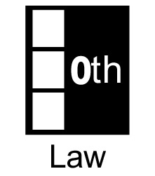 | If you don't grade it, students won't do it.

One consequence of the Zeroth Law of Education is that your students will work more effectively in cooperative groups when group problem solutions are occasionally graded. Group problem solutions are usually only 10% - 15% of a student's grade in the course. There are many ways that your team may grade the group problem solutions. For example, your team might assign 10% - 15% of each student's grade to a fixed number of group problem solutions. That is, groups occasionally turn in one problem solution for grading, and each group member gets the same grade for the group solution.

In some teams, each test has a group part and an individual part. The first part of the test is a group problem that students complete in their discussion sections. The following day students complete the individual part of the test. The group problem is usually about 25% of a student's total score for each test. When the final exam is added, the group problems are only about 15% of their total test scores. When other parts of the grade are added (e.g., individual laboratory reports), group problems are 10% or less of the students' course grade. [The advantage of this presentation of grading lies in the way students interpret their test scores. When groups are well managed, the highest score that students receive on a test is almost always for the group problem, which is also the most difficult problem on the test.1 This reinforces the advantages of cooperative-group problem solving.]

To avoid the free-rider effect, your team may decide to set the rule that group members absent the week before the graded group problem (i.e., s/he did not get to practice with her/his group) cannot take part in solving the graded group problem. Towards the end of the first semester, you could let the rest of the group members decide if the absent group member can take part in solving the graded group problem.

To encourage students to work together in lab, your team could decide that each member of the group receives bonus points if all group members earn 80% or better on their individual lab reports.

Understand the Problem

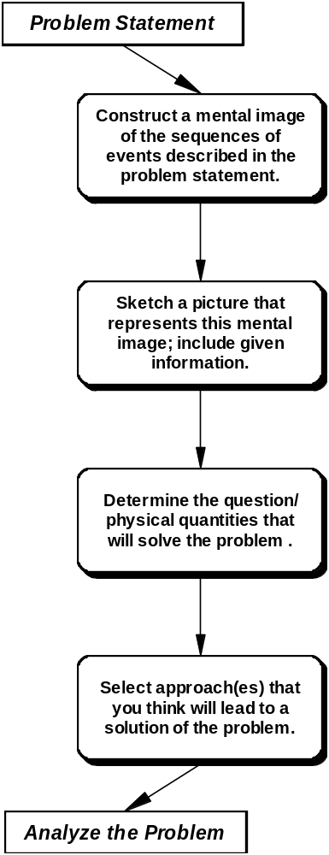 | Questions and Actions  • What's going on?  • What objects are involved?  • What are they doing? Where are they relative to each other?  • What is important and what is not?  • How should we draw the spatial relations between the objects?  • How should we draw the objects in motion?  • How should we draw the sequence of events?  • What information is given?  • What can we calculate that will answer this question?  • What physical quantities do we need to solve this problem?  • What physics concepts and principles might be useful to solve this problem? What kind of problem is it?  • How might these concepts and principles be used?  • Are different approaches useful for different time intervals?  • What approximations or assumptions are needed to use our approaches?  • Do we need to add information from our general knowledge or assume information that is not provided in the problem statement?

Analyze the Problem

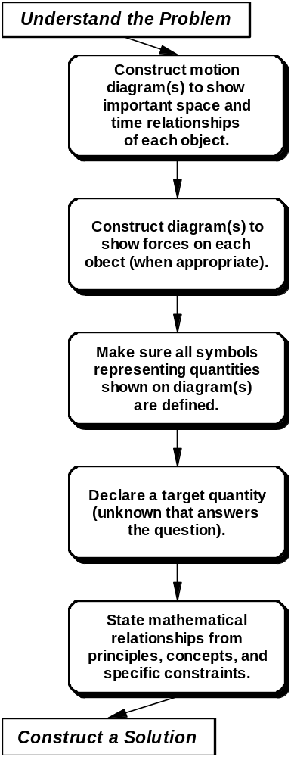 | Questions and Actions  • What coordinate axes are useful? Which direction should we call positive?  • Relative to the coordinate axes, where is (are) the object(s) for each important time?  • Are other diagrams necessary to represent the interactions of each object or what happens to the object over time?  • Which object should we isolate in our fee-body diagram?  • What are the forces acting on this object?  • What coordinate axes should we use for our force diagram?  • Do we need separate diagrams showing the forces acting on another object?  • What quantities are needed to define the problem mathematically using our approach(es)?  • Which symbols represent known quantities?  Which symbols represent unknown quantities?  • Are all quantities having different values labeled with unique symbols?  • Do the diagrams have all of the essential information from the picture?  • Which of the unknowns defined on the diagram(s) answers the question?  • What equations represent the fundamental concept(s) specified in our approach using the specific symbols for the physics quantities defined in the diagram?  • During what time intervals are those relationships either true or useful?  • Are there any equations that represent special conditions that are true for some quantities in this problem?

Construct a Solution
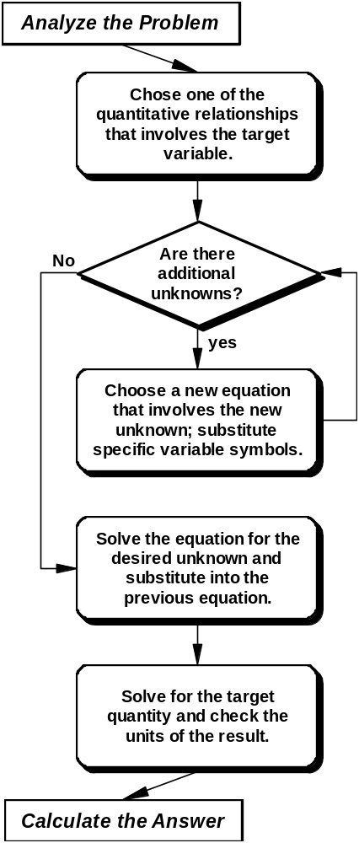 | Questions and Actions  • Which of the useful equations includes the target quantity?  • For what object does that equation apply?  • For what time interval does that equation apply?  • Are there any unknowns in the equation other than the target quantity?  • Are there any unknowns that we think will cancel out in the algebra?  • Which of the useful equations that have not already been used includes an unknown quantity? If there is more than one, which one shall we use?  • For what object and time interval does that equation apply?  • If there is no equation that involves the unknown quantity, can we make a different equation choice in the previous steps?  • Are there as many different equations used in this process as unknowns?  • What unknown is the target of this last equation?  • Let’s solve this equation for the unknown.  • Which previous equations have that unknown?  • Let’s substitute our expression for this unknown into all of these equations.  • Are there any quantities that cancel out in the algebra?  • After all the substitution for unknowns, is the only unknown left the target quantity?  • If not, where did we make our mistake?  • Are the units the same on both sides of the equation?

Understand the Problem

Questions and Actions

• Do we all agree that these are the important objects and this is the sequence of events?

• Sketch the important objects and sequence of events as discussed by your group. Show it to the other group members.
• Do we agree that this picture represents the situation accurately?
• Write down the information that the group decided might be important. Put it on the picture and show it to the other group members.
• Do we all agree on the useful information?

• Write down the question that your group decided on.
• Do we all understand the question and what quantity we need to calculate?

• As the group discusses the possible approaches to the problem, write them down. Write down the approach(es) that are chosen for this problem..
• Do we all understand why we are choosing the(se) approach(es)?
• Write down all approximations or assumptions that your group believes are necessary to solve the problem. Make sure everyone agrees.

Analyze the Problem

Questions and Actions
• Using a coordinate system chosen by your group, draw idealized objects at positions corresponding to all the important times.
• Draw vectors representing the velocity and acceleration associated with the idealized objects at each position chosen.
• Label all quantities with different symbols if they have different values.
• Show the diagram to other group members and get agreement.

• While your group discusses the forces, draw a free-body diagram for each important object based on the discussion.
• Using a coordinate system chosen by your group, draw a force diagram for each important object.
• Label all forces so that forces with different values have different symbols.
• Show the free-body and force diagrams to the other group members for agreement.

• While your group discusses the knowns and unknowns for the problem, write down the numerical value (with units) of each known quantity based on the discussion.
• Indicate which quantities are unknown.
• Make sure everyone agrees that all useful quantities have been identified and labeled.

• Write down the target quantity that your group decides on.
• Is the target quantity clearly defined on a diagram.
• Make sure everyone in your group agrees that solving for the target quantity answers the question.

• Write down the equations that your group decided might be useful to solve this problem.
• Write down equations that your group agrees represent conditions which are only true for this problem (e.g., v1 = v2 = v = constant)
• Make sure everyone in the group understands and agrees on the meaning of all the symbols in these equations.

Construct a Solution

Questions and Actions

• Write down the equation that your group decides to start with. Make sure this equation includes the target quantity (as well as the object and/or time interval for which it is applicable).
• Write down how your group decides to solve for the target quantity.
• Number the equation

• Write down any additional unknowns (other than the target quantity).
• Write down any unknowns that your group thinks will cancel out in the algebra.

• Write the new equation chosen by your group that includes the next unknown quantity (as well as the object and and/or time interval for which it is applicable).
• Number the equation.
• Write down how your group decides to solve for the unknown.
• Make sure that everyone agrees on the mathematics.

• Write down how your group decides to solve for the last unknown and substitute this unknown into previous equation(s) with this unknown.
• Make sure that everyone agrees with the mathematics.
• Check to see if any of the unknowns cancel out in the algebra.

• Write down how your group decides to solve for the target quantity.
• Check that the units of both sides of the equation are the same and make sure that everyone agrees.
• Make sure that everyone agrees on all the mathematical steps and on the answer.

Understand the Problem

Questions and Actions

• Where in the problem statement does it say what you claim?
• Give your group another interpretation of the problem situation and discuss why it is not as good as the one decided on.

• Have we left out any important objects? Make sure your group gives you good reasons why they are not important for this problem.
• Are there other times when the motion of the object(s) changed?
• Is there a better perspective to show the motion? How about from overhead? The front? The side?
• If one picture has been drawn, ask if it too complicated and propose a several pictures. If several pictures have been drawn, ask if one picture would be better.
• Describe to the group what you think the picture shows and see if they agree.

• What does it say in the problem statement that leads you to that question?
• Is there any other physical quantity we could calculate that would also solve the problem and might be easier?

• Do we have enough information to use this approach? Propose some information that might be missing.
• [If group decides there is information missing] Why don't we need this information? Make sure the group justifies why it is not needed.
• Can we break up the problem into simpler sub-problems?
• Make sure the group justifies every approximation or assumption made.
• Summarize the group’s decision about the approach(es) and how the approach(es) lead(s) to a solution.
Analyze the Problem

Questions and Actions
• Does our motion diagram show everything that is important in our picture? Show me.
• Are these coordinate axes the most convenient? Propose a set that might be easier to work with
• Are the spatial relations and/or vectors roughly to scale? If not, have the Recorder redraw them.
•Are the velocity and acceleration vectors pointing in the right direction? Explain.

• Ask someone to justify every force by identifying the other object that causes that force. Propose other forces and ask why they are not included.
• Are the forces pointing in the right direction?
• Are these forces roughly to scale? Have the Recorder change them if they are not.
• Is each object’s motion what is expected from the free-body diagram? Show me.
• Are these coordinate axes the most convenient for the force diagram? Suggest a different set and discuss why they should not be used.

• Are the known values clearly stated in the problem? Show me where.
• Can the value of some of our unknowns be inferred from the information in the problem, even if not clearly stated? Show me how.?
• Have we used the same symbol to represent different values? Have we used two different symbols to represent the same values?

• Have someone explain how knowing the target quantity will answer the question.

• Ask the group how each equation follows the group’s decision about the approach(es).
• Do these equations apply only in special cases? If so, are those cases true in this problem?
• Can we use some of these equations only in certain time intervals?
Construct a Solution

Questions and Actions

• Are there any reasons why we should not use this equation for this object at this time?
• Is there another equation from our list that also has the target quantity in it? Why not use it?

• Did we miss any additional unknowns?

• Have we used this equation already?
• Are all the quantities in this equation defined in our diagram or in our list of known and unknown quantities?
• Do all references to the same quantity use the same symbol?

• Are we sure that we have substituted for this unknown whenever it occurs in all other equations?
• Is the mathematics correct?

• Has the target quantity been isolated in terms of known quantities only?
• Ask someone to justify that the units of each term is correct.

Calculate the Answer

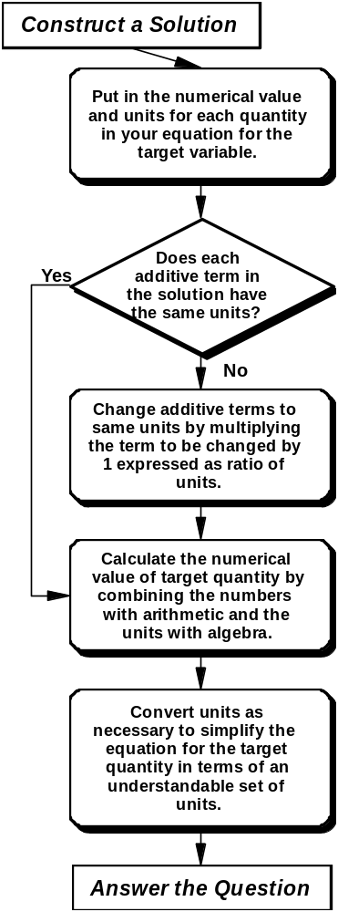 | Questions and Actions  • What values (numbers with units) from your list of known quantities should be put into the equation for the target quantity?  • Do we need to convert units?  • What ratio of units equals 1? 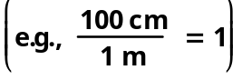  • Use a calculator for the numbers and algebra for the units.  • Do any units cancel?  • Do we need to convert any units?  • What is the most reasonable set of consistent units for this problem?  • Does the quantity we have calculated answer the question?

Footnotes

Redish, E. F. (2003). Teaching Physics With the Physics Suite, NJ: John Wiley and Sons
Schoenfeld, A. H. (1985). Mathematical problem Solving, Academic Press.
Heller, P., Keith, R., & Anderson, S. (1992). Teaching problem solving through cooperative grouping. Part 1: Group versus individual problem solving. American Journal of Physics, 60, 627-636.
Heller, P., & Hollabaugh, M. (1992). Teaching problem solving through cooperative grouping. Part 2: Designing problems and structuring groups. American Journal of Physics, 60, 637-644.
Johnson, D. W. and Johnson, R. T. (1989). Cooperation and Competition: Theory and Research, Edina, MN: Interaction.

