Introduction

The most effective teaching methods to use depend on the specific goals of a course, the strengths of the instructor(s) and the needs of the students, bound by the constraints imposed by the situation (for example, the number of students in the introductory courses, the number of graduate-teaching assistants available, the size of the lecture rooms, the size of the laboratory rooms, and so on). There is no known "best" way to teach. Cooperative Problem Solving is one technique that fits the goal (for students learn physics through problem solving) and constraints for the introductory physics courses at the University of Minnesota (UMn). It is not the "magic bullet" that, by itself, will assure that all of your students learn the content of introductory physics. It is, however, based on a solid research foundation from cognitive psychology, education, and physics education. We have over 15 years of experience testing and refining Cooperative Problem Solving by many professors with thousands of students.

Our Laws of Education

To guide the actual implementation of the UMn course design, we have invented, only half seriously, four "Laws of Education" in analogy with the "Laws of Thermodynamics." In the same spirit as classical thermodynamics, these "laws" describe robust empirical observations that are based on the current state of knowledge of human behavior. The overriding principle of human behavior addressed by the laws is that most human beings do not like to change their behavior. As with thermodynamics, our “laws” are statistical in nature -- you will certainly know of specific counter examples.

The Laws of Education are described below.

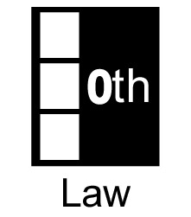 | If you don't grade it, students won't do it.  It would be wonderful if we lived in a world in which all students were intrinsically motivated to learn new things, and our physics class was the only class students were taking. But it just isn’t so. Humans expend the minimum energy necessary to survive. Students expend the minimum energy necessary to get a “good” grade.
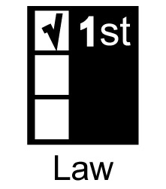 | Doing something once is not enough.  From the beginning of human civilization, most effective way for humans to learn any complex skill (like hunting or problem solving) is apprenticeship. A key feature of apprenticeship is repeated, coaching of the apprentice (student) by an expert or master (the instructor) while students are engaged in solving problems.
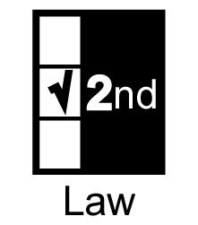 | Don't change course in midstream.  Humans are very resistant to change. It is easier on both instructors and students to start with what may seem a rigid structure (e.g., roles for working in groups, a problem-solving framework, answer sheets), then fade slowly as the structure is no longer needed. It is almost impossible to impose a different or more structured procedure in the middle of the course, after you discover that students need the structure.
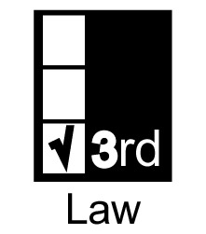 | Make what you want students to do easier than what you don't want them to do.  Humans are very resistant to change. They will persist in a behavior until it is no longer viable for survival. Students will persist in their novice plug-and-chug or pattern matching problem solving strategies if it is possible to survive the course (get a decent grade) with these strategies.

Learning physics through problem solving is a difficult, time consuming, and frustrating process -- like climbing a steep mountain. Most students either give up (drop the course) or try to run around this mountain by using their novice problem-solving strategies. So a course structure must include scaffolding (ladders) that help students learn how to solve problem solving and barriers (fences) to keep students form succeeding using their novice strategies

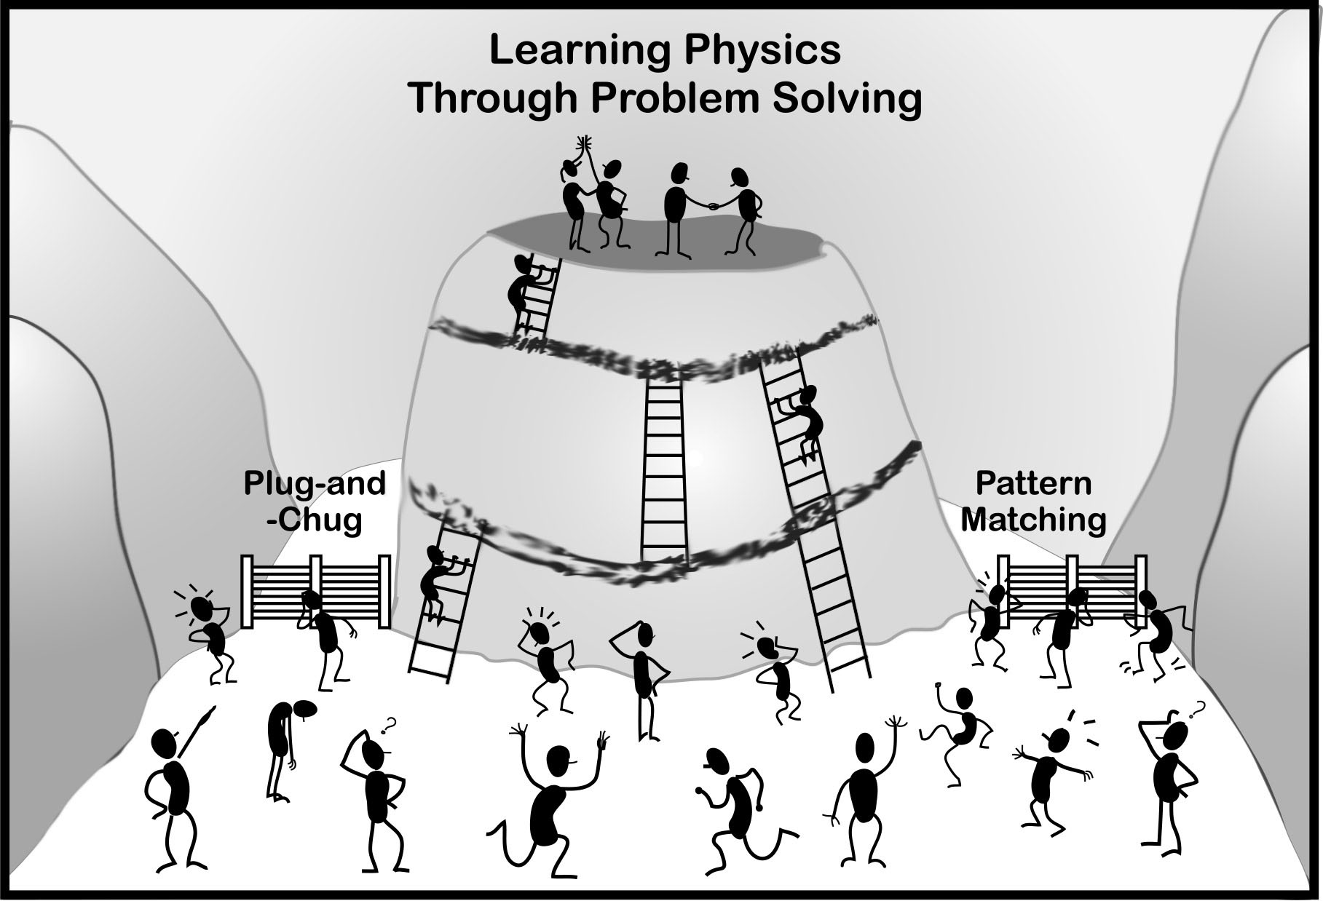

How To Use This Book
We have tried to write this handbook so that you can jump in anywhere that addresses an issue of interest to you. For that reason, there are frequent references to other chapters or sections. There is also some repetition to facilitate this type of random-access reading.


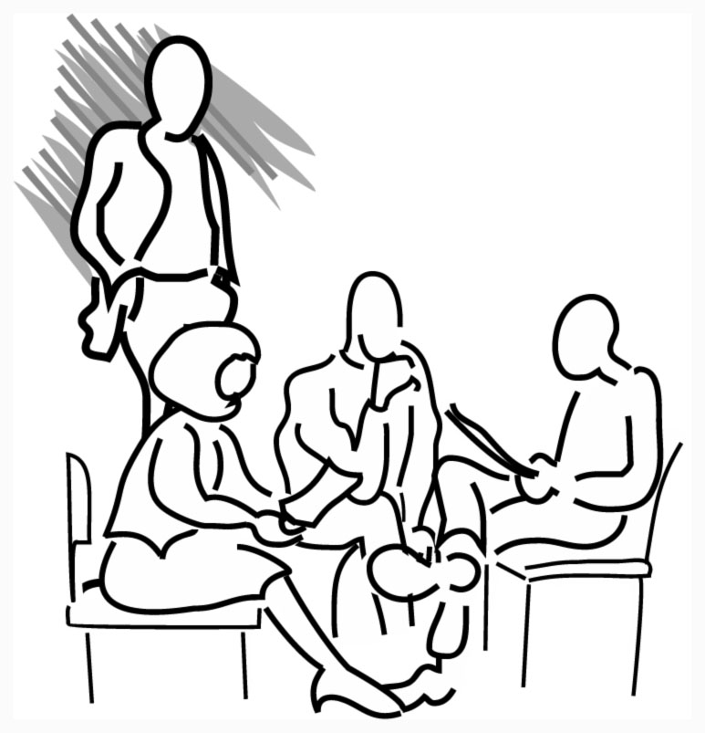
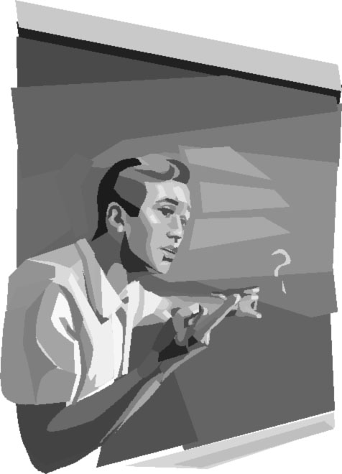
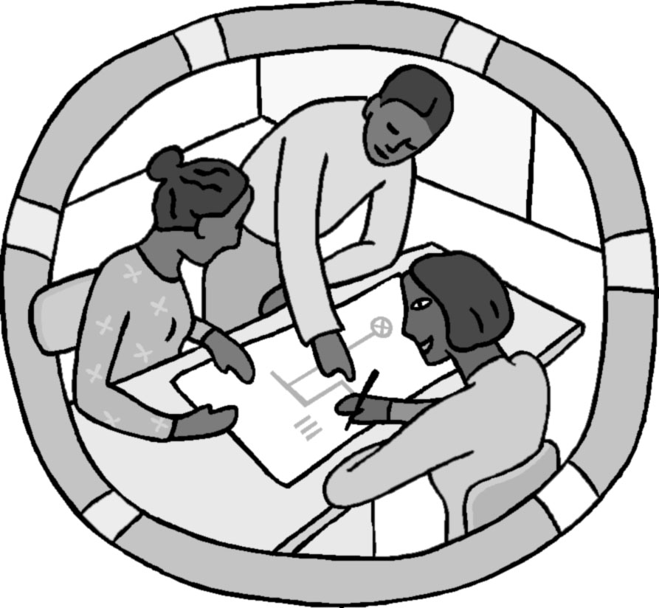

Chapter 1

Your Teaching
Responsibilities

Page
I. A Description of Specific Duties 3
II. Using Your Mentor TAs 9

I. Description of Specific Duties

Most teaching assistants (TAs) will be assigned to a teaching team responsible for one of the introductory physics courses. Your most likely assignment is the first term of the calculus-based course for scientists and engineers (Physics 1301) since this course serves the most undergraduates. A teaching team typically consists of one faculty member and 8 - 9 TAs. This team is responsible for all aspects of the course for about 200 undergraduates.

If you have a 25% appointment, you will be teaching one discussion session and one lab, with the same students (less than 20) in your discussion session and your lab. If you have a 50% appointment, you will be teaching two discussion sessions and two labs, with two sets of students. Discussion sessions meet for 50 minutes on Thursdays, and labs meet throughout the week for 2 hours at a time.

Failure to fulfill your TA duties could result in a loss of fellowship.

Team Organization Meetings
Each week, the TAs and professor will meet as a team to discuss their course. This is the opportunity to discuss the mechanics of the course (e.g., who will grade what, who will proctor, etc.). However, the most important reason for the meetings is the communication between the different members of the teaching team. Important issues for this feedback are:
• The professor describing what is going on in lecture and why.
• Discussion about what to emphasize in the next discussion and lab sessions.
• Trading information and analyzing what students understand and do not understand. Since there can be a large diversity between the different discussion and lab sections, each TA should discuss and compare their section with other sections. This information is an invaluable input for the professor(s), who do not have the close contact with students that you do.
Attendance at these meetings is mandatory. If you inadvertently miss a meeting, be sure to call or e-mail your professor right away.

TA Seminar
All new TAs are required to take the course "Teaching Introductory College Physics (CI: Curriculum and Instruction 5540)" in both Fall and Spring semesters. In the seminar, you will become familiar with the equipment and procedures for the next labs you will teach (part of your lab preparation time). Instructors will also help you to become more comfortable with the decisions you need to make before and during your teaching. The fall semester seminar has one credit; the spring semester seminar has two credits because it includes the scores of TA summer orientation.

Preparation for Laboratory
You will have new lab problems to teach every week. You should become very familiar with the equipment, and consult the Instructor's Lab Manual and experienced TAs to find what might go wrong with it or what kinds of mistakes students might make. If you can, it is a good idea to observe someone else's lab session before you teach yours. With your team, select which Lab problems have priority.
• Your team should decide during each weekly team meeting which lab problems your students will solve the following week.
• You need to solve the assigned lab problems by answering the Method Questions. In the team meetings (and some seminars), you will discuss difficulties that students have had with the physics principles they need to solve the lab problem.
• Students will solve computer laboratory preparation quizzes before each new Lab. You will be shown how to use a program to check whether your students have successfully passed the quiz before they get to lab. You should go through these questions before your students do, because some of your students might ask questions about them.
- Have a goal (learning focus) for each Lab session, something you want your students to learn. This should be decided in your team meetings after discussion with the professor and other TAs. See page85 for how to prepare for a lab session.

Teaching Laboratory Sections
Make sure you get to your laboratory room at least 5 – 10 minutes before class starts, and do not let the students enter until you are ready. Use this time alone to check the lab equipment to make sure it is all there, neatly arranged, and in working order. If you are teaching a computer lab, you should check to make sure the computers are working properly. Any other quiet time can be used to make final preparations. Make sure the door is locked and the lab is in order before you leave.

If you are late for your lab, be sure to call Mette Marie Stewart, 624-7375.

Preparation for Discussion Sections
• Solve the group problem students will solve in discussion section. Discuss with your team the parts of the qualitative analysis of the problem that you expect will be difficult for the students.
• Look at the syllabus and homework problems assigned for the week. Be prepared to tell your students which homework problems are similar to the group problem.
• In some sections, you may be asked to work with other TAs to design or write a group problem. You will present the first draft of your problem to your team for critique, and may be asked to write a second draft. This will occur once or twice a semester.
• In some sections, you may be asked to choose the material for the discussion sections for some of the weeks. You may want to pool your skills and ideas with other members of your team, either during your team meeting or outside of it.
• Occasionally, a problem is selected that is inappropriate for a group problem (e.g., one- step problems). Be prepared to modify the problem slightly so it will work with a group.

Refer to information about planning a discussion session on page 101.
Teaching Discussion Sections
Try to get to your assigned classroom several minutes early (before your students. You may need to tidy the classroom, clean the blackboard, rearrange the chairs (see Fig.1 and 2 on Page 34), and/or write on the blackboard (see page 97).
Well before the first class, check out the room to see if it is appropriate for a discussion section. If it is not appropriate, tell the undergrad office and they will try to get it changed.

If you are late for your discussion section, be sure to call Mette Marie Stewart, 624-7375.

Office Hours/Tutoring
Office hours will be held in Physics 230. This is your chance to interact one-on-one with students, and it is your students' chance to get some personal tutoring. You will have one office hour a week for each of your sections (i.e., one office hour/week for 25% appointment and two office hours/week for a 50% appointment). During office hours, you must wear a name tag. Refer to page 129 for more information about office hours.

Meeting with Your Mentor TA
You will each have a half hour appointment with your mentor TA twice in the semester. These meetings are to provide you with coaching to become better teachers. You might ask about problems with your students, difficulties in grading, classroom management, course organization, or other questions or problems you may have. You will also discuss other things that your mentor may have noticed in your section. Feel free to bring up anything else that relates to being a TA.

Attending the All-TA Meeting
Every other week the mentor TAs will convene a lunchtime, All-TA Meeting for the TAs of the introductory physics courses. These meetings will include an informal time to talk about teaching plus some time for a more formal discussion on how to handle difficult situations (such as cheating) and how to teach physics that has been difficult for students in the past. Since this meeting is optional, lunch will be provided by the Physics Department.

Grading Labs
You will grade written lab reports at least four times during the semester. As with all grading, prompt feedback to the students is essential. Discuss the grading policy (e.g. how many points each lab report has, the criteria to decide points) in the first team meeting because every TA in your team must have the same policy. Be sure to return graded lab reports within a week, unless otherwise specified by the professor, so that students can use the feedback to get help.

You will also collect and grade your students’ answers to the Method Questions for the next lab session you will teach (see page 71). These are useful to gauge your students’ understanding of the material of the lab.
Grading Homework
Different teams will make different decisions about how homework will be collected and graded. Whatever scheme you decide to use cannot take much of your time. Be sure to grade and return homework as soon as possible, so that students can use the feedback to get help. Be sure to return graded labs within a week, unless otherwise specified by the professor, so that students can use the feedback to get help.

Grading Tests
• At this time, the estimate for how much time it takes to grade a difficult problem is as follows:
On average, each TA will grade 3 such questions each semester, plus one group problem (about 70 problems). This should average to less than 3 hours/week. In your team meetings you will arrange which TAs will grade which problems.
• After you spend the time classifying a subset of tests, it is estimated that a quiz problem will take, on the average, 3 minutes to grade. Obviously some student solutions will be extremely convoluted and some will be blank (see the details of grading on page 132).
• After you have completed the grading, you will enter the grades into the computer (see Electronic Submission of Grades on page 135).
• Grading should be completed and scores should be entered into the computer as soon as possible. It is important the students receive prompt feedback on all graded assignments.

Proctoring
You will all be asked to proctor the tests for your course. While proctoring, you are responsible for answering student questions and deterring cheating. The schedule for proctoring will be discussed in your team meetings. Make sure to get spare pencils and calculators from room 148 when you pick up a test. Refer to page 130 for more information.

Miscellaneous
If you get a chance, it is highly recommended that you go to lectures. It is a good opportunity to see exactly what material is being covered or how it is being presented. It also shows the students that you think lectures are important.

Final Exams and Lab Grades
Each TA will probably grade one or two final exam problems that will take about 11 hours each. This grading will occur, in most cases, after your last final exam so make sure that you plan enough time at the end of the semester. Keep the record of your students’ grades through out the semester and make a backup of the grade periodically.
Average Time/Week During the 14-week Semester

Often, TAs want to know about how much time they should be spending on different duties. Your average weekly load during the 14 weeks of class for a 50% appointment should be approximately that listed below.

Contact with Students:
2 Discussion Sections 2.0 hrs
2 Laboratory Sections 4.0 hrs
Office Hours 2.0 hrs
8.0 hrs

Preparation:
Laboratory 1.0 hrs
Discussion 1.0 hrs Teams will decide how to
Team Meeting 1.0 hrs structure this between team
TA Seminar 1.0 hrs meetings and individual prep.
4.0 hrs

Proctoring, Grading and Entering Grades:
Labs 2.5 hrs (average)
Tests and Homework 4.0 hrs (average)
6.5 hrs

Feedback and Support:
Meet with Mentor TA 0.5 hrs
All - TA meeting 0.5 hrs (optional)
0.5 hrs

Miscellaneous: 1.0 hrs
(dealing with the front office, helping
students outside of office hours, etc.)

TOTAL 20.0 hrs/week*

* The University does not recognize the time between terms as holidays. Although the Physics Department typically does not assign TA duties after final exam grades are recorded, this time must be counted to compute your actual average hours worked per week.

II. Using Your Mentor TAs

Your mentor TAs each work 10 to 20 hours a week to help you improve the skills you need to become a better TA, which will ultimately improve the undergraduate education in the physics department.

Specifically, the duties of the mentor TAs are to:
• Be active instructors in the TA orientation in August.
• Co-teach the TA Seminar in the Fall and Spring, including the following topics:
- lab preparation;
- grading exams and homework;
- alternative conceptions your students may have;
- effective coaching of problem solving;
- difficult students; and
- your issues and ideas about teaching.
• Visit several of your labs and discussion sessions to:
- observe your teaching techniques;
- help you with intervening in groups; and
- give you feedback and answer questions about your teaching.
• Report any inappropriate behavior (i.e. behavior that is harmful to students) to the director of undergraduate studies.
• Make recommendations for the TA award given at the end of the year.

If you ask them to, the mentor TAs will also:
• be resources for you in the physics department.
• serve as an anonymous conduit of your concerns to an individual professor or the department.
• help you find information in the education literature.
• help you write your lesson plans.
• help you find and practice with the laboratory equipment.
• advise you on grading, writing cooperative group problems, interacting with professors, and forming new groups.
• write teaching letters of recommendation.
• be willing to discuss the graduate school experience (both good and bad.)

Remember, like any instructional relationship, the mentor TA can provide you with ideas and suggestions, but the only impetus to improve your teaching lies within you.

