In the first laboratory, you studied the behavior of electric fields and their effect on the motion of electrons using a cathode ray tube (CRT). This beam of electrons is one example of an electric current – charges in motion. The current in the CRT was simple in that the electrons moved through a vacuum. The forces on them were completely known. Their behavior could be determined by calculating the electric field and then applying kinematics.

In contrast to the CRT, the most familiar electric currents are inside materials such as wires or light bulbs. Even though the interactions of electrons inside materials are quite complicated, the basic principles of physics still apply. Conservation of energy and charge allow us to determine the overall behavior of electric currents without the need to know the details of the electrons’ interactions. This approach to problem solving, in the ubiquitous realm of electric circuits, will give you more experience in applying the very useful principles of conservation.

Objectives

After successfully completing this laboratory, you should be able to:
- Apply the concepts of circuits to electrical systems.
- Apply the concept of conservation of charge to determine the behavior of the electrical current through any part of a circuit.
- Apply the concept of conservation of energy to determine the behavior of the energy output of any element in a circuit.
- Use the concept of electric potential to describe the behavior of a circuit.
- Relate the electric charge on a circuit element to the potential difference across that element and the capacitance of that element.
- Relate the electric current through a circuit element to the resistance of that element and potential difference across that element.
- Measure the current through a circuit element with a digital multimeter (DMM).
- Measure the voltage between two points in a circuit with a DMM.
- Measure the resistance of a circuit element with a DMM.

Preparation

Read Fishbane: Chapter 24 section 1; Chapter 25, sections 1, 2, 4; Chapter 26,27. It is likely that you will be doing these laboratory problems before your lecturer addresses this material. The purpose of this laboratory is to give you these experiences as an introduction to the material. So, it is very important that, when you read the text before coming to lab, you remember the objectives of the laboratory.

Before coming to lab you should be able to:
- Describe the relationship between charge and current.
- Describe the relationship between potential and potential energy.
- Describe the essential difference between an insulator and a conductor.
- Identify what is an electrical circuit and what is not.
- Apply conservation of energy and conservation of charge to current flowing around a circuit.
- Write down Ohm's law and know when to apply it.
- Describe the difference between a capacitor, a resistor, and a battery.
- Use a DMM to measure potential difference, current, and resistance.

exploratory PROBLEM #1
simple circuits

You need more light in your workroom, so you decide to add another light fixture to your track lighting. However, you are concerned that adding another light may dim the lights that are already in the track. When you proceed with the addition of another light, you notice that none of the lights are dimmer than before. You wonder what type of circuit your track lighting uses. You decide to build models of circuits with two bulbs connected across a battery, and to compare the brightness of the bulbs in these circuits to a reference circuit with a single bulb. The circuit in which each bulb is as bright as the one in your reference circuit is the same type as the circuit in your track lighting.

Equipment

You will build three simple circuits shown below out of wires, bulbs, and batteries.  Use the accompanying legend to build the circuits. | 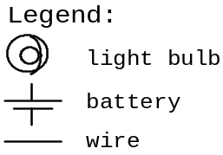
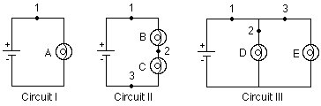

Note: Some of the light bulbs in the lab may be of different kinds and have different resistances. To find identical light bulbs look for markings and check to see that the color of the plastic bead separating the filament wires is the same.

Prediction

Restate the problem. Rank, in order of brightness, the bulbs A, B, C, D, and E from the brightest to the dimmest (use the symbol ‘=’ for "same brightness as" and the symbol ‘ >’ for "brighter than"). Write down your reasoning.

Exploration

Reference Circuit I
Connect Circuit I to use as a reference. Observe the brightness of bulb A. Replace the bulb with another one and again observe the brightness. Repeat until you have determined the brightness of all your bulbs when they are connected into the same type of circuit. If the bulbs are identical, they should have the same brightness.

Note: Pay attention to large differences you may observe, rather than minor differences that may occur if two "identical" bulbs are, in fact, not quite identical. How can you test whether minor differences are due to manufacturing irregularities?

Circuit II
Connect Circuit II. Compare the brightness of bulbs B and C. What can you conclude from this observation about the amount of current through each bulb?
Is current "used up" in the first bulb, or is the current the same through both bulbs? Try switching bulbs B and C. Based on your observation, what can you infer about the current at points 1, 2, and 3?

How does the brightness of bulb A (Circuit I) compare to the brightness of bulbs B and C (Circuit II)? What can you infer about the current at point 1 in each of the two circuits?

Circuit III
Connect Circuit III. Compare the brightness of bulbs D and E. What can you conclude from this observation about the amount of current through each bulb?

Describe the flow of current around the entire circuit. What do your observations suggest about the way the current through the battery divides and recombines at junctions where the circuit splits into two branches? How does the current at point 1 compare with the currents at points 2 and 3?

How does the brightness of bulb A (Circuit I) compare to the brightness of bulbs D and E (Circuit III)? What can you infer about the current at point 1 in each of the two circuits?

Comparing the three circuits, does the amount of current at point 1 appear to remain constant or to depend on the number of bulbs and how they are connected?

Conclusions

Rank the actual brightness of the bulbs. How did this compare to your prediction? Make sure you adequately describe what you mean in your comparisons, i.e. “the same brightness as”, “brighter than”, “dimmer than”. What type of circuit is used in your track lighting? Circuit II is called a series circuit and Circuit III is called a parallel circuit.

Can you use conservation of energy and conservation of current to explain your results? The rate that energy is output from a bulb is equal to the potential difference (voltage) across the bulb times the current through the bulb. Does a battery supply a constant current or a constant potential difference to circuits?

To check your understanding, rank the brightness of the bulbs in the following circuits.

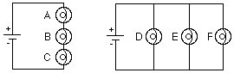

Use the lab equipment to see if your answer is correct.
exploratory PROBLEM #2
More complex circuits

It is the holiday season once again so you have decided to put up your decorations. You have three strings of decorative lights and only one electrical outlet between the tree and your doorway. To have enough lights to cover the tree, you will need to connect two of your light strings together end to end. The other set of lights will be enough to light up your doorway. You know that you have a few ways of connecting the lights. You want to hook up the lights so they are all as bright as possible. In order to determine which arrangement gives the most light before making your final decorating plans, you build a reference circuit and a model of the possible ways of connecting the sets of lights. In your model one light bulb represents a light string.

Equipment

You will build four simple circuits shown below out of wires, bulbs, and batteries.

Use the accompanying legend to build the circuits.

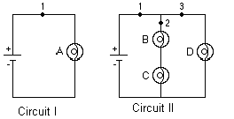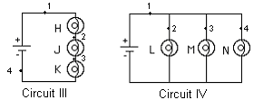

Note: Some of the light bulbs in the lab may be of different kinds and have different resistances. To find identical light bulbs look for markings and check to see that the color of the plastic bead separating the filament wires is the same.

Prediction

Restate the problem. Rank the brightness of the bulbs A, B, C, D, H, J, K, L, M, and N from the brightest to the dimmest (use the symbol ‘=’ for "same brightness as" and the symbol ‘>’ for "brighter than"). Write down your reasoning.

Exploration

It is important to measure voltages of the batteries that you will be using to verify that they are the same before experiments.

Reference Circuit I.
Connect Circuit I to use as a reference.
Note: Pay attention to large differences you may observe, rather than minor differences that may occur if two "identical" bulbs are, in fact, not identical. How can you test whether minor differences are due to manufacturing irregularities?

Circuit II
Connect Circuit II. Compare the brightness of bulbs B and C. Compare the brightness of bulbs B and C to bulb D. What can you conclude from this observation about the amount of current through each bulb?

How does the brightness of bulbs B and C compare to the brightness of bulb A (Circuit I)? What can you infer about the current at point 2 in Circuit II and the current at point 1 in Circuit I?

How does the brightness of bulb D compare to the brightness of bulb A (Circuit I)? What can you infer about the current at point 3 in Circuit II and the current at point 1 in Circuit I?

Describe the flow of current around the entire circuit. What do your observations suggest about the way the current through the battery divides and recombines at junctions where the circuit splits into two parallel branches? How does the current at point 1 in Circuit II compare with the current at point 1 in Circuit I? Explain any differences.

Circuit III.
Connect Circuit III. Compare the brightness of the bulbs. What can you conclude from this observation about the amount of current through each bulb?

How does the brightness of bulb H compare to the brightness of bulb A (Circuit I)? What can you infer about the current at point 1 in Circuit III and the current at point 1 in Circuit I?

Circuit IV.
Connect Circuit IV. Compare the brightness of the bulbs. What can you conclude from this observation about the amount of current through each bulb?

How does the brightness of bulb L compare to the brightness of bulb A (Circuit I)? What can you infer about the current at point 1 in Circuit IV and the current at point 1 in Circuit I?

Conclusions

Rank the actual brightness of the bulbs A, B, C, D, H, J, K, L, M and N. Make sure you have adequately defined your comparisons: “same brightness as”, “brighter than”, and “dimmer than”. How did your prediction compare to your results? Can you use conservation of energy and conservation of current to explain your results?

How will you connect your three strings of lights so that they are all as bright as possible?

Exploratory PROBLEM #3
Short circuits

A friend of yours who manages a movie theater is having a problem with the lights that surround the marquee. Some of the light bulbs don’t light up. But when he takes out the bulbs and checks them individually, they all work. You tell him he must have a short circuit. You explain that you have a short circuit when a wire makes an alternate path for the current to bypass a circuit element. To demonstrate this idea, you build a few simple circuits to show the results of a short circuit.

Equipment

You will build three simple circuits shown below out of wires, bulbs, and batteries.

Use the accompanying legend to build the circuits.
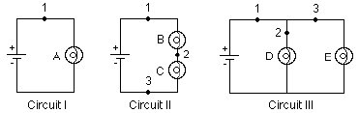
Note: Some of the light bulbs in the lab may be of different kinds and have different resistances. To find identical light bulbs look for markings and check to see that the color of the plastic bead separating the filament wires is the same.

Prediction

Restate the problem.
Circuit II: What happens to the brightness of bulbs B and C when a wire is attached across bulb B (from point 1 to point 2)?

Circuit III: What happens to the brightness of bulbs D and E when a wire is attached across bulb E?

Circuit I: What happens to the brightness of the bulb A when a wire is attached across the bulb?

Exploration

 | WARNING: A short circuit is what happens any time a very low-resistance path (like a wire, or other piece of metal) is provided between points in a circuit that are at different potentials, like the terminals of a battery or power supply. Short circuits can destroy equipment and injure people! Always avoid short circuits in other circuits! Short circuits damage equipment by causing larger currents in a circuit than they are designed for. These currents can cause great heat and damage to nearby circuit elements or measuring devices. Any short circuits suggested in this manual have been tested, and determined not to significantly damage the equipment.

Build Circuit II. What happens to the brightness of bulbs B and C when you place a wire across bulb B? How did the current through C change? How did the current through B change? Did the current through point 1 change? If so, in what way? Did the wire across bulb B get warmer? Explain your answers.

Build Circuit III. What happens to the brightness of bulbs D and E when you place a wire across bulb E? Did the current through D change? Did the current through E change? Did the wire across bulb E get warm? What would be the brightness of a bulb inserted in the circuit at point 1? Explain your answers.

Build Circuit I. Place a wire across the bulb. What happens to the brightness of the bulb? Hold on to the wire that is across the bulb. Is it getting warmer? How did the current through the bulb change? The current coming out of the battery? Make sure you disconnect the battery when you are done.

Placing the wire across the bulb causes a short circuit and it is called "shorting out" the bulb.

Conclusions

Did your predictions match your observed results? What have you learned from experiments, which agreed with your predictions? Draw more conclusions based on the experiments where your predictions were different from what you observed.

PROBLEM #4
cHARGING A CAPACITOR (Part A)

You have designed a circuit using a battery and a capacitor to automatically dim the lights for a theatrical production. However, the lighting consists of many different kinds of bulbs, which have been manufactured differently, and which consequently have very different resistances. You need to be able to precisely control the rate at which the lights dim, so you need to determine how this rate depends on both the capacitance of the capacitor and the resistance of the bulb. You decide to model this situation using a circuit consisting of a battery, a capacitor (initially uncharged), and a resistor, all in series. You will try to ascertain how the current in the circuit changes with time.

Equipment

Build the circuit shown below using wires, resistors, capacitors, and batteries. Use the accompanying legend to help you build the circuits. You will also have a stopwatch and a digital multimeter (DMM).
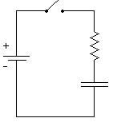  Circuit VIII | 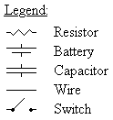

Prediction

When the circuit is closed, with the capacitor initially uncharged, how does the current in the circuit change with time? How long does it take for the current to fall to zero?
Sketch a graph of current against time for this circuit, assuming the capacitor is initially uncharged.

Warm-up Questions

Read: Fishbane Section 27-5.

1. Draw a circuit diagram, similar to the one shown above. Decide on the properties of each of the elements of the circuit that are relevant to the problem, and label them on your diagram. Label the potential difference across each of the elements of the circuit. Label the current in the circuit and the charge on the capacitor.

2. Use energy conservation to write an equation relating the potential differences across all elements of the circuit. Write an equation relating the potential difference across the capacitor plates and the charge stored on its plates. What is the relationship between the current through the resistor and the voltage across it? Are these three equations always true, or only for specific times?
3. Describe qualitatively how each quantity labeled on your diagram changes with time. What is the voltage across each element of the circuit (a) at the instant the circuit is closed; (b) when the capacitor is fully charged? What is the current in the circuit at these two times? What is the charge on the capacitor plates at these two times?

4. From the equations you constructed above, determine an equation relating the voltage of the battery, the capacitance of the capacitor, the resistance of the resistor, the current through the circuit, and the charge stored on the capacitor plates.

5. Write an equation relating the rate of charge accumulation on the capacitor plates to the current through the circuit.

6. Use the equations you have written to get a single equation that relates the current and the rate of change of current to the known properties of each circuit element. To do this, you may find it helpful to differentiate one of your equations.

7. Solve the equation from step 6 by using one of the following techniques: (a) Guess the current as a function of time, which satisfies the equation, and check it by substituting your current function into your equation; (b) Get all the terms involving current on one side of the equation and time on the other side and solve. Solving the equation may require an integral.

8. Complete your solution by determining any arbitrary constants in your solution, using the initial value of the current you obtained in question 3.

Exploration

WARNING: A charged capacitor can discharge quickly producing a painful spark. Do not handle the capacitors by their electrical terminals or connected wires by their metal ends. Always discharge a capacitor when you are finished using it.

If you have not used the digital multimeter (DMM), read the relevant section of Appendix D, and get familiar with its different operations.

Examine each element of the circuit before you build it. How do you know if the battery is "good"? Is the capacitor charged? Carefully connect the two terminals of the capacitor to ensure it is uncharged. How can you determine the resistance of your resistor? Is there a way to confirm it?

Once you are convinced that all of the elements are working and that the capacitor is uncharged, read the note below and start building Circuit VIII. Leave the built circuit open until you begin your experiment.

NOTE: Be sure that the polarity of the capacitor’s connection is correct — that the part of the circuit connected to the battery’s “+” terminal is connected to the capacitor’s “+” terminal, and the part of the circuit connected to the battery’s “–“ terminal is connected to the capacitor’s “–“ terminal. Reversing the polarity would irreversibly change the capacitor’s capacitance.

Close the circuit and observe how the brightness of the bulb changes with time. What can you infer about the way the current in the circuit changes with time? From what you know about a battery, how does the potential difference (voltage) across the battery change over time? Check this using the DMM set for potential difference (Volts). From your observations of the brightness of the bulb, how does the potential difference across the bulb change over time? Check this using the DMM. What can you infer about the change of voltage across the capacitor over time? Can you check with a DMM? Use the concept of potential difference to explain what you observe.

Now, discharge the capacitor, and reconnect the DMM in such a way that it measures the current in the circuit. Close the circuit and observe how the current changes with time? Is it as you expected? How long does it take for the current to fall to zero?

Replace the light bulb with a resistor. Qualitatively, how will changing the resistance of the resistor and the capacitance of the capacitor affect the way the current in the circuit changes with time? How can you test this experimentally?
Choose a suitable capacitor and resistor combination that allows you to easily and accurately measure how the current changes with time. How many measurements will you need to make? What time interval between measurements will you choose?

Complete your measurement plan.

Measurement

Measure the current flowing through the circuit for as many times as you deem necessary. Make your measurements using a resistor, not a bulb. What are the uncertainties in each of these measurements?

Analysis

Use your measured values for the resistance of the resistor, the capacitance of the capacitor, and the voltage of the battery, along with your prediction equation, to construct a graph of your predicted current against time.

Make a graph of the measured current flowing through the circuit against time.

Compare these two graphs, noting any similarities and explaining any differences.

Conclusions

Describe which of your predictions were confirmed by experiments and draw conclusions accordingly. To continue conclusions, explain what was incorrect in those of your predictions that your laboratory observations or measurements did not support (or what went wrong with the experiment that failed to verify your prediction). Finally, use theory and your experimental results from this problem to answer the following question: Does the current in the circuit change linearly with time?

PROBLEM #5
circuits with two capacitors

You are modifying the design of a sturdy, low-cost beeper to be used as a safety device on children’s bicycles. The sound-producing component of the beeper is will not pass current or make noise until after the potential difference across it reaches a certain value. This component is connected in parallel to the capacitor in an RC circuit. When the threshold voltage is reached, the capacitor discharges through the sound-producing component, and then begins to charge again. The time between beeps is thus determined by the time it takes for the capacitor to charge to a certain value. You wish to shorten the amount of time between beeps and decide to modify the capacitance. You don’t want to buy new capacitors because the original ones are extremely cheap and reliable. You decide to use two of the original capacitors for each beeper. There are at least two different ways to arrange the capacitors in the circuit: in series with each other, or in parallel. How would you arrange the capacitors in order to reduce the time between beeps? In order to understand the quantitative behavior of each circuit, you decide to make some measurements on the circuits with the sound emitter removed.

Equipment

You will build the circuits shown below out of wires, resistors, 2 uncharged capacitors of equal capacitances, and a battery. To visualize the presence of electric current in the circuits, you will replace resistors with light bulbs. (Note, however, that you cannot fairly compare capacitances in the circuits unless the bulbs are identical. Using the same bulb in all circuits is a possible way to ensure that.) You will have a stopwatch and a digital multimeter (DMM) for measurements.
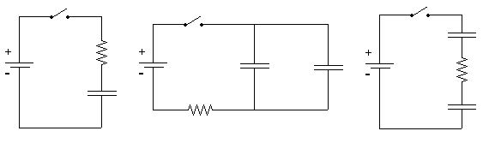
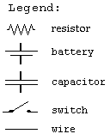

Circuit IX Circuit X Circuit XI

Prediction

For each of Circuits IX, X, and XI, draw a graph to qualitatively describe the current through the resistor (or the light bulb) as a function of time after the switch is closed, if the capacitors are initially uncharged. Compare the times it will take for light bulbs to go off in each circuit. For the comparison to be fair, do you think it is important that in each circuit
- The resistances of light bulbs are the same, and
- The light bulb is connected in series with the battery?
Having made necessary assumptions for a fair comparison, rank Circuits IX, X, and XI by the time it will take for the bulbs to go off.

Warm-up Questions

Read: Fishbane, Sections 25-4 and 27-5.

1. For each of the circuits, draw a circuit diagram, similar to those shown above. Decide on the properties of each of the elements of the circuit that are relevant to the problem, and label them on your diagram. Label the potential difference across each of the elements of the circuit. Label the current in the circuit and the charge on each capacitor. What is the relationship between the charges on the two capacitors of Circuit X? What about the two capacitors of Circuit XI? Under what conditions will the bulb go out?

2. Write an equation relating the potential difference across each of the elements of the circuit. What is the relationship between the potential difference across the plates of each capacitor and the charge stored on its plates? What is the relationship between the current through a resistor (in the place of each bulb) and the voltage across it? Are these equations always true, or only for specific times?

3. Explain how each of the quantities labeled on your diagram changes with time. What is the voltage across each of the elements of the circuit (a) at the instant the circuit is closed, (b) when the capacitor is fully charged? What is the current through the resistor at these two times? What is the charge on each of the capacitors at these two times?

4. From the equations you constructed above, determine an equation relating the voltage of the battery, the capacitance of each of the capacitors, the resistance of the resistor, the current through the resistor, and the charge stored on each of the capacitors.

5. Write an equation relating the rate of charge accumulation on the capacitor plates to the current through the circuit.

6. Use the equations you have written to get a single equation that relates the current and the rate of change of current to the known properties of each circuit element. To do this, you may find it helpful to differentiate one of your equations.

7. Solve the equation from step 6 by using one of the following techniques: (a) Guess the current as a function of time, which satisfies the equation, and check it; (b) Get all the terms involving current on one side of the equation and time on the other side and solve. Solving the equation may require an integral.

8. Complete your solution by determining any arbitrary constants in your solution, using the initial value of the current obtained above.
Repeat the above steps for the other two circuits.

Exploration

WARNING: A charged capacitor can discharge quickly producing a painful spark. Do not handle the capacitors by their electrical terminals or connected wires by their metal ends. Always discharge a capacitor before you use it and when you are finished using it. To discharge a capacitor, use an insulated wire to briefly connect one of the terminals to the other.

Review your exploration from Problem #4.

Before you start building a circuit, examine each element of it. How do you know if the battery is "good"? Are the capacitors charged? Carefully connect the two terminals of each capacitor to ensure it is uncharged. Make sure you that have two capacitors of the same capacitance.

NOTE: Be sure that the polarity of the capacitor’s connection is correct — that the part of the circuit connected to the battery’s “+” terminal is connected to the capacitor’s “+” terminal, and the part of the circuit connected to the battery’s “–“ terminal is connected to the capacitor’s “–“ terminal. Reversing the polarity would irreversibly change the capacitor’s capacitance.

Check that the polarity of the capacitor’s connection is correct and begin your observations by using bulbs instead of resistors.
Build Circuit IX, but do not close the switch. Do you think the bulb will light when the circuit is closed? Record your reasoning in your journal. Close the circuit. Record your observations and explain what you saw using conservation of charge and the concept of potential difference.

Build Circuit X, but do not close the switch. Do you think the bulb will light when the circuit is closed? Record your reasoning in your journal. Close the circuit. Record your observations and explain what you saw using conservation of charge and the concept of potential difference. Does it make a difference if you put the bulb in series with of one of the capacitors?

Build Circuit XI, but do not close the switch. Do you think the bulb will light when the circuit is closed? Record your reasoning in your journal. Close the circuit. Record your observations and explain what you saw using conservation of charge and the concept of potential difference. Does the order in which you connect the two capacitors and the bulb in the circuit matter? Try following one capacitor with the other capacitor and then the bulb.

Now, replace the light bulbs in your circuits with resistors. How can you determine the resistance of the resistor? Is there a way to confirm it? Connect a DMM in each of the circuits and observe how the current changes with time. For each circuit, decide how many measurements you will need to make in order to make a graph of current against time, and what time interval between measurements you will choose. Complete your measurement plan.

Measurement

Measure the current in each circuit for as many different times as you deem necessary. Make your measurements using resistors, not bulbs. What are the uncertainties in each of these measurements?

Analysis

Use your measurements to plot the (measured) values of current as a function of time for circuits IX, X, and XI.

Conclusions

How well did your graphs drawn from your data compare to those in your predictions? Explain any differences. How did your predicted rankings of the time each bulb would remain lit compare to your measurements? Explain any differences.
PROBLEM #6
CHARGING A CAPACITOR (PART B)

You are an electrical engineer working for a company designing ultrasonic bug-repellent devices. Your group has decided that in order to find the minimum power needed for the ultrasonic emitter to be effective, you should design a circuit in which the current to the emitter falls to half its initial value, then to half of that value, then to half again, all in equal time intervals. They will then observe the insects to see at what point they are no longer repelled. You tell your colleagues that a simple circuit consisting of a capacitor and a resistor in series will have this property. They are unconvinced, so you decide to demonstrate to them that the time required for the current in the circuit to decrease to half its value is independent of the time that you begin measuring the current. You build a circuit consisting of a battery, a capacitor (initially uncharged), and a resistor, all in series in order to demonstrate this property.

Equipment

Build the circuit shown below using wires, resistors, capacitors, and batteries. Use the accompanying legend to help you build the circuits. You will also have a stopwatch and a digital multimeter (DMM).
Circuit VIII

Prediction

In a circuit consisting of a battery, a capacitor (initially uncharged), and a resistor, all in series, calculate the dependence of the time it takes for the current to fall to half its initial value.

Sketch a graph of current against time for this circuit, assuming the capacitor is initially uncharged. Indicate on your graph the time taken for successive halving of the current in the circuit (the time at which the current is ½, ¼, ⅛ … of its initial value).

Warm-up Questions

Read: Fishbane, Sections 25-4 and 27-5.

1. If you have done Problem #4, you will already have the equation that describes the way in which the current in the circuit changes with time and depends upon the capacitance of the capacitor and the resistance of the resistor. If not, you should answer the warm-up questions in Problem #4.

2. Using your equation for the current, find the time taken for the current to fall to half its initial value. Now find the time taken for the current in the circuit to halve again, and so on. How does the time for the current to be cut in half depend on the amount of time after the circuit was closed?

Exploration

WARNING: A charged capacitor can discharge quickly producing a painful spark. Do not handle the capacitors by their electrical terminals or connected wires by their metal ends. Always discharge a capacitor before you use it and when you are finished using it. To discharge a capacitor, use an insulated wire to briefly connect one of the terminals to the other.

Before you build the circuit, examine each element of it. How do you know if the battery is "good"? Is the capacitor charged? Carefully connect the two terminals of the capacitor to ensure it is uncharged. How can you determine the resistance of the resistor? Is there a way to confirm it?

If you have completed Problem #4, review your exploration notes from your lab journal. If not, complete the exploration from Problem #4.

Build circuit VIII. To measure the current in the circuit, connect a DMM in series.

NOTE: Be sure that the polarity of the capacitor’s connection is correct — that the part of the circuit connected to the battery’s “+” terminal is connected to the capacitor’s “+” terminal, and the part of the circuit connected to the battery’s “–“ terminal is connected to the capacitor’s “–“ terminal. Reversing the polarity would irreversibly change the capacitor’s capacitance.

Check that the polarity of the capacitor’s connection is correct and begin your experiment. Close the circuit and observe how long it takes for the current in the circuit to halve. How does changing the capacitance of the capacitor or the resistance of the resistor affect this time? Choose a combination of a resistor and a capacitor that allows you to measure this time as accurately as possible. Observe how long it takes for the current in the circuit to successively halve in value. Is this as you had predicted?

Complete your measurement plan.

Measurement

Measure the time taken for the current in the circuit to successively halve in value. Make at least two measurements for each setup for averaging.

Analysis

Using the measured value of the capacitance of the capacitor, the resistance of the resistor, and the voltage of the battery, calculate the times for successive halving of the current in the circuit. These times are what theory predicts for your circuit. Compare them to the measured times, at which the current decreases to ½, ¼, ⅛ … of its initial value.

Conclusions

How well did your prediction agree with your results? Explain any differences.

Using these times for successive halving of the current, can you determine how long it would take for the current to fall to zero? Does this agree with your experimental evidence?

PROBLEM #7
CHARGING A CAPACITOR (PART C)

You have read on the internet that you can use a large capacitor to increase the bass volume in your car stereo. However, you know from physics that a charged capacitor will only provide current for a short time before it needs to be recharged. You decide to figure out how long it will take the capacitor to recharge as a function of the total resistance of the recharging circuit. You know that one way to quantify this time is to measure how long it takes for the charging current to fall to one half of its initial value. You decide to model this situation using a circuit consisting of a battery, a capacitor (initially uncharged), and a resistor, all in series.

Equipment

Build the circuit shown below using wires, resistors, capacitors, and batteries. Use the accompanying legend to help you build the circuits. You will also have a stopwatch and a digital multimeter (DMM).
Circuit VIII

Prediction

For a circuit consisting of a battery, a capacitor (initially uncharged), and a resistor, all in series, how does the time taken for the current in the circuit to fall to half its initial value depend on the resistance of the resistor.

Use your calculation to graph the time taken for the current to fall to half its initial value against the resistance of the resistor.

Warm-up Questions

Read: Fishbane, Sections 25-4 and 27-5.

1. If you have done Problem #4, you will already have the equation that describes the way in which the current in the circuit changes with time and depends upon the capacitance of the capacitor and the resistance of the resistor. If not, you should answer the warm-up questions in Problem #4.

2. Using your equation for the current, find the time taken for the current to fall to half its initial value. Sketch a graph of this time against the resistance of the resistor.

Exploration

WARNING: A charged capacitor can discharge quickly producing a painful spark. Do not handle the capacitors by their electrical terminals or connected wires by their metal ends. Always discharge a capacitor when you are finished using it.

Before you build the circuit, examine each element of it. How do you know if the battery is "good"? Is the capacitor charged? Carefully connect the two terminals of the capacitor to ensure it is uncharged. How can you determine the resistance of the resistor? Is there a way to confirm it?

If you have completed Problem #4, review your exploration notes from your lab journal. If not, complete the exploration from Problem #4.

NOTE: Be sure that the polarity of the capacitor’s connection is correct — that the part of the circuit connected to the battery’s “+” terminal is connected to the capacitor’s “+” terminal, and the part of the circuit connected to the battery’s “–“ terminal is connected to the capacitor’s “–“ terminal. Reversing the polarity would irreversibly change the capacitor’s capacitance.

Construct Circuit VIII, including a DMM in the circuit to measure the current. Check that the polarity of the capacitor’s connection is correct and begin your experiment.

Close the circuit and observe how long it takes for the current in the circuit to halve. How does changing the capacitance of the capacitor or the resistance of the resistor affect this time? Choose a capacitor and a range of resistances that allow you to effectively construct a graph and test your prediction. Complete your measurement plan.

Measurement

Measure the time taken for the current in the circuit to halve in value for different resistances in the circuit. Be sure to make at least two measurements for each resistor.

Analysis

Using the measured value of the capacitance of the capacitor, construct a graph showing how the time it takes the current to halve should depend on resistance in the circuit. This is based on the theory, as you use a formula. Now construct a graph of the measured times against resistance, using your experimental data.

Conclusions

Compare your prediction graph with your graph showing your data. Explain any differences.
How does the time taken for the current in the circuit to halve in value depend upon the resistance of the charging circuit? Does this time depend upon the voltage of the battery? If yes, then how?
What are possible sources of systematic uncertainty in this experiment (see Appendix B)? How do contributions to the systematic uncertainty from the equipment imperfections and from human error compare? Provide detailed explanations.
PROBLEM #8
Resistors and light bulbs

Your research team has built a device for monitoring the ozone content in the atmosphere to determine the extent of the ozone holes over the poles. You have been assigned the job of keeping the equipment at the South Pole running during the winter months when no supplies can get in. When a piece of equipment fails, you need to replace two resistors. Unfortunately you have only one. You do have a light bulb but wonder how well a light bulb can substitute for a resistor in the circuit. You decide to make a direct comparison.

Equipment

You will have wires, a power supply, a digital multimeter (DMM), a light bulb, and a resistor.

Predictions

Restate what elements of electric circuits (and by what criteria/parameters) you are to compare in this problem. Use your experience to draw a graph of voltage versus current for (a) a standard resistor, and (b) a light bulb. Explain your reasoning, including physical assumptions you have made.

Warm-up Questions

Read: Fishbane section 26-3.

1. What is the relationship between the current through a resistor and the potential difference (voltage) across the resistor if the resistor is made of ohmic material? Draw a graph of voltage versus current for this resistor. How is the slope of the graph related to its resistance?

2. As more current goes through a light bulb, it gets brighter. As it gets brighter, it gets hotter. Do you expect the increasing temperature to affect the resistance of the bulb? If so, how?

3. Sketch a qualitative graph of voltage across a light bulb versus current through the light bulb.

Exploration

WARNING: You will be working with a power supply that can generate large electric voltages. Improper use can cause painful burns. To avoid danger, the power must be turned OFF and you must wait at least one minute before any wires are disconnected from or connected to the power supply. Never grasp a wire by its metal end.

Sketch the circuit you will build to check your prediction. Can you test both the light bulb and the resistor at the same time? Is this a good idea?

Read Appendix D and become familiar with the different operations of the digital multimeter (DMM).

Measurement

There are three methods for determining the electrical resistance of a resistor.

1. Use the chart provided in the laboratory (and also in Appendix D) to determine the resistance of your resistor based on its color code. What is the uncertainty in this value?
2.Use the DMM set to ohms to measure the resistance of the resistor. What is the uncertainty in this value? Why is this procedure not helpful with a light bulb?
3. Use your power supply, DMM, and resistor to determine the voltage across the resistor and measure the current through the resistor for several different voltages. What is the uncertainty in the value of the resistance obtained by this method?

Analysis

Make a graph of voltage versus current for your resistor and light bulb. How do the values of the resistance compare for the different methods used?

Conclusions

Are the color-coded resistor and light bulb both ohmic resistors? If so, what are their resistances? Did your prediction match your results? If not, can you use the bulb over some limited range of voltages? What range? Explain your reasoning.

What are possible sources of systematic uncertainty? (See Appendix B) Does the equipment contribute? Do you? Be specific in explaining how and why.

PROBLEM #9
Quantitative circuit analysis (Part A)

As a member of the safety group for the space shuttle scientific program, you have been asked to evaluate a design change. In order to improve the reliability of a circuit for the next shuttle flight, a navigation electronics team has suggested adding a second battery. The proposed design is shown below. You worry about the heat generated by the circuit since it will be located next to an experiment that uses liquid oxygen. Your manager asks you to calculate the rate of thermal energy output by the proposed circuit. As a first step, you decide to calculate the current through each resistor. You consult with the team to build a prototype circuit and test your calculation.

Equipment

You will have wires, resistors, and batteries or a power supply to build a circuit shown to the right.  You will have a digital multimeter (DMM) to measure resistances, voltages, and currents. | 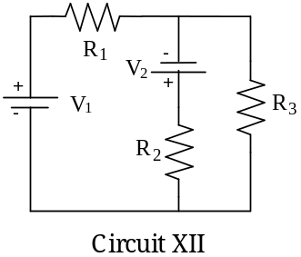

Prediction

To predict currents through resistors in the circuit under study, you will need to use Kirchoff’s laws. The goal is to derive theoretical formulas for the currents. Once you have the formulas, you can plug in them parameters of your circuit, such as voltages of the batteries and resistances of resistors, and calculate the currents. These (predicted) values will be compared with the currents measured in the experiment.

Warm-up Questions

Read: Fishbane, Section 27-3. Pay attention to the examples 27-55, 27-6, and 27-7.

1. Draw and label a circuit diagram, showing all voltages and resistors. You may need to redraw the given circuit to see which resistors are in series and which are in parallel. For this problem, the voltages and the resistors are the known quantities and the currents in the resistors are the unknowns.

2. Assign a separate current for each leg of the circuit, indicating each current on the diagram.Identify the number of circuit paths (loops) and label them on the diagram.

3. Apply conservation of current to each point in the circuit at which wires come together (a junction).Use conservation of energy to get the sum of the potential differences across all of the elements in each loop, ensuring your signs are correct. Does the potential difference increase or decrease across each circuit element, in the direction you have chosen to traverse the loop? Use Ohm's law to get the potential difference across each resistor.
Check that the number of equations you wrote above matches the number of unknowns.

4. Complete the calculations and write your solution. Simplify your equations as much as possible, but be warned that your final solutions may look quite complicated.

Exploration

To get familiar with a DMM and various modes of its operation, read Appendix D.

Build Circuit XII. How can you tell if there is current flowing through the circuit? What happens to the current at each junction? What is the resistance of each resistor? What is the potential difference provided by each of the batteries? What is the potential difference across each resistor? Use the DMM to check your answers to each of these questions.

Complete your measurement plan.

Measurement

Measure the resistance of the resistors. Measure the current flowing through each resistor, and the potential difference provided by each battery. So that you can check your measurements, measure the potential difference across each resistor.

Analysis

Calculate the current through each resistor from your prediction equations, using your measured values of the resistance of each resistor and voltage of each battery. Compare those results to the measured values of each current.

Conclusions

Did your measured and predicted values of the currents through the resistors agree? If not, explain the discrepancy.

As a check for the consistency of your measurements, calculate the potential difference across each resistor using the currents that you measured. Compare these values with the potential difference across each resistor that you measured with the DMM.

PROBLEM #10
Quantitative circuit analysis (Part B)

You apply for a summer job at an electronics company. As part of the interview process, the manager gives you a circuit and asks you to calculate the current flowing through each resistor. You are then given some batteries, resistors and wires, and asked to build the circuit to check your calculation.

Equipment

You will have wires, resistors, and batteries or a power supply to build a circuit shown to the right.  You will have a digital multimeter (DMM) to measure resistances, voltages, and currents. | 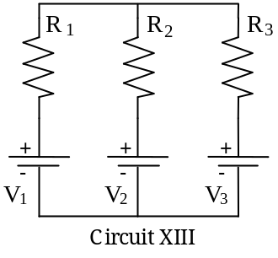

Prediction

Derive formulas to calculate the current through each of resistors in Circuit XIII as a function of voltages of the batteries and resistances involved in the circuit.

Warm-up Questions

1. Draw and label a circuit diagram showing all voltages and resistors. Sometimes you may need to redraw the given circuit to help yourself see which resistors are in series and which are in parallel. For this problem, the voltages and the resistors are the known quantities and the currents in the resistors are the unknowns.

2. Assign a separate current for each leg of the circuit, indicating each current on the diagram. Identify the number of circuit paths (loops) and label them on the diagram.

3. Apply conservation of current to each point in the circuit at which wires come together (a junction). Use conservation of energy to get the sum of the potential differences across all of the elements in each loop, ensuring your signs are correct. Does the potential difference increase or decrease across each circuit element, in the direction you have chosen to traverse the loop? Use Ohm's law to get the potential difference across each resistor.

Check that the number of linear equations that you have now matches the number of unknowns.

4. Complete the calculations and write your solution. Simplify your equations as much as possible, but be warned that your final solutions may look quite complicated.

Exploration

To become familiar with a DMM and various modes of its operation, read Appendix D.

Build Circuit XIII. How can you tell if there is current flowing through the circuit? What happens to the current at each junction? What is the resistance of each resistor? What is the potential difference provided by each of the batteries? What is the potential difference across each resistor? Use the DMM to check your answers to each of these questions.

Complete your measurement plan.

Measurement

Measure the resistance of each of the three resistors, as well as the currents flowing through each of them. Measure the potential difference provided by each battery. So that you can check your measurements, measure the potential difference across each resistor.

Analysis

Calculate the current through each resistor from your prediction equations, using your measured values of the resistance of each resistor and voltage of each battery. Compare those results to the measured values of each current.

Conclusions

Did your measured and predicted values of the currents through the resistors agree? If not, explain the discrepancy.

As a check for the consistency of your measurements, calculate the potential difference across each resistor using the currents that you measured. Compare these values with the potential difference across each resistor that you measured with the DMM.

PROBLEM #11
qualitative Circuit Analysis

You have just become a manager at an engineering firm. The engineers who report to you are constantly describing complex circuits; to pinpoint possible problems with their designs, you have to quickly decide which resistors in the circuits will carry the most current. You have been using a calculator to calculate the current through each resistor, and the process is too slow.. A fellow manager suggests that a purely qualitative analysis could get you reliable results much more quickly. You decide to test the technique on the three circuits below, using identical light bulbs so that the brightnesses of the bulbs indicate which parts of the circuit carry more or less current. You will also do some practice calculations to see if you can get faster. You decide to double-check your work by actually building the circuits.

Equipment

You will have batteries, wires, and five identical bulbs that you can connect to make the three circuits shown below.
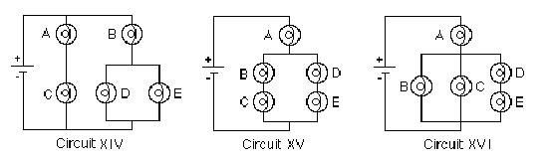

Note: Some of the light bulbs in the lab may be of different kinds and have different resistances. To find identical light bulbs look for markings and check to see that the color of the plastic bead separating the filament wires is the same.

Predictions

You will need to use both qualitative rules and formulas from your text book to make predictions about the brightness of the light bulbs in the circuits under study. The following rules are nothing but consequences of conservation of charge, conservation of energy, and Ohm's law in electric circuits.

1. a) Resistors in series all have the same current flowing through them.
b) Resistances in series add.
c) The current through a path across a fixed potential difference decreases as the total resistance of the path increases.

2. a) Current divides at a junction.
b) The current through each path across the same potential difference depends on the resistance of the path – the larger the resistance, the smaller the current.
c) Paths of equal resistance will have the same current.

3. a) Resistors in parallel offer less total resistance than the smallest resistance in the configuration.
b) Parallel branches connected directly across a battery are independent – each set of parallel branches has the same potential difference as if it were the only connection to the battery.

The above rules will help you predict how the bulbs within each circuit should compare in brightness. Include in each prediction, which rule(s) you used answering the question.

Circuit XIV
How will the brightness of bulb A compare with the brightness of bulb B?
How will the brightness of bulb B compare with the brightness of bulb D?
How will the brightness of bulb C compare with the brightness of bulb D?

Circuit XV
How will the brightness of bulb A compare with the brightness of bulb B?
How will the brightness of bulb B compare with the brightness of bulb C?
How will the brightness of bulb B compare with the brightness of bulb D?

Circuit XVI
How will the brightness of bulb A compare with the brightness of bulb B?
How will the brightness of bulb B compare with the brightness of bulb C?
How will the brightness of bulb B compare with the brightness of bulb D?
Now, try to rank the circuits by the brightness of bulb A. First, decide, which quantity does the brightness of a bulb depend on? Then derive an equation for this quantity in terms of two variables – the resistance of each bulb, say R, (remember that all the bulbs are identical) and the voltage of each battery, say V (same in each of the three circuits). Begin by finding equivalent resistances of certain parts of the circuits. In your text book or lecture notes, look up equations for equivalent resistances of two resistors connected in parallel and in series. Gradually simplify each circuit applying appropriate equations to pairs of bulbs in series or in parallel up to the point when you can use qualitative considerations to rank the circuits by the current through bulb A or by the potential difference across this bulb.

Exploration

Set up each circuit and observe the brightness of the bulbs. How can you test whether minor differences you observe are due to manufacturing irregularities in “identical” bulbs?

Measurement

Coordinate with other groups to compare the brightness of bulb A in each of the three circuits. If necessary, use a DMM (see Appendix D) to measure the current through bulb A in each of the three circuits.

Conclusions

Qualitative circuit analysis is very useful for quickly checking the results of the algebra that come from quantitative circuit analysis. It is a great way to catch mistakes before you fry expensive circuits.

Explain any differences between your predictions and your observations.

Each qualitative rule is the result of applying conservation of energy (Kirchhoff's loop rule), conservation of charge (Kirchhoff's junction rule), and Ohm’s law to different circuit configurations. . To summarize the material learned, for each qualitative rule, write the corresponding equation(s).
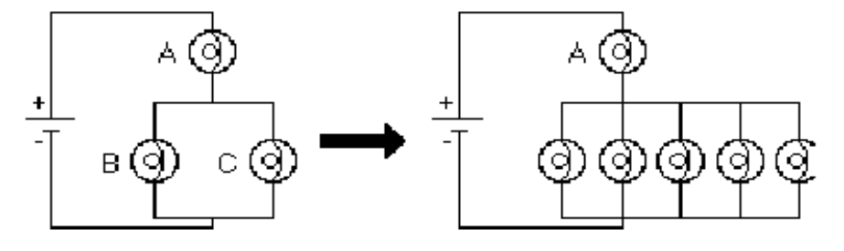
1a. What would happen to the brightness of bulb A in the circuit below if more bulbs were added parallel to bulbs B and C?

1b. In household circuits, a fuse or circuit breaker is in the position occupied by bulb A, why?

2. In circuits I through IV below, the four batteries supply the same voltage and all bulbs are identical. Rank the circuits from the largest current at point 1 to the smallest current at point 1. Explain your reasoning.

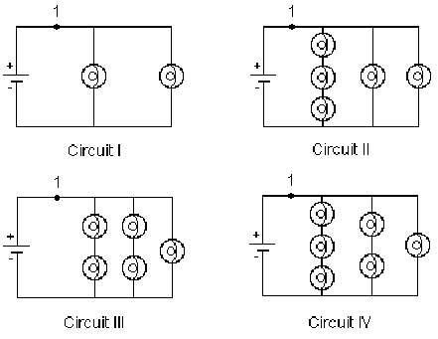

3. Predict what will happen to the brightness of bulbs A, B, C and D if bulb E were removed from its socket. Explain your reasoning. | 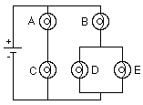

4. For the circuit below, determine the current in each resistor.

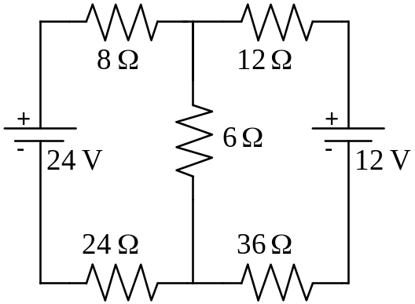

5. For the circuit below, determine the value for R such that the current I3 is 0.1A with the indicated direction.

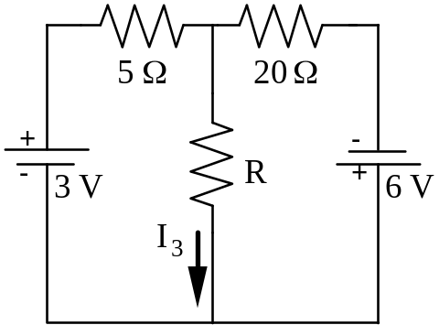

What is the value for R that will give a current I₃ = 0.1 A, but in the opposite direction to what is shown?

PHYSICS 1302 LABORATORY REPORT

Laboratory IV

Name and ID#:
Date performed: Day/Time section meets:
Lab Partners' Names:
Problem # and Title:
Lab Instructor's Initials:
Grading Checklist | Points*
LABORATORY JOURNAL:
PREDICTIONS
(individual predictions and warm-up questions completed in journal before each lab session)
LAB PROCEDURE
(measurement plan recorded in journal, tables and graphs made in journal as data is collected, observations written in journal)
PROBLEM REPORT:
ORGANIZATION
(clear and readable; logical progression from problem statement through conclusions; pictures provided where necessary; correct grammar and spelling; section headings provided; physics stated correctly)
DATA AND DATA TABLES
(clear and readable; units and assigned uncertainties clearly stated)
RESULTS
(results clearly indicated; correct, logical, and well-organized calculations with uncertainties indicated; scales, labels and uncertainties on graphs; physics stated correctly)
CONCLUSIONS
(comparison to prediction & theory discussed with physics stated correctly ; possible sources of uncertainties identified; attention called to experimental problems)
TOTAL(incorrect or missing statement of physics will result in a maximum of 60% of the total points achieved; incorrect grammar or spelling will result in a maximum of 70% of the total points achieved)
BONUS POINTS FOR TEAMWORK
(as specified by course policy)

* An "R" in the points column means to rewrite that section only and return it to your lab instructor within two days of the return of the report to you.

